ADOLESCENCE PSYCHOLOGY
VOCABULARY

- Adjustable: variante (aggettivo)
- Adjustment: adattamento
- Appreciable: considerevole
- Approval: approvazione
- Expense: spesa
- Instantly: all’istante
- Major: importante
- Mood: umore
- Noteworthy: notevole
- Peak: picco
- Pride: amor proprio, orgoglio
- Questioning: interrogazione
- Recognition: riconoscimento
- Reluctant: restio
- Sovereign: sovrano (aggettivo)
- To aspire: aspirare
- To attain: raggiungere
- To perceive: notare
- Unstable: instabile
- Unsteady: insicuro
- View: parere

TEXT ANALYSIS

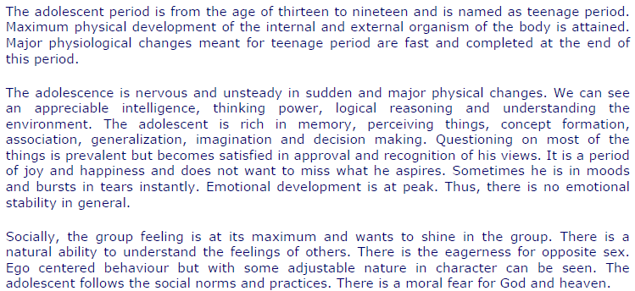 | 1. Physical development
 | 2. Emotional changes
 | 3. Social behaviour

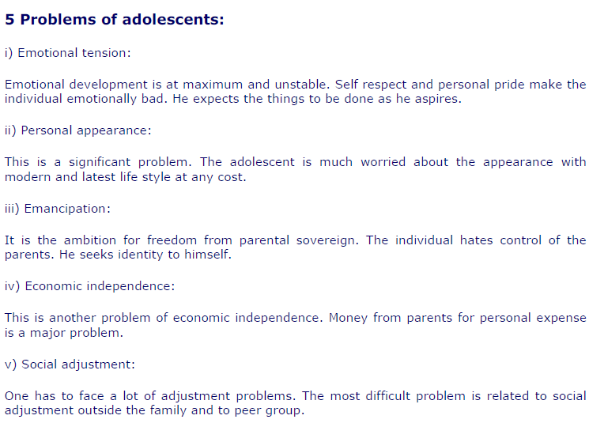 | Conclusion (summary)

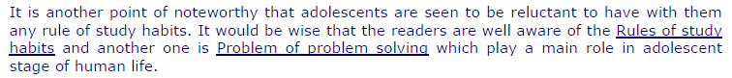 | Notes and references

SUMMARY
Adolescence, or teenage period, covers the age from thirteen to nineteen. It is usually a time of happiness and it’s full of ambitions.
During adolescence, many physical changes occur both in the internal and external organism. Most of them are fast and completed at the end of the period.
The adolescent usually has got an appreciable intelligence and good thinking power. Memory, concept formation, generalization, imagination and decision making are improved. The teenager tends to question on most of the things but becomes satisfied in approval and recognition of his views.
Adolescents aren't stable emotionally, because the emotional development is at a peak.
The adolescent has great self-respect and personal pride which can make him feel emotionally bad when things aren't done as he aspires.
Socially, the teenager wants to shine in his peer group and outside the family. He is much worried about the appearance and follows the fashion, the social norms and practices. There is the eagerness for opposite sex. Teenagers have the natural ability to understand the feeling of the others. Adolescents usually want to escape from the parental control, however they still depend on them economically. Somebody is also reluctant with rules or study habits. Besides, there is a moral fear for God and heaven.

TECHNICAL TERMS
- Physical changes: they are all the growth processes which occur during adolescence, for example the voice breaking, the reaching of the physical maturity, …
- Concept formation: the capacity to definite things neatly.
- Generalization: the capacity to assign a definition to things and group together.
- Imagination: the capacity to imagine things and concepts.
- Decision making: the capacity to decide what to do without somebody else’s approval.
- Emotional instability: it is the sudden changeover from happiness to sadness (or vice versa) without a real cause.
- Personal pride and self-respect: the self-image

