War memorial
 | Peace | War | Conclusion
Definition | or (predominating in modern times) to commemorate those who died or were injured in a war. | A war memorial is a building, monument, statue or other edifice to celebrate a war or victory | We can already find a shift between ancient and modern times
Historical usage | The oldest war memorial in the United Kingdom is Oxford University's All Souls College itself. It was founded in 1438 with the provision that its fellows should pray for those killed in the long wars with France. | War memorials for the Franco-Prussian War (1870–71) were the first in Europe to have rank-and-file soldiers commemorated by name. Every soldier that was killed was granted a permanent resting-place as part of the terms of the Treaty of Frankfurt (1871). | We can find two opposed kinds of memorials. The first is created to commemorate the dead. The second is made to commemorate the soldiers,too, but mostly highlights the nation that “granted a permanent resting-place” to “every soldier”, thus almost using the dead soldiers.
Modern usage | In modern times the main intent of war memorials is not to glorify war, but to honor those who have died. | They may also serve as focal points of increasing understanding between previous enemies. | We can find a contradiction even in modern times. In this case we can find the commemoration of the dead, but also the use of war memorials for political reasons
Pacifist war memorials | Instead of commemorating the glorious dead, pacifist war memorials denounce war with figures of grieving widows and children rather than soldiers | -Such memorials provoked anger among veterans and the military in general  -Feelings ran so high that the memorial was not officially inaugurated until 1990 and soldiers at the nearby army camp were under orders to turn their heads when they walked past. | In this case, the author is very supportive of peace. In the first quote, he disdains the old kind of memorial to embrace the pacifist one (as shown by the terms “Instead” and “the glorious dead”).
Conclusion | By the elements I’ve gathered, we can conclude that the text promotes peace, since the author is either neutral or very supportive of peace.

Tomb of the Unknown Soldier
 | Peace | War | Conclusion
Definition | A Tomb of the Unknown Soldier refers to a monument in dedication to the services of an unknown soldier and to the common memories of all soldiers killed in any war. | Such tombs can be found in many nations and are usually high-profile national monuments. | The second phrase obscures the first, highlighting the word “nation” that is repeated twice.
Symbolism | These remains are considered impossible to be identified, and so serve as a symbol for all of a country's unknown dead wherever they fell in the war being remembered. | it could be the tomb of anyone who fell in service of the nation, and therefore serves as a monument symbolizing all of the sacrifices. | Even though the first quote promotes a peaceful message, the soldier’s belonging to the “country” is still underlined. This is emphasized in the second quote since the soldier “fell in service of the nation” and is ported as a “sacrifice”.
David Railton’s idea |  | David Railton proposed the creation at a national level of a symbolic funeral and burial of an "Unknown Warrior", proposing that the grave should include a national monument in the form of what is usually, but not in this particular case, a headstone. | The word nation is underlined since it’s repeated twice
Conclusion | By the elements I’ve gathered, I can conclude that the text promotes war.

Country | Location | Image | Description
France | Tomb of the Unknown Soldier beneath the Arc de Triomphe de l’Étoile in Paris | 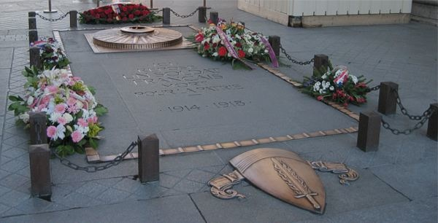
Italy | Piazza Venezia in Rome | 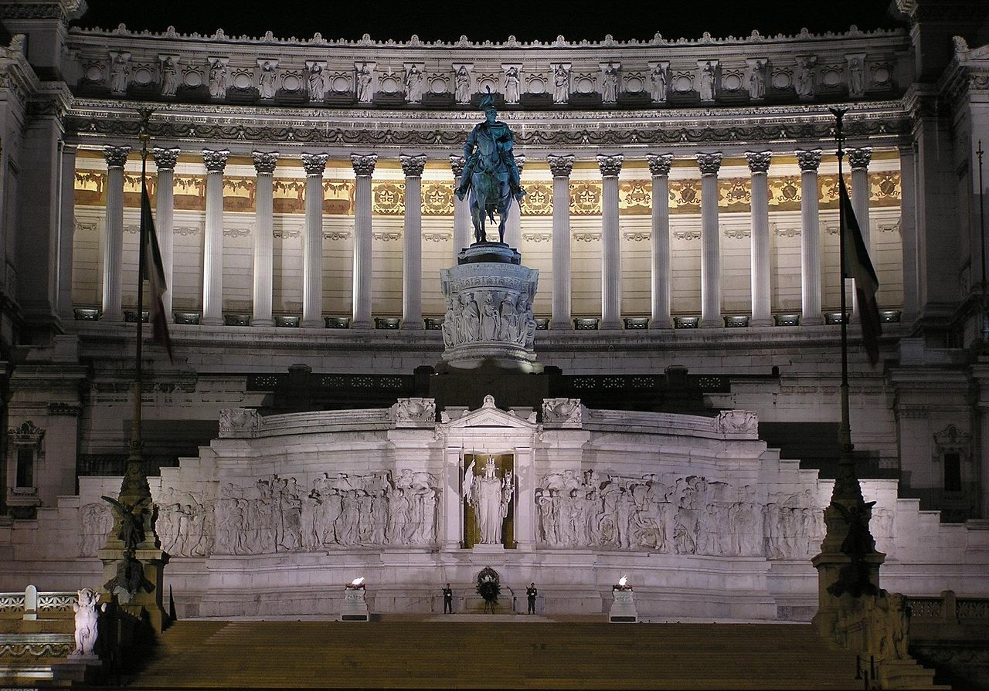 | The Tomb of the Milite Ignoto in the Altare della Patria (Vittoriano)
United Kingdom | Tomb of the Unknown Warrior, Westminster Abbey in London | 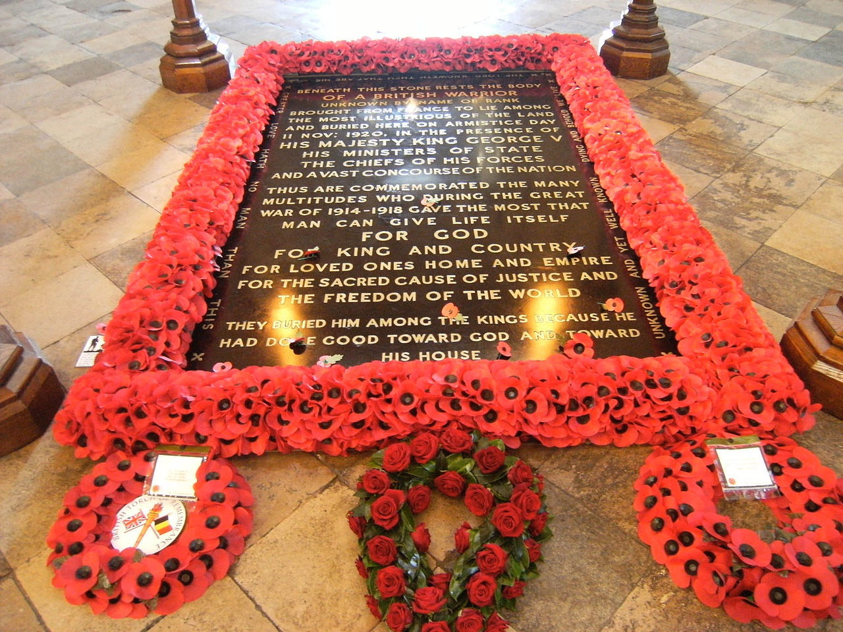
United States | Tomb of the Unknowns, Arlington National Cemetery in Arlington, Virginia | 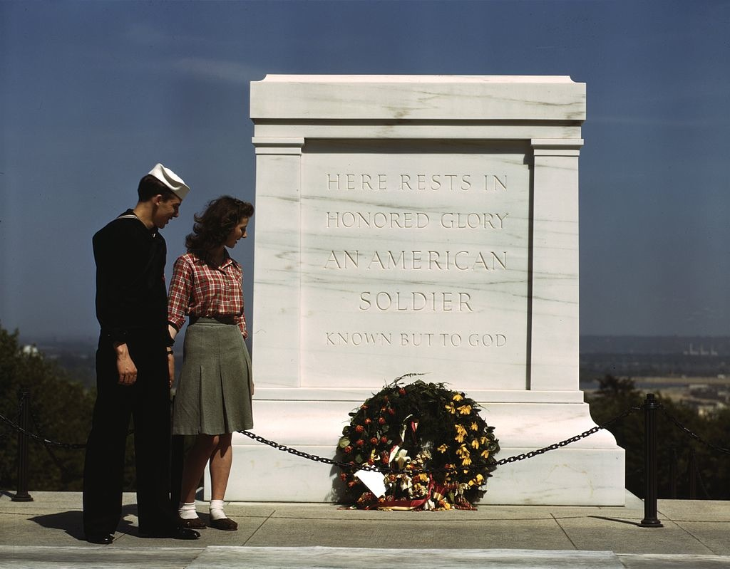 | The Tomb of the Unknown Soldier at Arlington National Cemetery stands atop a hill overlooking Washington, D.C.. On March 4, 1921, Congress approved the burial of an unidentified American soldier from World War I in the plaza of the new Memorial Amphitheater.  The white marble sarcophagus has a flat-faced form and is relieved at the corners and along the sides by neo-classic pilasters, or columns, set into the surface. Sculpted into the east panel which faces Washington, D.C., are three Greek figures representing Peace, Victory, and Valor. The six wreaths, three sculpted on each side, represent the six major campaigns of World War I.  Inscribed on the back of the Tomb are the words: Here rests in honored glory an American soldier known but to God  The Tomb sarcophagus was placed above the grave of the Unknown Soldier of World War I. West of the World War I Unknown are the crypts of unknowns from World War II and Korea, plus one empty crypt honoring missing service members from all conflicts. Those three graves are marked with white marble slabs flush with the plaza. The empty crypt originally held the remains of an unknown from the Vietnam War, but its occupant was identified in 1998 and his remains returned to his family for burial in St. Louis.

