CAESAR’ S LEGACY: THE CLASH BETWEEN ANTONIO AND OTTAVIANO

The solemn funeral of Caesar are celebrated on 20 March of 44 a.C.   
The figure of Marco Antonio , lieutenant (right arm in military campaigns) of Caesar reads to the crowd the will of the dictator, who gives the people the gardens of Janiculum and three hundred gold (coins) for each commoner. He showed with a flourish the bloody robe of Caesar to the crowd causing a popular uprising: the crowd attacked the houses and the villas of the Assassination of Julius Caesar - (Brutus, Cassius and the other conspirators) who were forced to flee.

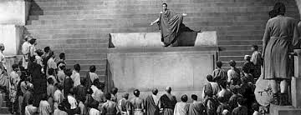

*Antonio's speech at the funeral, in a film based on the tragedy "Julius Caesar" by the great playwright William Shakespeare*

The day after the funeral, a young just nineteen, (Octavian) showed up to collect the inheritance.  
As a son of Gaius Octavius and a niece of Caesar (it was adopted by Caesar himself) he had the name of Gaius Julius Caesar Octavian. He immediately collected the favor of the veterans’ army and the Senators , while Antonio, who aspires to turn to the role of successor, judges him like a rival and try to hinder it. The two arrive to arms, facing each other in Modena: Octavian wins and march on Rome to be proclaimed consul.

When Octavian became consul in 43 a.C. he announced revenge against Assassination of Julius Caesar and sides with Antonio. Along with Lepidus, (Commander of the cavalry of Caesar) conclude the second triumvirate.   
Unlike the first triumvirate, it is a public and official agreement with the duration of five years, with whom they share the control of the provinces. To further establish their union, Antonio marries Octavian's sister, Octavia, while Lepidus is established in Spain, Octavian and Antonio march against the Assassination of Julius Caesar, who organize extreme resistance in Greece.  
In Macedonia, at Philippi takes place the final battle: is the defeat for Brutus and Cassius, who take their own lives.

Octavian back quickly in Italy, where he fights for a long time against Sextus Pompey, son of the great Pompey, who practices piracy in the Mediterranean. The Senate celebrated him as a restorer of peace in the seas.  
After the victory of Philippi, Antonio has appropriated the province of the East, where he has had the opportunity to meet Cleopatra. He falls in love with her, repudiates Octavia and he married Cleopatra in a ceremony in Alexandria, sitting on a gold throne with the typical costumes of the eastern monarchs, revered as gods by their subjects.   
Cleopatra gives him two twins, who are called Alexander Helios and Cleopatra Selene.

Cleopatra deeply influence Antonio, pushing it to take attitudes by King Pharaoh and to support Egypt's independence from Rome.  
All that deeply shocked the Romans, to the benefit of Octavian, who unleashed a smear campaign against his rival:

* He, Octavian, has at heart the interests of Rome, while Antonio has lost his mind and could transfer the capital in Egypt;
* Ottaviano claims to represent the true values of the res publica: honesty, sobriety, austerity, while Antonio lives in Eastern luxury and softness;
* Octavian wants to defend the institutions and traditional religion, while Anthony aspires to be worshiped as a god;
* Ottaviano is a true Roman man, Antonio instead is maneuvered by a woman, Cleopatra, immoral and corrupt, who laid a curse to seduce him.

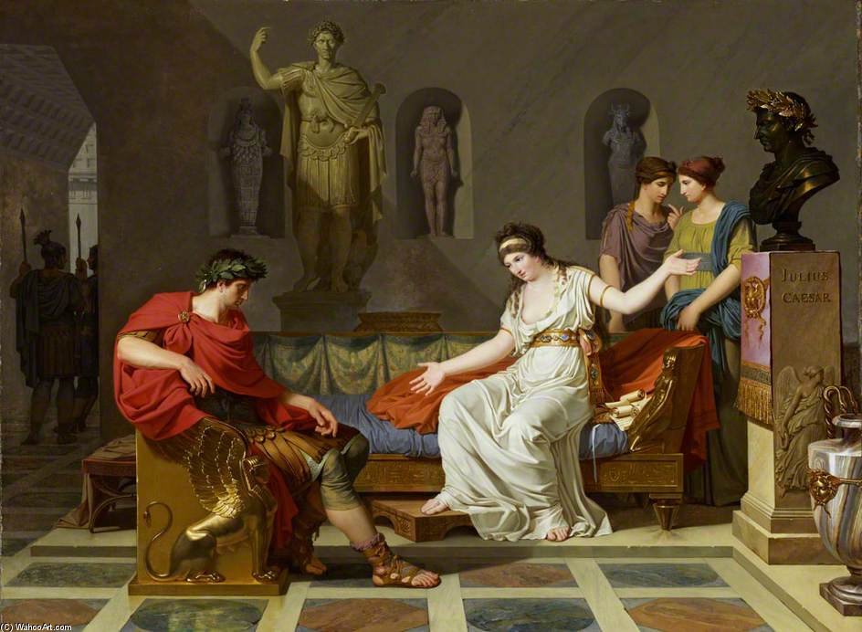

Cleopatra and Antony

The decisive battle occurs in 31 to. C. at Actium, on the western coast of Greece. Antony and Cleopatra have a higher number of men and ships, but Agrippa, Admiral of Octavian's fleet manages to lock their supplies.

Rather than fall into the hands of Octavian, the couple decides to flee to Egypt and to commit suicide.

According to tradition, Cleopatra is do bite the breast from an asp (other than by a cobra, considered sacred snake) hidden in a fruit basket.

Octavian won. When he returned to Rome, a new era begins.