Elisa Calligaris

Classe 4ASA

Sir Herbert Edward Ryle was born in London, on the 25 May 1856. He was the second son of John Charles Ryle, the first Bishop of Liverpool, and his second wife, Jessie Elizabeth Walker.He was educated at Eton College and King's College, Cambridge and became a teacher until he was ordained.

Ryle was appointed Honorary Chaplain to Queen Victoria in March 1896. In December 1900 he was appointed Bishop of Exeter, being consecrated at Westminster Abbey in January 1901.In December 1910 Ryle was appointed Dean of Westminster.

During World War I Ryle used to take the midday service of intercession and he was responsible for the many special services held in wartime.

The idea of a Tomb of The Unknown Warrior was first thought in 1916 by the Reverend David Railton, he wrote to Dean Ryle in 1920 proposing that an unidentified British soldier fallen in France be buried in Westminster Abbey. David Railton was born on the 13th November 1884 in State Newington London and was a [Church of England](https://en.wikipedia.org/wiki/Church_of_England) [clergyman](https://en.wikipedia.org/wiki/Cleric), a [Military chaplain](https://en.wikipedia.org/wiki/Military_chaplain). The idea of a ritual to pressure the memory of those who lost their life on fighting in the Great War broken out there, in Nothern France, when David Railton saw a grave with a rough cross on which was the inscription :”An Unknown British Soldier”. He was really expressed by those few words, and this is the reason why, in August 1920,as I said in the previous lines he wrote to the Dean of Westminster and thanks to his efforts and the approvation of King George V and the Prime Minister the memorial was carried into effect.

King George was [King of the United Kingdom](https://en.wikipedia.org/wiki/Monarchy_of_the_United_Kingdom) and the [British Dominions](https://en.wikipedia.org/wiki/Dominion), and [Emperor of India](https://en.wikipedia.org/wiki/Emperor_of_India), from 6 May 1910 until his death in 1936.

Commento visita

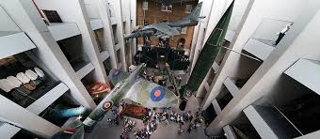During the visit teaching in London we could visit many museums and monuments about the first world war.For example,one of my favorite museum has been “Imperial War Museum”.This is a new museum,many museums and monuments on the first world war.The objects were very interesting and moving, one among many that struck me was a letter written by a child who wanted to go to war to save his homeland.

This made me reflect on the concept that people had of the war and how dramatic was the situation during this period.

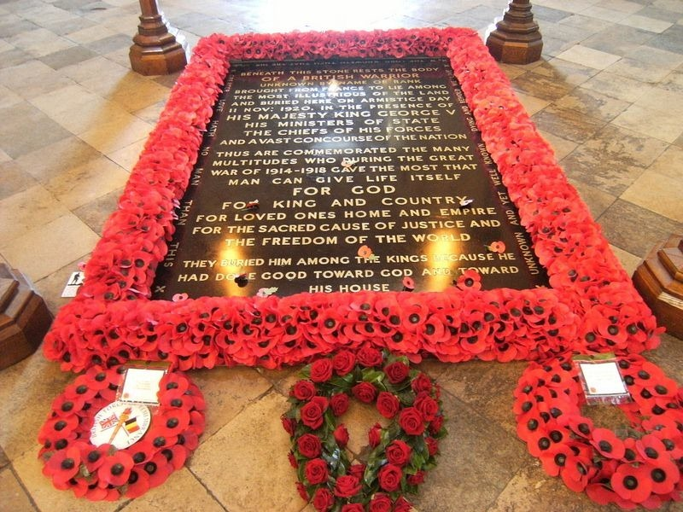After we visited the Westminster Abbey where we saw the tomb of Unknown soldier.After 20 minutes in a row we we entered in the majestic and golden abbey.Upon entering we were immediately provided with a transistor radio and a guide led us to the place where it was placed the tomb.The first very important thing that struck me was the abbey's interior care, but most of the area where there is the tomb.This area was so controlled and protected that there has not been allowed to take any photos advising us to take them from the official website on the internet.Another aspect that was very surprising was that we knew a lot more informations than driving, thanks to the thorough study done in class.Having studied before these events was very interesting to see everything and made me put herself in that time.The third monument that we visited was “The Cenotaph”.The Cenotaph is a war memorial situated in London in particular along a street called “Whitehall” zone very important area where the Queen passes. My opinion about this monument is that it is very important to the British in fact located in a very important and noble area to also emphasize its importance.

Every day millions of people pass in front of the memorial and the only act of gratitude is a silence to remember the British victims

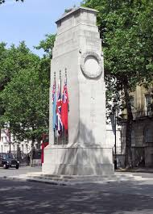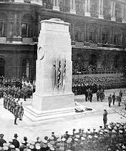In conclusion I can say I am very happy to have treated first in great depth the topics and then subsequently see them in person because you understand many things and you can not see with new eyes the reality that surrounds us.

THE CEREMONY ON 11 NOVEMBER 1920

NOWKe