***The American Unknown Soldier***

**The birth of the idea**

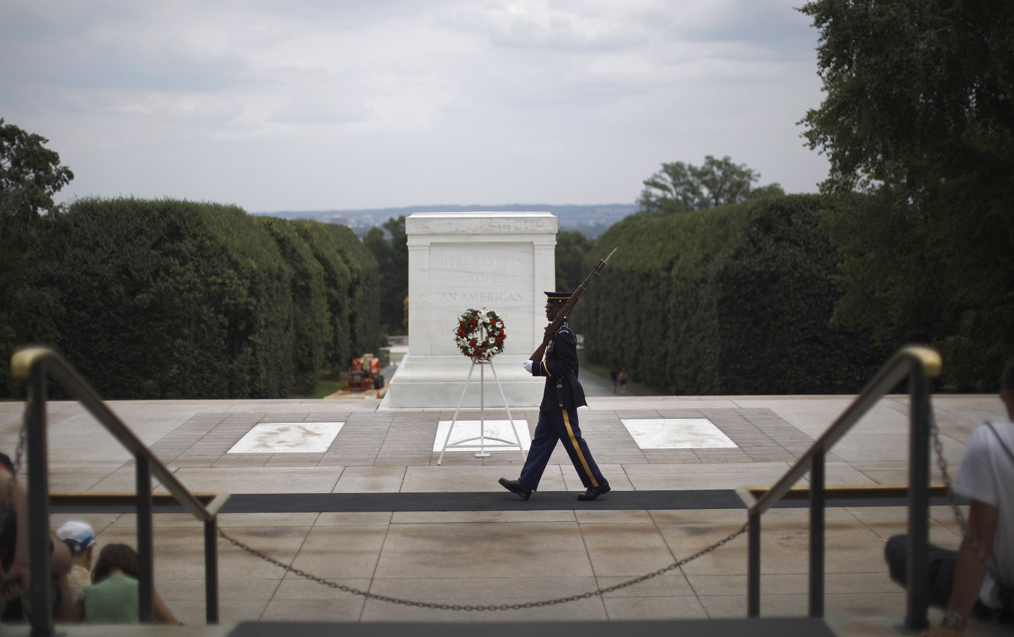Inspired by the French idea, Brigadier General William D. Connor proposed to General [Peyton C. March](http://www.arlingtoncemetery.net/pcmarch.htm) for the United States on 1919. March disagreed because he thought that the Army Graves Registration Service would probably identify all American casualties; in addition he explained that the United States hadn’t an appropriate burial place for the American Unknown Soldier as the “Arc de Triomphe de l'Étoile” or Westminster Abbey. In 1920 the idea became a matter for the Congress: Hamilton Fish Jr found the ideal solution providing to the return of an unknown American casualty of the French front and projecting his funeral ritual in a grave at the Memorial Amphitheater in Arlington National Cemetery. The Fish’s idea was approved by the Congress on 1921 and therefore the construction of the grave would take place at Arlington National Cemetery. The grave had originally been a simple structure, it was improved between 1926 and 1929. Fish proposed the ceremony to be taken place on Memorial Day (an American federal holiday for remembering the people who died in war fighting for the United States Armed Force, the holiday is celebrated on the last Monday of May every year) in 1921, but the Secretary of War John W. Weeks chose Armistice Day (like the British ceremony). The War Department ordered to Quartermaster General Harry L. Rogers to make an effective “selection ceremony” for an unknown soldier from France. It took place at Chalons-sur-Marne on 23 October 1921, a body was taken there from each of American cemeteries in France during the previous day and before arriving in Chalons-sur-Marne they had been inserted in alike coffins.

**The selection ceremony**

Differently from British selection of the Unknown Soldier, the American one was a real ceremony. At the event delegations from American and French army participated: the American representation was ruled by Quartermaster General and the French one was led by General Duport (commander of the French 6th Army Corps, the Prefect of Marne and the Mayor of Chalons-sur-Marne. The officials prepared the city hall for the event: it was adorned by American and French flags in the outside, the hallways were garnished with plants like palms or potted trees. A room for each step of the ceremony was prepared, indeed after the welcome another room was prepared for the conveyance of the chosen unknown soldier to a special coffin. Major Harbold rearranged the coffins disposition making the provenience unidentifiable and he chose Sergeant Edward F. Younger of Headquarters company for the selection of the unknown soldier even if originally an appointed officer would choose the body. The change of plan was due to the fact that General Rogers learnt about French selection where a soldier chose the French Unknown Soldier. For the ceremony General Duport guided American and French officers to the reception room for dead’s honors, after that Duport and Rogers made speeches and Sergeant Younger guided the passage and while the French band played hymn in the courtyard Younger chose a coffin laying down a spray of white roses on it, then the officials made their last respects to the bodies; then the remaining coffins were taken to Romagne Cemetery. After the official selection the procession of the Unknown Soldier began, from the city hall of Chalons-sur-Marne to the railroad station; the French escort of the ceremony included a band, dragoons, infantry, artillery and a motor transportation unit and the American unit was assembled only from the Quartermaster Corps. In addition to the military escort there was a no-military escort composed by students, firemen, war veterans and representatives of French societies.

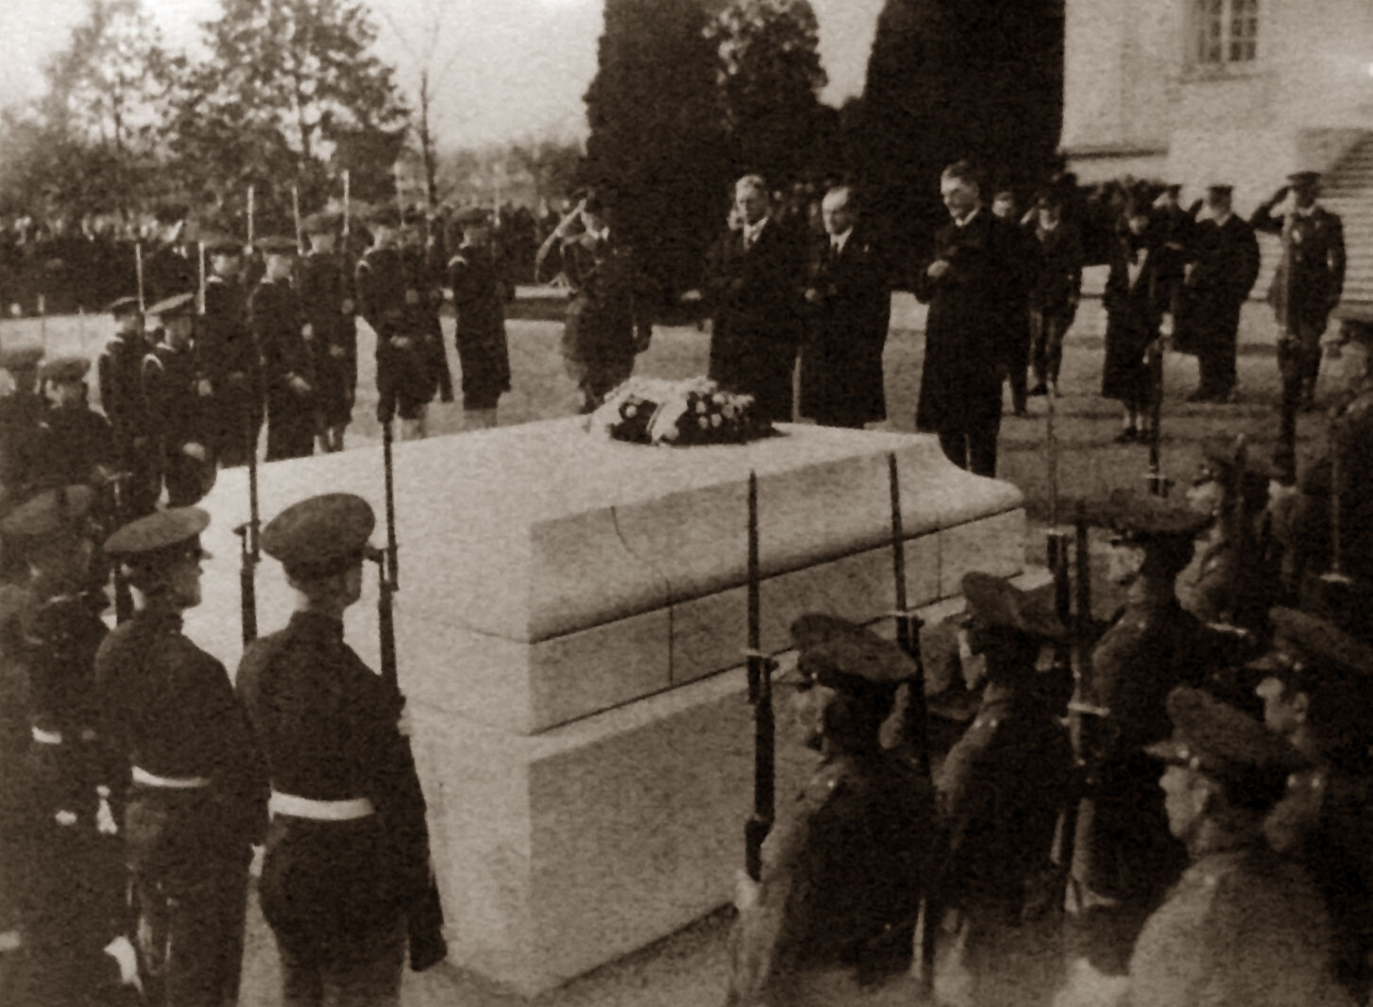On 24 October the train which contained the coffin left the city and arrived in Paris where French officials and other representatives of French government made their last respects. The selection ceremony celebrated in France symbolized the strength of the relationships between the United States and France, an alliance that persisted from the American Indipendence.

**The funeral ceremony**

On 25 October the American Army honor guard and French guards and representatives brought the coffin from Paris to Le Havre where, according to the plan, the coffin and the military convoy left France with the cruiser USS Olympia for the United States. In the United States an appointed military officer, Brigadier General Harry H. Bandholtz, had to organize the funeral ceremony in all its steps.

On 9 November the Olympia arrived to the Potomac River’s outlet at the Washington Navy Yard, where the Unknown Soldier was received by Brigadier General Bandholtz, the third Cavalry and its band and important military officials like the General of the armies of the United States John Pershing, Admiral Robert Coontz, Major General John Lejeune, Secretary of War John Weeks and Secretary of Navy Edwin Denby. The third Cavalry was in line facing the war ship and the band is situated on the left of the cavalrymen. The marines brought the coffin to the gangway and at the same time the cruiser started with canons shot and the band played the “Funeral March” of Chopin. After the reception eight cavalrymen placed the coffin on a caisson and the procession began. The band led the procession to Washington D.C., following in order were a squad of cavalrymen that guided the caisson containing the coffin, the remaining men of the third Cavalry and military rulers and civil representatives in their cars; the way was lined on the two sides by marines and the Capitol was literally “invaded” by soldiers belonging to all military branches. The eight body bearers took the coffin crossing the honour cordon and put it on the Lincoln catafalque where President Warren Harding and his wife subsequently placed a wreath of crimson roses and a white band of ribbon with a pinned National Shield on the coffin. Then Vice President, Speaker of the House, Chief Justice, Secretary of War and Secretary of Navy put wreaths for the institution each represented in that order. Capitol employees on the evening of the 9th roped off areas in the rotunda which would channel the crowds as they entered from the east, moved past the bier, and continued out the west door: this maneuver improve the Unknown Soldier’s route from the rotunda on 11 November. Public was admitted on 10 November and delegations of patriotic organizations arrived from all over the country. On the morning of Armistice Day the coffin was taken by the military escort from the rotunda to the Memorial Amphitheater in Arlington National Cemetery, following the escort President, Vice President, Chief Justice and the military rulers walked. After the procession, at the Amphitheater the President of the United States assigned the Unknown Soldier the Congressional Medal of Honour (highest American military honour) and the Distinguished Service Cross. Following the funeral ceremony each diplomatic representation of the allied countries of USA of the First World War conferred the Unknown Soldier the most important military honour of their country.