Comment about places we visited in London of the project Erasmus

The purpose of our school excursion was to make a visit in the places of the British Unknown Soldier’s history and in the Imperial War Museum. In the afternoon of the second day of the trip, we visited the Imperial War Museum: the first impression the visitor creates is the size of the museum which, at first, is conferred by seeing the two huge canons in front of the entrance. The dimensions are particularly due to the fact that the museum exhibits lots of military vehicles like a Supermarine Spitfire, a tank M4A1 Sherman, a German R75 sidecar with MG34…

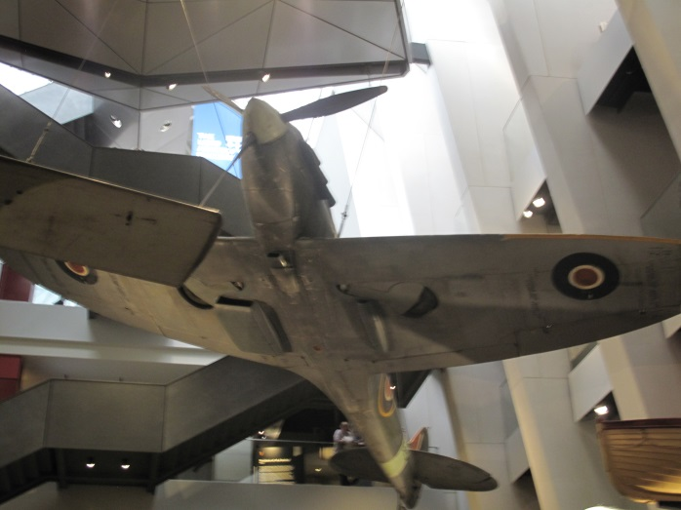Supermarine Spitfire

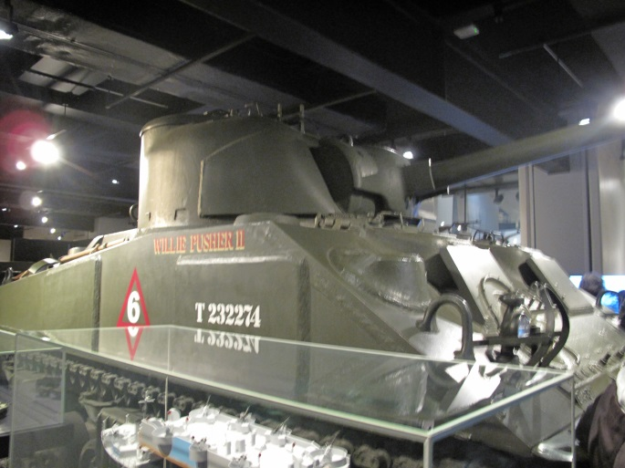M4A1 Sherman

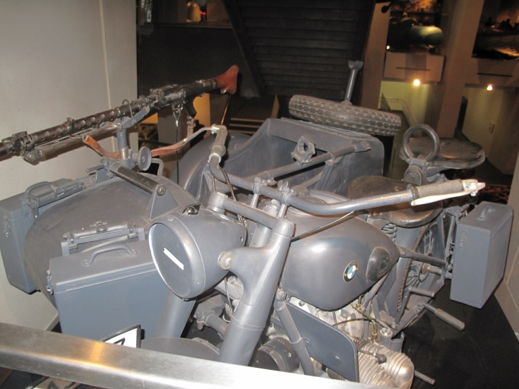 R75 sidecar with MG34

The museum is perfectly organized and offers lots of services (like every English museum) to enhance the visitor’s itinerary. The edifice had been originally built as a hospital, then it became a museum which initially exalted war; today the aim of the museum is allowing people to understand war and his impact on individuals and society. There are six floors into the museum: we focused our attention on the First World War’s route because it is the museum’s area which is pertinent to the project, if you want to visit accurately the museum you have to remain there for an entire day! The route is very accurate because it analyses the First World War in all its aspects using lots of objects like photos, military equipment, maps… The parts of the way are divided according to the war’s features: the uniforms and the weapons underlined the innovation of the “First Modern War” and the different development of the involved countries, showing the strength of German and British Empire; the propaganda’s activity of the countries, for example the involvement of the British colonies like India or Australia; the life the citizens conducted during the war is represented by photos and texts; the conditions of soldiers in trenches that the visitor can imagine with photos and there is also a reconstruction of a trench in real dimensions. The museum privileged the First World War’s area because the area has a bigger collection and it is better organized than the other ones. The itinerary was very useful to improve our knowledge of the Unknown Soldier’s history because it creates a perfect imagine of his historical context and his situation in the battlefield.

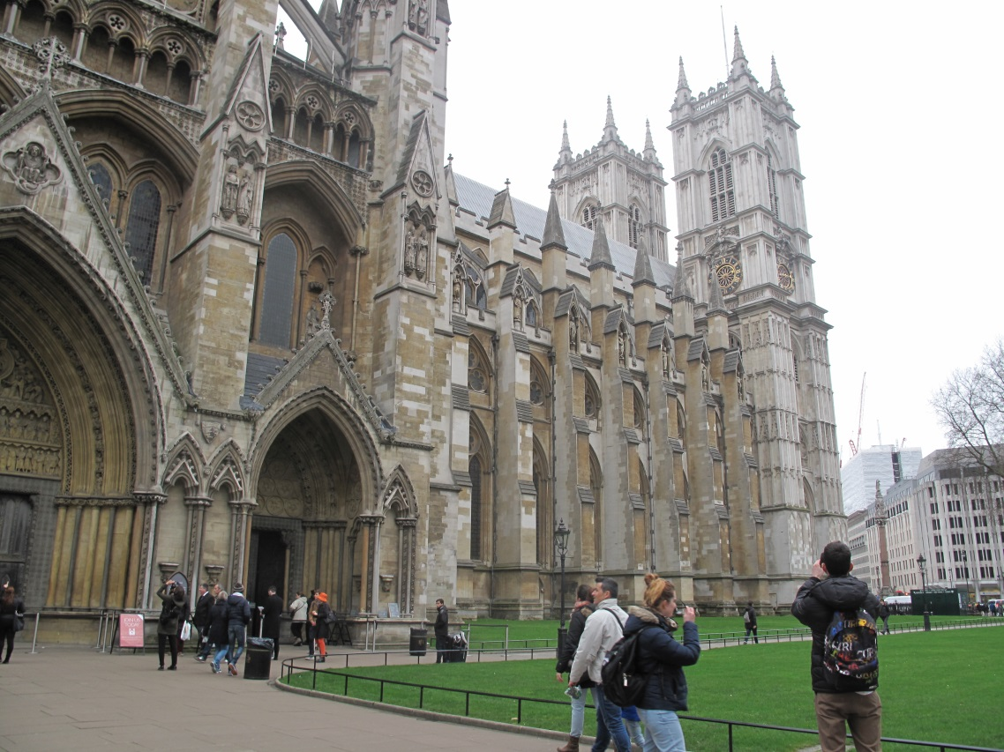

In the following day we went to Westminster Abbey where the British Unknown Soldier is buried. The first characteristic the visitor notices is the elegance of the architecture. The structure dates back to Edward the Confessor’s reign, it is the setting of every coronation since its foundation and of royal events like baptisms or weddings. Lots of fundamental characters of the British history like Charles Robert Darwin, Elizabeth I and Mary I Tudor or Geoffrey Chaucer are buried there. At the west end of the Nave of the abbey the Unknown Warrior is buried, we listened the history we had studied at school: the only new aspect of the tomb we have learnt was the selection of the flower for the perimeter of the grave. An interesting characteristic of the church is that taking photos isn’t allowed, it underlines there is a lot of respect for history.

The last place pertinent to the project we visited was the Cenotaph. It is situated in Whitehall, Westminster. It is a particular monument because it is situated in the center of the road, so nobody can move close to the memorial. It was built in 1920 and it is a war memorial which represents all British casualties of WWI and it actually is adorned by flags that represent the United Kingdom, the Royal Navy, the British Army and the RAF, originally the flags displayed were a Union Jack, a White Ensign and a Red Ensign. Every year a celebration took place there on the closest Sunday to Armistice Day, it underlines again the respect of British people for the country’s history.

