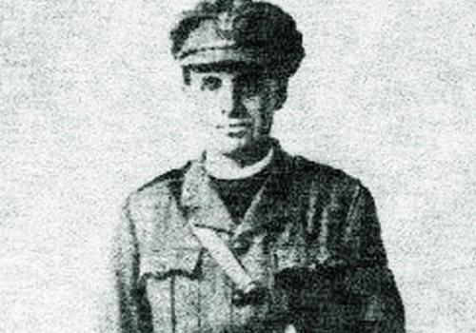**DAVID RAILTON**

David Railton was born on 13 November 1884 in London, he was a clergyman and he is known to be the originator of the idea of the Unknown Soldier’s tomb.

The Railtons were a Scottish family and David Railton’s father George Scott Railton worked together with General William Booth in the founding of the Salvation Army. Educated in Oxford and Liverpool, David joined the Church of England in 1908: when the First World War broke out he was a curate in Folkestone and he saw hundreds of thousands of soldiers leaving the town for the Western Front, he became a military chaplain to the 2nd Battalion of the Hon Artillery Company, as a member he took personally part in the conflict. He was awarded the Military Cross for an important military action: he saved two comrades under fire of a heavy machinegun.

In 1916 in France, he found a makeshift grave which brings a particular inscription on a wooden cross that read An Unknown British Soldier. It was the first step to the birth of the war memorial in Westminster Abbey. Railton had the idea to have a symbolic burial in Great Britain to commemorate those who died in the Great War without a name and to come out of the project he convinced the most important British authorities. He could not know that his project would come true and one of the most important British war memorials and would allow the ritual and cult of the Unknown Warrior.

When the war finished he became vicar of Margate and in 1920, two years after the end of the First World War, he informed Herbert Ryle, Dean of Westminster. The building of a memorial in Westminster Abbey would be the symbol of all WWI’s casualties without identification. The idea was approved by King George V, the Parliament and the government.

David Railton sadly died in a train on 13 June 1955.

***Sources***

The documents used as sources for the study of the figure of Railton are arranged into paragraphs, where each of them tells of a step of the chaplain’s idea and his connection with the Unknown Soldier’s memorial. The texts are informative and use a formal register, so the ideal reader is someone interested in history and one who wants to provide information about key people of his idea connected with Westminster Abbey’s war memorial.

**SIR HERBERT EDWARD RYLE,**

**DEAN OF WESTMINSTER**

Sir Herbert Edward 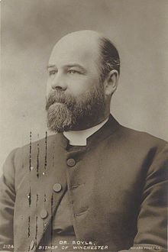Ryle was the [Bishop of Exeter](https://en.wikipedia.org/wiki/Bishop_of_Exeter), the [Bishop of Winchester](https://en.wikipedia.org/wiki/Bishop_of_Winchester) and the [Dean of Westminster](https://en.wikipedia.org/wiki/Dean_of_Westminster).

He was born in [Onslow Square](https://en.wikipedia.org/wiki/Onslow_Square), [South Kensington](https://en.wikipedia.org/wiki/South_Kensington), London, on 25 May 1856 and was the second son of [John Charles Ryle](https://en.wikipedia.org/wiki/John_Charles_Ryle), the first [Bishop of Liverpool](https://en.wikipedia.org/wiki/Bishop_of_Liverpool), and his second wife, Jessie Elizabeth Walker.

In 1868 Edward Ryle went to [Eton College](https://en.wikipedia.org/wiki/Eton_College). There in 1875 he won the Newcastle scholarship, and in the same year he went to [King's College in Cambridge](https://en.wikipedia.org/wiki/King%27s_College,_Cambridge).

Ryle studied theology at Cambridge with excellent results; since he was a very intelligent and careful student.

Sir Herbert Ryle became [Dean of Westminster](https://en.wikipedia.org/wiki/Dean_of_Westminster) [Abbey](https://en.wikipedia.org/wiki/Westminster_Abbey)on 20th April 1911.

Under his guidance and with the help of his advisers, the Abbey services was notably increased.

David Railton fought in the First World War and proposed thinking to build a tomb to commemorate all the men who had died in WWI. At first the king refused his idea, but

later, in 1920, David Railton wrote a letter to Herbert Edward Ryle: Railton proposed him to create an official ceremony where an unknown-soldier had to be buried as representative of all the men who had died in the conflict; Ryle immediately accepted this idea.

At first king George did not like Railton’s idea, but when Herbert Ryle wrote him a letter and in the end he accepted the proposal.

Ryle was a supporter of the King and was always on his side. He also tried to pass himself off as a founder of the project, because he wanted to glorify himself.

Ryle was buried on 25 August in Westminster Abbey in a spot close to the tomb of [The Unknown Warrior](https://en.wikipedia.org/wiki/The_Unknown_Warrior).

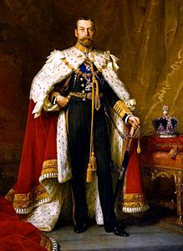**GEORGE V**

George Frederick Ernest Albert was King of Great Britain, Ireland and Emperor of India. He reigned from May 6, 1910, until January 20, 1936.

George inherited the English throne in a particularly turbulent period of national history.

He had to govern in length of time many complicated and difficult in England and had to face the difficult conditions of World War I and the postwar period.

George V was considered a model to follow and imitate by his citizens.

Throughout his political life he had to change his ideas and his plans for solving the complicated issues of the First World War over and over again.

**COMMENT:**

**THE PLACES WE VISITED IN LONDON**

Before going to London, we studied the history and function of the different places of the city that were connected to the Unknown Soldier.

Having studied about these places or monuments before visiting knew was very useful to our project when we found ourselves in front of them, we could see what we had studied about and be more involved. We also could admire them closely and understand all their features.

Upon arriving near Westminster Abbey one can immediately see even from afar the majesty and charm Westminster Abbey.

Upon entering the Abbey, the staff was very polite and friendly to us. After buying a map of the church we started our tour. The Abbey houses many famous and prestigious personalities: poets and writers, scientists and physicists and individuals of the Royal Family.

Later we could reach the grave of the Unknown Warrior where a museum guide (who had also lived for a long time in Italy) explain us the history of the burial and of the Unknown Soldier.

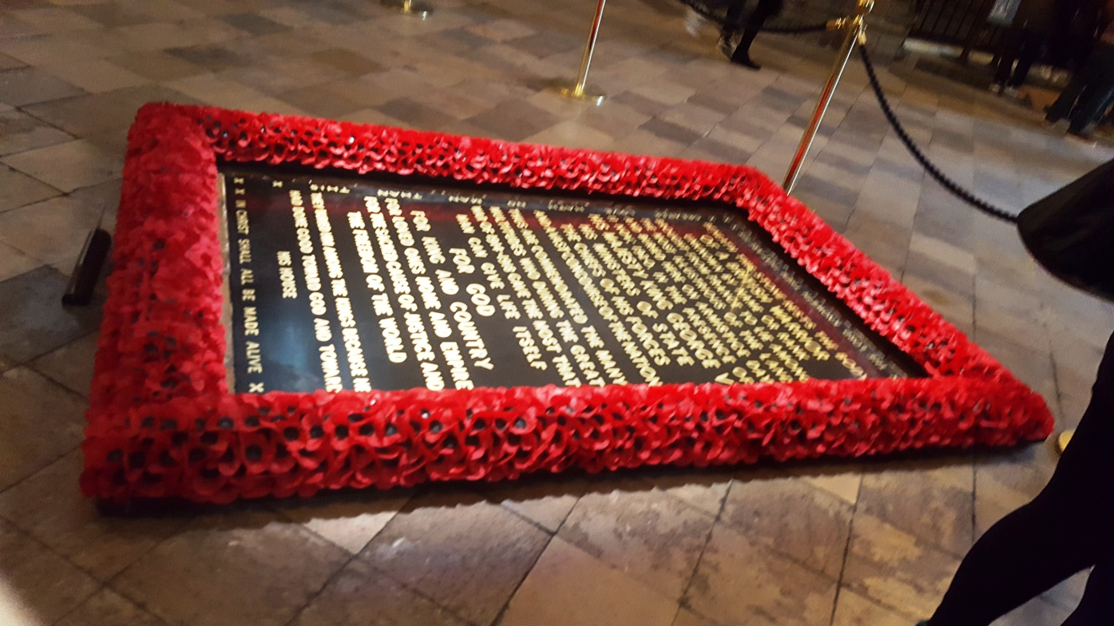

We understood that the English were proud as well as a bit jealous of their monuments and of their history. We also saw that the English consider their monuments and museums very important for their identity. There were lots of children visiting the tomb, in Italy you can see very few children in the museums.

Before visiting Westminster Abbey, we had visited the Imperial War Museum: it was very well organized and interesting. Even if the theme of the museum is the War, the purpose is to condemn the War and make people to a reflection thought of peace.

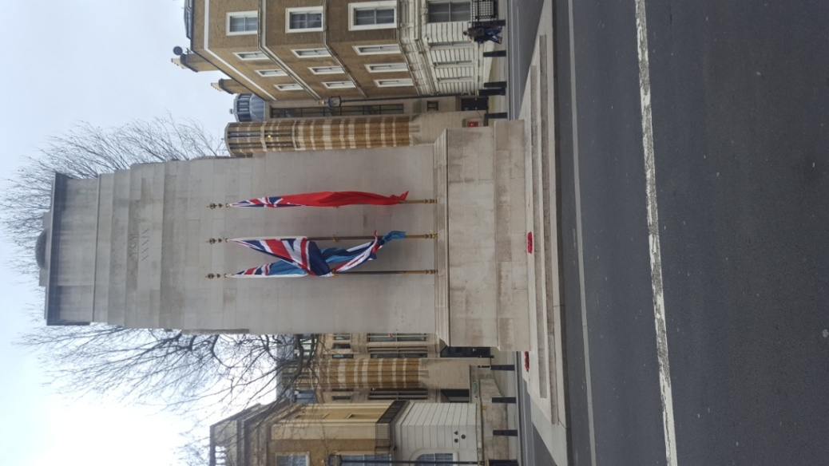

Besides, we also visited the Cenotaph, at Whitehall. The Cenotaph is an empty tomb that commemorates all the dead of the first World War.

An architect, Edwin Lutyens was committed to produce a design for a temporary structure: taking inspiration from the Greeks and the Egyptians, he put forward the idea of an empty tomb awaiting the return of a missing soldier to commemorate all the British war dead : it went under the name of ‘Cenotaph’ –from Greek ‘empty tomb’–.

It took Lutyens almost two weeks to build the structure which, set in Whitehall- in London, seemed to be a theatrical set by wood and plaster.

But nonetheless Lutyens’ design was simple, elegant and neutral and the chosen inscription “THE GLORIOUS DEAD” was free from any national, imperial and warlike connotations: it was a commemoration of a fallen who could represent any race or creed of the world.

That’s why the Cenotaph became highly popular: thousands of people laid bouquets, wreaths and flowers on it, making crowds even bigger and after that other parades were organized, including the use of bonfires and fireworks.

Later, the Cabinet decided to place a permanent Cenotaph on the same site because such memories and a mass feeling of the population could not be uprooted. Lloyd George was indeed determined to give to the population patriotic, unifying symbols and rituals, making people feel citizens of a ‘whole community’.

Lutyens’ first fragile structure was demolished but he had already been commissioned to produce the permanent memorial whose design remained unaltered from the previous.