**Key figures in the history of the British unknown Soldier**

There are four people that represent a key role in the British unknown soldier’s history.

**David Railton**

The first is David Railton, whose figure is relevant because he was the first to have suggested the idea of an Unknown soldier’s grave. The proposal was born when, in the middle of the war in 1916, noticed a makeshift grave on which were penciled the words 'An Unknown British Soldier'. His aim was to commemorate thousands of missing men who knew no grave and ease the pain of their parents and friends. To achieve his goal, in 1920 he wrote to the Dean of Westminster who took another important role in the following events.

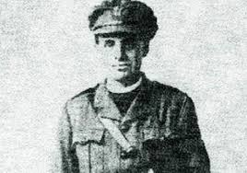

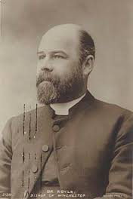**The Dean of Westminster**

Sir Herbert Edward Ryle -The Dean of Westminster- was moved by Railton’s sensibility towards the thousands of dead soldiers and became the first supporter for the idea that eventually resulted in the Unknown soldier’s grave in Westminster Abbey. The grave became one of the first memorials of his kind and made the Abbey increase its importance.

**L. J. Wyatt**

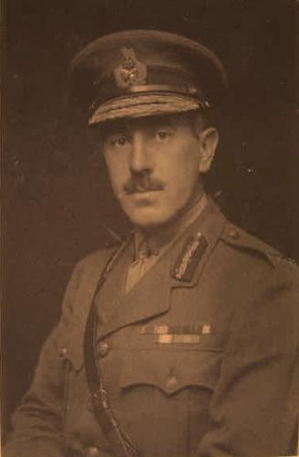In the middle of the history, another key figure took an important role: General Brigadier L. J. Wyatt. He was assigned the selection of the body of the Unknown soldier.

On identification he was blindfolded because he was supposed to choose among identified corpses because the chosen body had to symbolically represent all the soldiers that had died during the conflict. When he entered a hut in the village of St. Pol (near Ypres, in northern France), he had in front of him four bodies or the remains of them (the real number of the bodies were controversial). All the bodies were covered under the Union Flags. The bodies had been disinterred from unmarked graves in each of the main battlefields: the Aisne, the Somme, the Arras and Ypres. Four blank crosses had been chosen for them. The soldiers were supported to have taken part in the early years of the war because the bodies had to be as old as possible so that they could be surely sufficiently decomposed not to be identified.

**King George V**

King George V who is reminded to have been a respectable king’: he ruled during the period of the start of the Unknown soldier’s cult and during the War he made many visits to the front. He crushed many problems during his reign (for example Irish and financial crisis) but he managed to resolve them.