GROUP 2: Saponaro Alexia, Spanghero Leonardo, Vidal Anna

ASaponaro: The best of LSpanghero's and AVidal's notetaking

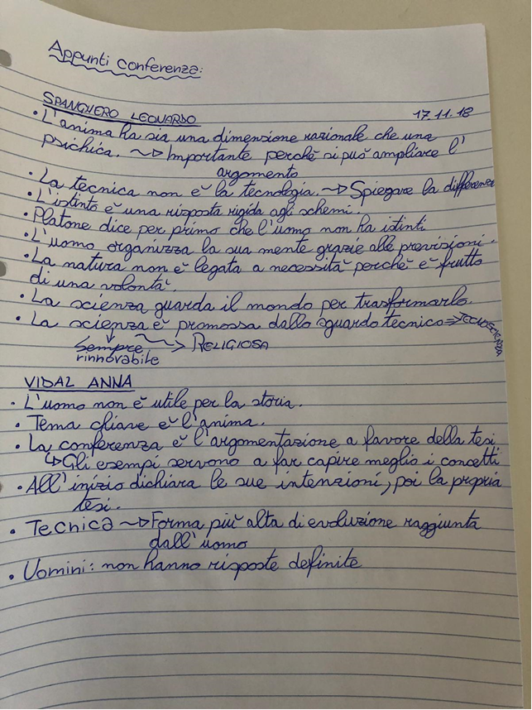

LSpanghero: The best of ASaponaro's and AVidal's notetaking

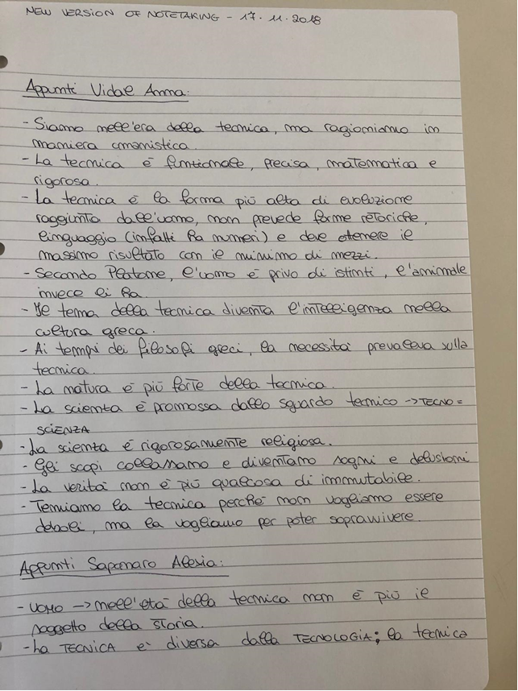

AVidal: The best of ASaponaro's and LSpanghero's notetaking

