**QUARANTINE LOCKDOWN**

**Quarantine has been overwhelming for everyone. Sudden and new, it came into people’s lives without asking permission and we all had to learn to cohabit with it.**

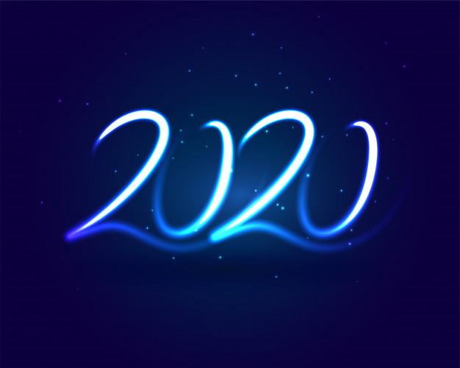A CHALLENGING YEAR.

2020 went straight for our weakest spot, imposing us an obliged reclusion. We are social beings and need social interactions daily: being forced to keep distance from society proved to be a burden right away. Obviously, everyone faced this new condition in their own way, trying to cope with the idea they would only see their families for a time.

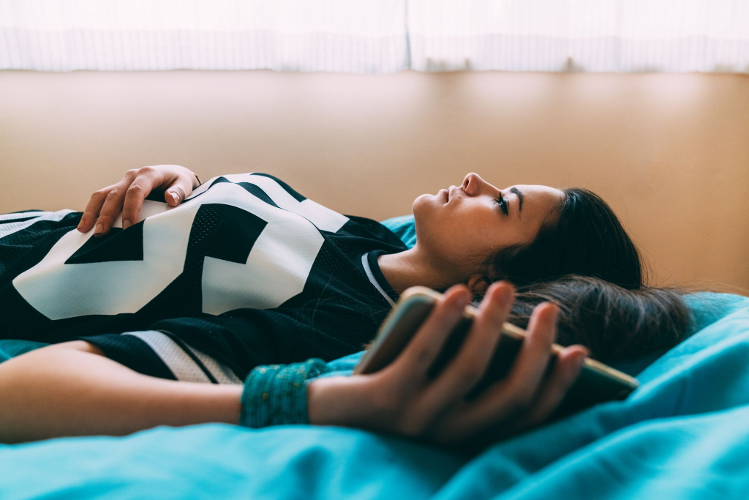TEENAGERS.

This was the most challenging part for teenagers: not being able to meet up with their friends and taking a break from their parents. They could just imagine what it would be like, as described by Zeynep Uluğ in his story Dreaming of life after lockdown. Two young friends daydreaming about the day they would gain their freedom again perfectly suits the spread feeling among youngsters.

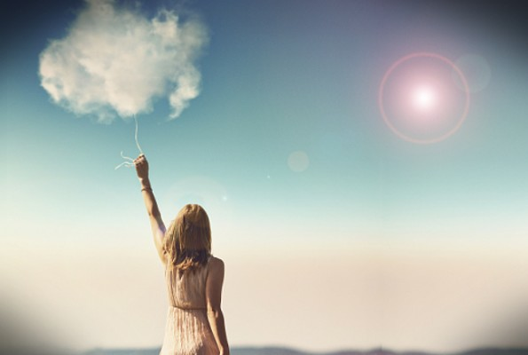DAYDREAMING.

Daydreaming became the only way of survival: telling ourselves stories turned out to be an effective way to get through the days. “When we’ll be out,” “when we will see each other again,” “when this will be over” seem to be the only hopes carrying them along.

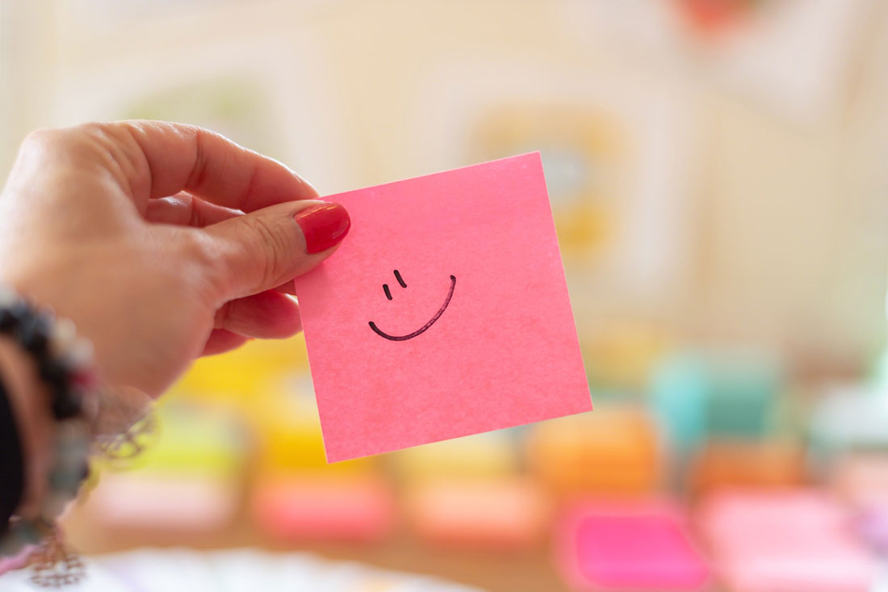POSITIVITY.

However, this idyllic time of freedom feels further and further away every day. It is a never-ending story: once the end is near, it gets postponed and it is all over again. But, maybe, waiting for quarantine to be over is the best way for everyone to be productive. They take up hobbies to keep them sane: while it is impossible to go out, people have time to concentrate on themselves. Is it such a bad thing?

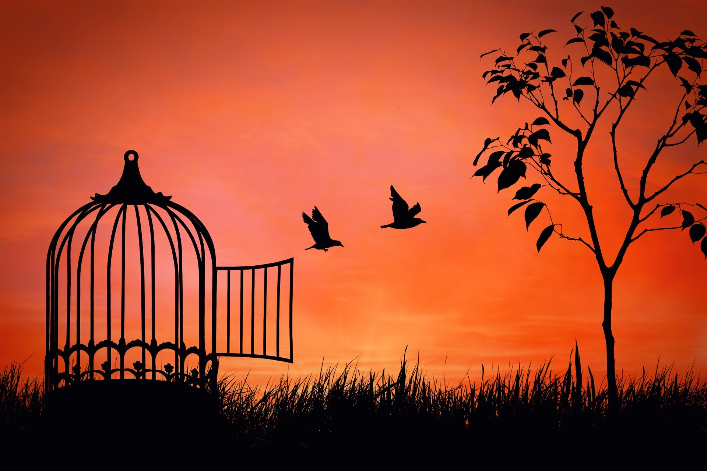COHABITING.

Right now, it feels like people have learnt how to coexist with this new condition, as we slowly approach freedom. Anyhow, we managed to find our way to handle quarantine and now we are being set free, step by step. There is always an end. It will not be the easiest to go back to normal, but if we succeeded in being quarantined for over two months, we will be able to face normality.

But what will normality mean once we get it back? Will it be the same as before?