REFLECTIONS AND LIFE DURING THE LOOKDOWN.
What is coronavirus and how has our lives changed since the epidemic?

The CORONAVIRUS is a large family of respiratory viruses that can cause a wide range of diseases, from common colds to serious illnesses. Few cases of those affected soon turned into a real pandemic causing many deaths.
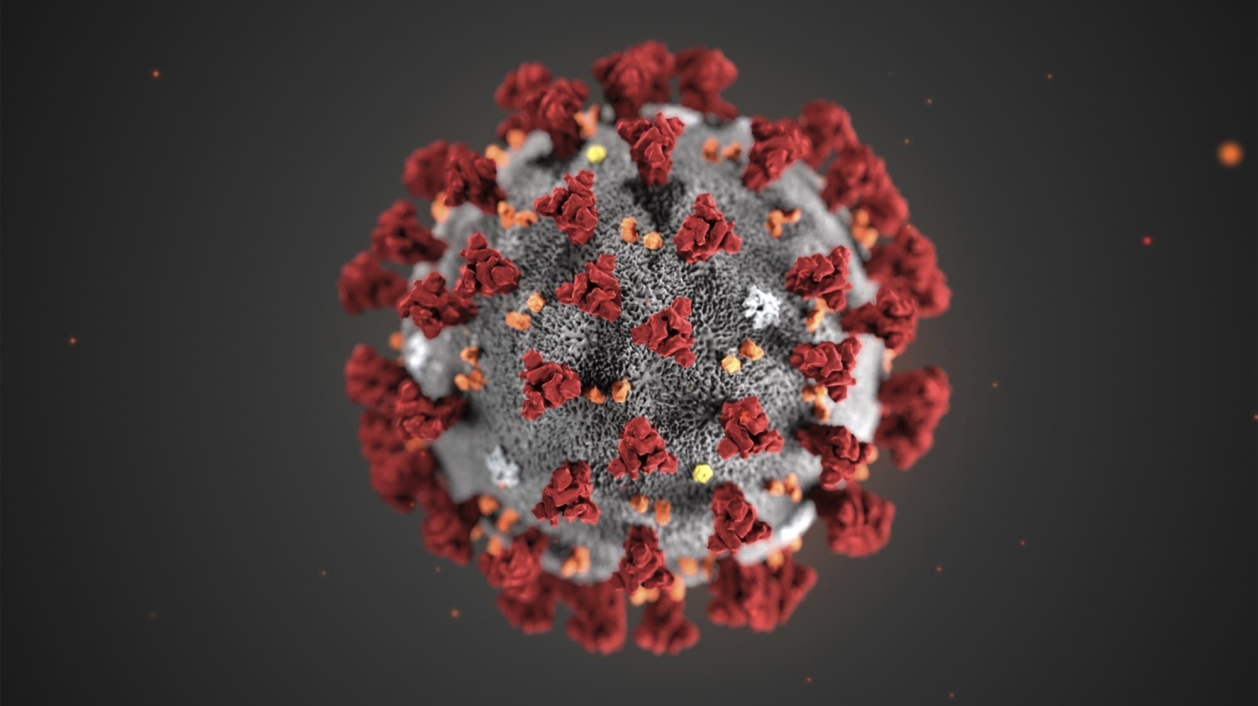

Life during the pandemic

During the pandemic, the majority of the population was forced to remain in quarantine, without being able to see friends, boyfriends, family members. Everyday life, which seemed obvious, was turned upside down in an instant. Every lost moment began to weigh in everyone's life, it was something unexpected that in a short time destroyed many projects, ideas and above all human lives and entire families. People's moods are disturbed and you live in uncertainty and anguish. All activities such as going to school, playing sports, taking a simple walk end up becoming desires and people start to take refuge in memories. Everyone is looking forward to an improvement, but it is too late to arrive and especially the students of all schools are suffering the heaviness and difficulty of a new world, very heavy to face: distance learning. All their certainties are discarded and the future is uncertain. Students will miss their best moments at school, the opportunity to be with their classmates and to continue to live their experiences.

Distance learning does not work and stress is considerable, a lot of willpower and responsibility is needed to deal with the situation.

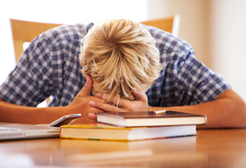

Moods and post pandemic risks

Not only students but also workers are concerned about the future of the economy. The damage will be high and the health system will be destroyed, like the hearts of many people who suffer family griefs. The streets are desolate and people express their opinions on what to be often conflicting and without logical foundations. The little ones can't understand what's going on and they're agitated. Relationships are put to the test and the risk of falling back into apathy is high. Many relationships solidify a lot, others get complicated and some end. Many projects are postponed and many dreams destroyed. In most cases people lose unrepeatable events in their lives.
People in the hospital die alone without to give a final goodbye to their loved ones and the only words that are addressed to them are "we can't let anyone in".
You can only go out to do the shopping using the mask and gloves.

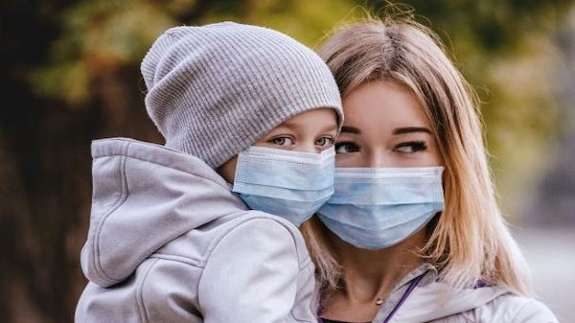

What can we do?
All we can and must do is keep calm and rely on our common sense, protect our health and that of others, and try to be confident about our relationships. We must try to preserve our physical and mental health by waiting for a whole new future.
Determination, strength and hope are needed to overcome victorious from this situation.

