Topics Summery | Corona virus: A Window on the Best version of Ourselves  Is there a positive side for us in this situation?  In such difficult time that implies forced isolation it is easy to fall into despondency and see only the dark side of the moon, in this article I will show you the way to see the light again.  
  - House Care
  - Who I am living with?
  - Mens sana in Corpore sano
  - Reading: Mind’s food
  - The Internet: an improving tool

House Care

In order to be able to deal with this situation with a minimum of serenity it is important to live in an environment that facilitates this condition.
Make your home a comfortable, clean and harmonious place.
Apply the changes you've long thought to make, add that shelf for the novels you’ve bought online, add some nice seedlings, in short take care of your home and make it 100% yours, it will be your safe harbor now more than ever.

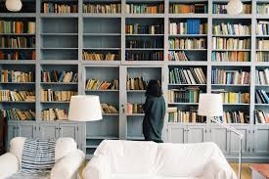

Who I am Living with?

Often dragged along by the frenetic rhythms of the dynamic society in which we live, we do not realize the people with whom we live.

We do not devote them the time they deserve, this is the right time to do it!

We often take our loved ones for granted but this situation more

than ever teaches us how much human life is subject to unforeseen.

Mens Sana in Copore Sano

To achieve a condition of serenity, also body plays its role. Take care of yourself, practice some daily exercise in fact, a total sedentariness is very harmful, before the lockdown even if you did not attend the gym you used to walk to go to school or office thus practicing unconscious exercise. Take care of yourself by paying special attention to your diet making it rich, healthy and balanced and occasionally giving yourself some delicious cuddles.


Reading: Mind’s Food

And if mind needs a healthy body to be healthy, it also needs food: reading. Reading is the best way to combine profit with pleasure. Reading is often master of life as the following article indicates The end of coronavirus: what plague literature tells us about our future in The Guardian May 1st,2020 (control and click to access) Dedicate yourself to a varied reading, literature is a world to discover, let's embark on this adventure!
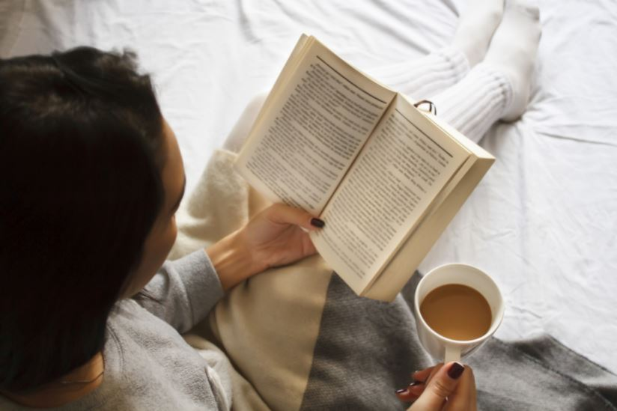

The Internet: Improving Tool

Everything when used excessively or incorrectly is harmful and this also applies to the internet but when used judiciously it becomes an indistinguishable source of knowledge. Reading we previously talked about can be integrated with internet searches. Document and cultivate every little passion you have now that you have time at our disposal!
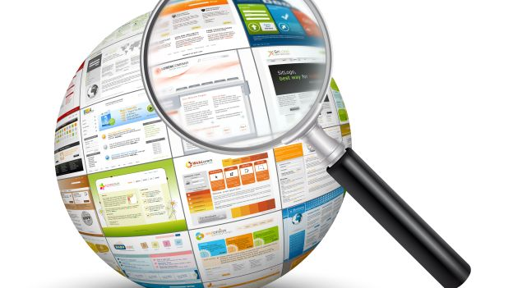
Obviously in conclusion we cannot forget the daydreaming, together we imagine the day of the lockdown and when all this terrible situation is over, an example provides us with his fascinating voice McEwan in the following reading Mc Ewan reads Zeynep Uluğ from Turkey (control and click to access).

