**How to stay positive during the Coronavirus lockdown?**

After Covid-19 emergency in China, the coronavirus has also arrived in Europe and one of the most affected countries was Italy. Since March, Italy has applied several restrictions to limit the spread of the virus including lockdown. People had to stay at home, could not visit relatives and travel. Schools, shops, restaurants and bars were closed for a long time.

The emergency in Italy started at the end of February and only on May 4th the government started to reduce restrictions. Now, we can see our relatives and get back to some of our daily activities but always respecting social distancing measures.



Quarantine brought a mix of emotions. On one hand, I have been very busy with video-lessons every day and therefore time flew quickly but on the other hand I was missing my grandmother because I was used to visit her every-day.

I am also upset because of the current situation, I don’t know when I will be able to see my sister next time. She lives in London and until flights will be reintroduced she will not be able to come home.

Even though we perceive the situation as new and unexpected, literature actually teaches us that similar circumstances had happened in the past. It is possible to find examples from Boccaccio’s *Decameron*, Defoe’s *A Journal of the Plague Year* to understand how our ancestors dealt with similar situations in the past.

Reading is one of the most common hobbies during lockdown but besides individual activities we also need to remember the importance of relationships and keep in touch with our relatives and friends. Thanks to technology today we are able to speak and see people staying home.

During the isolation period, people may feel alone and we should show our presence even just with a simple call. Love can help people to be stronger and survive during these strange times.

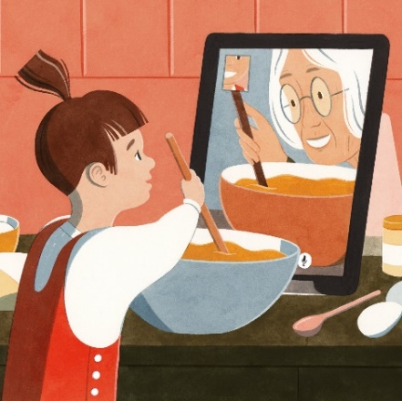

Going back to our usual everyday life will take some time so I’m sharing a list of activities to keep yourself busy:

* Read a book
* Do an online workout
* Call your grandparents
* Support local businesses

What are you doing to feel positive during this time? I’m looking forward to reading your comments below.