Gender violence
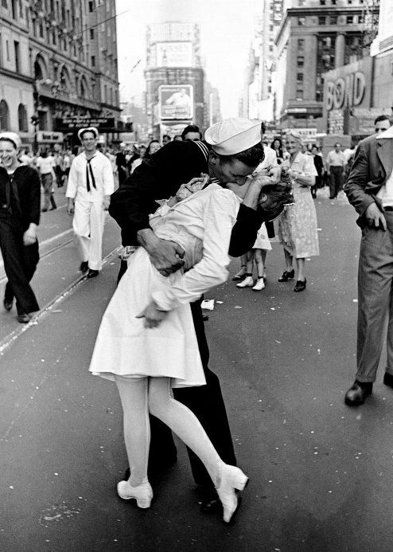
Gender differences

Passionate
Relationship II World War

Characterization by contrast with
Sally Rooney’s novel: Normal People

