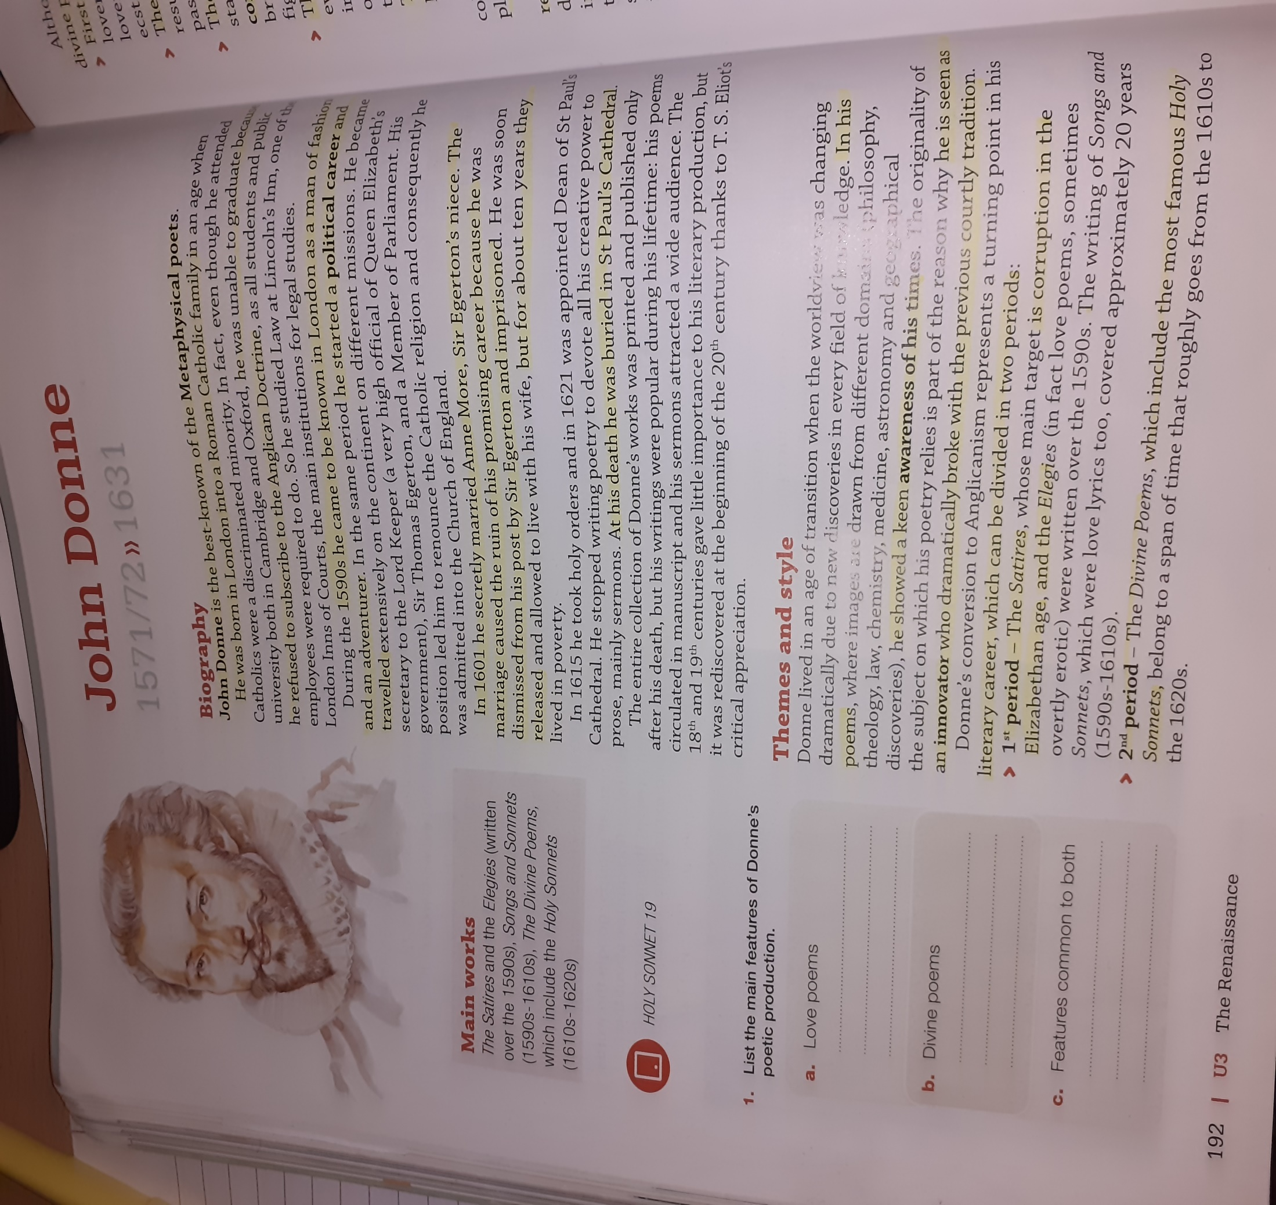

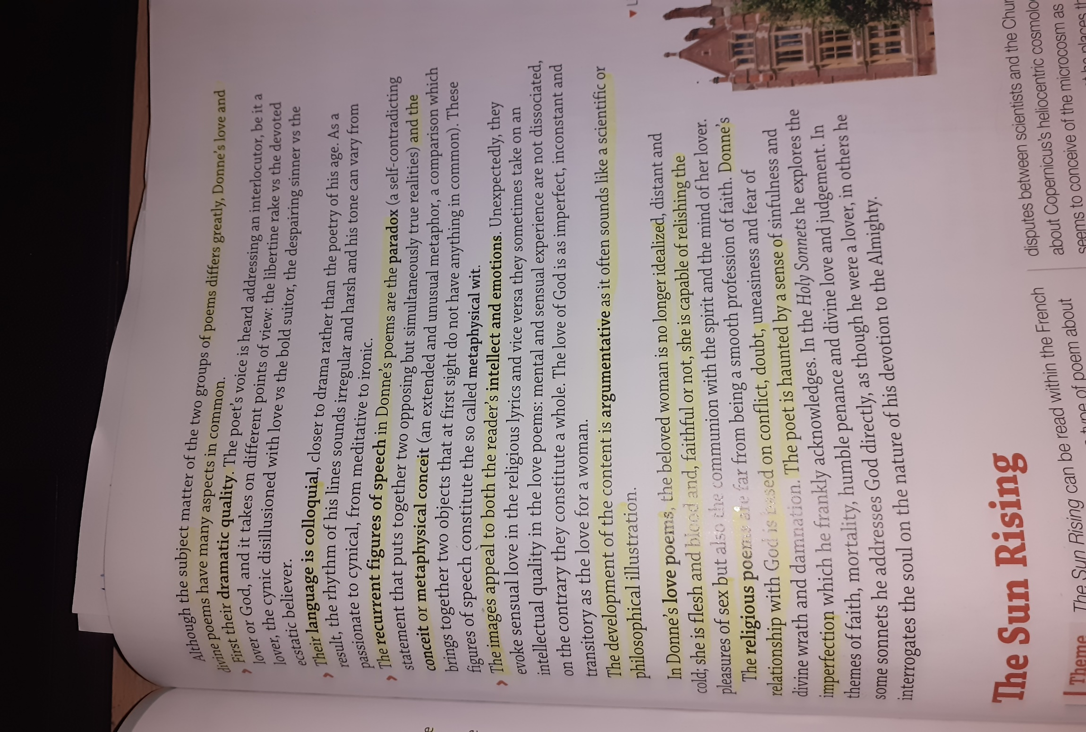

Analysis of first stanza of “The Sun Rising”

reveals the setting, status and mood of poet. The poet was making love with his beloved in bedroom but sunrays have disturbed him while peeping through the windows. It is the time of morning and sunrise. Due to the unkind (the poet thinks it unkind) behavior of the sun, he becomes angry. He directly addresses it. in a negative manner. He says that the sun is a ‘fool’. The sun is trying to peek into their bedroom and signal that its morning now and they must wake up. That signifies their end of time together. The poet gets annoyed by that. He instead advises the sun to wake up the schoolboys, the huntsmen to wake up and start doing their duties.

Thus, this poem is a kind of dialogue between the sun and poet, whereas beloved of the poet is a silent listener. The poet has not given tongue to the sun; therefore, he is also a silent listener. The lovers are not subject to time, they don’t know hours, days or seasons, their love is immutable.

2 STANZA

In the initial part of the second paragraph, the poet tries to mock the sun by telling that its sun rays are nothing compared to their bond of love. He says that he can eclipse the sun rays with a wink. So, what basically he means to say is he can cut his view from the sun by closing his eyes. However, the lover doesn’t want to close his eyes. It’s because, on doing that he will be ‘losing her sight’. The eyes of the lovers are more bright than the rays of the sun. He does not wish to look away from his lover. The lover says that the sun does not have enough power to impact on their love. The above lines signify that her eyes are more impressive than the sunlight. The valuable spices and the rich gold of Africa is nothing compared to the relationship between him and his lover. He wants to say that his love is SUPREME.

3 stanza

John Donne compares himself to the kings of world and comes to the conclusion that he is superior to them. Glory of kings and princes is just ridiculous and their “honor’s mimique”. The poet also points out weaknesses of the sun. It is alone and has no beloved. Moreover, it does not have the feelings of love; it also does not have emotions. Sun, thus, is also inferior to him.Duty of the sun is to give light to the world, says Donne but the sun has grown old now. The poet, his beloved and their room is the whole world; therefore, the sun can fulfill his duty by giving light only to their room. After doing so, the sun can do rest as he needs it in this age; “thine age askes ease”. As mentioned above, bedroom of the poet is the whole world. The sun should revolve around the bedroom of poet. The poet is saying so, because it was believed that the sun revolved around the earth. Bedroom of the poet is whole earth. The poet ends the poem while expressing his world of love in following lines: