Reading skills practice: Video games are good for you – exercises

You know all those people that told you that video games are bad for you? They were wrong. Read this to find out more.

Preparation
Write the type of computer game next to the description.
 | Fighting game | Role-playing game (RPG) | Strategy game
 | Platform game | Racing game | Shooter
1. | A game that involves travelling and jumping across platforms, often with obstacles and other elements like ladders. |  | Platform game
2. | A game that focuses on one-on-one combat against an opponent. |  | Fighting game
3. | A game whose main focus is combat involving guns or other projectile weapons such as missiles. |  | Shooter
4. | A game in which the player controls a central character. They explore the game world, solve puzzles and take part in tactical fights to complete their quest. |  | Role-playing game (RPG)
5. | A game that requires careful planning and tactics to achieve victory, often from a godlike perspective over the game world. |  | Strategy game
6. | A game in which the player races against opponents in some type of transportation. |  | Racing game
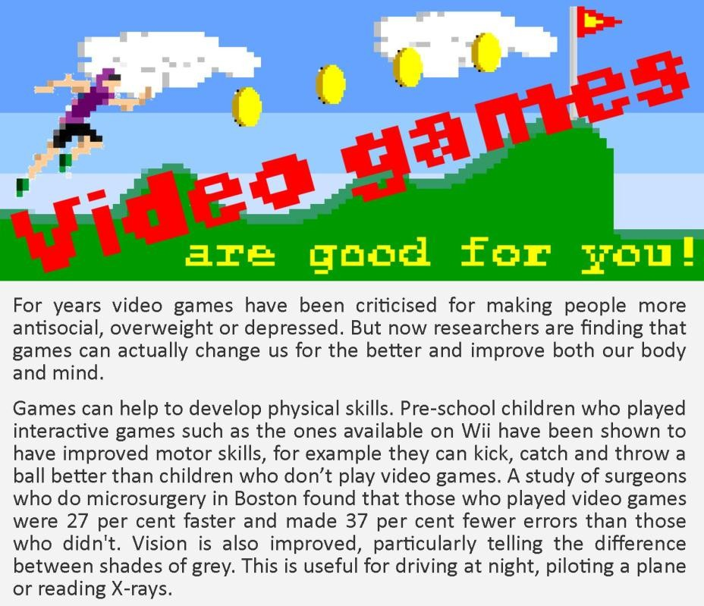

Reading skills practice: Video games are good for you – exercises

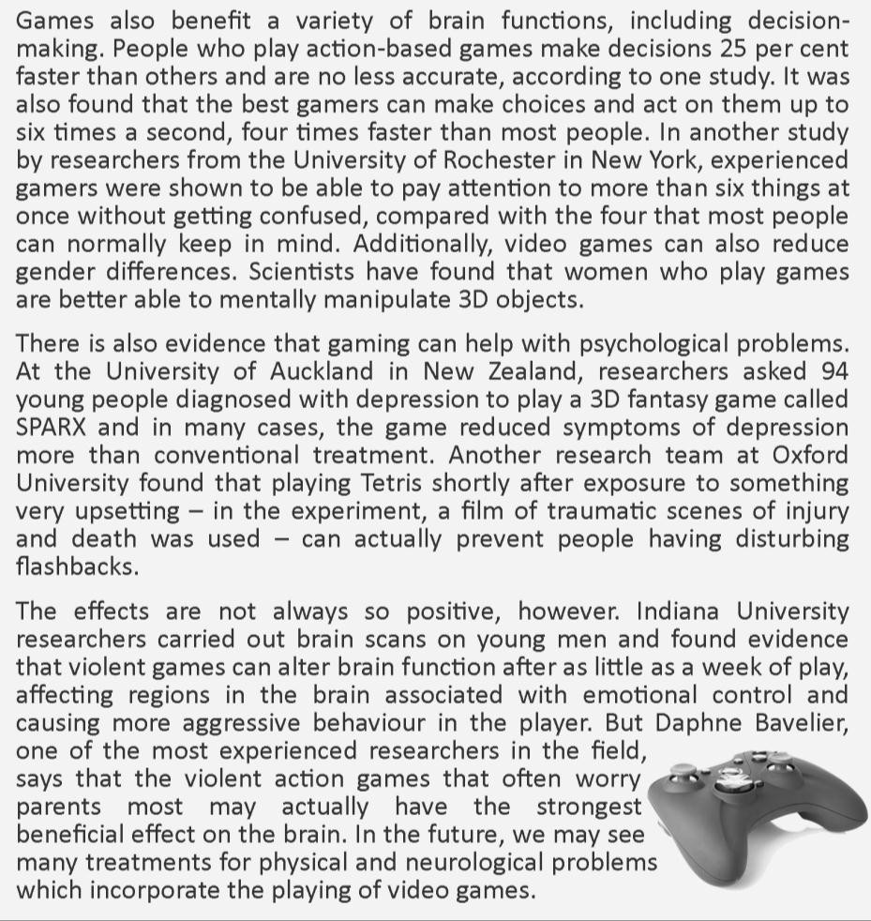

1. Check your understanding: multiple choice
Circle the best option to complete these sentences.
1. | Only relatively recently have people started to realise .
- the harmful effects of video games
- the beneficial effects of video games
- how much we don't know about video games' effects
- how much video games affect the people that play them
2. | Very young children show improved after playing video games.
- muscle control and co-ordination
- social interaction
- decision-making
- ability to differentiate between different colours

Reading skills practice: Video games are good for you – exercises

3. | Playing video games helps doctors .
- do operations and read X-rays
- make decisions under pressure
- operate complex equipment
- tend to more than one patient at a time
4. | Video gamers' decision-making speed is significantly improved by .
- years of gaming experience
- long periods of game playing
- playing video games in short bursts
- certain types of video game
5. | Women who play video games demonstrate .
- faster reaction speeds
- reduced stress levels
- better spatial awareness
- better multitasking ability
6. | In one research study, the video game Tetris helped people to .
- improve their concentration
- overcome depression
- forget disturbing experiences
- make decisions faster
7. | Research shows that violent video games .
- have no negative effects on players
- only affect players' brains after extended hours of play
- may have positive and negative effects on the brain
- only affect players' brains in beneficial ways
8. | In the future, computer games may be used for .
- treating a variety of medical problems
- training doctors to deal with emotional pressure
- helping parents to deal with difficult teenagers
- treating prisoners with a history of violent behaviour

Reading skills practice: Video games are good for you – exercises

2. Check your vocabulary: gap fill
Complete the gaps with a noun from the box.
 | shades | attention | decisions | behaviour
 | errors | skills | field | scans | difference
1. | Playing video games improves the speed at which people can make decisions .
2. | Video gamers also demonstrate an improved ability to pay attention to several things at once.
3. | Pre-school children who play video games have been shown to have improved motor  skills .
4. | Playing video games also has a beneficial effect on vision, increasing players' ability to tell the  Difference between varying shades of grey.
5. | Surgeons who play computer games work faster and make fewer errors .
6. | Researchers from Indiana University investigated the effects of violent video games by doing some brain scans on video gamers.
7. | Their research showed that violent video games affect emotional control and may cause more aggressive behaviour .
8. | Daphne Bavelier is one of the most experienced researchers in her field .

Vocabulary Box
Write any new words you have learnt in this lesson.

Discussion
What kind of computer games do you like?
Do you think they are good for you? Why or why not?

