Teacher: Mara Covasso

CLIL for nursery school

The Children are five and six years old.

Content: “THE THIRTEEN COLONIES OF AMERICA”

Step 1
Warm up.
The teacher uses a puppet to introduce the subject.
Mousy is carrying his baggage and says:” Bye bye children, I’m going to America! I have still a long journey, America is so far!!”

The teacher asks children: “ Is Mousy going to America by car? 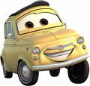
“ “ “ “ by train?
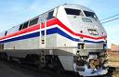
“ “ “ “ by ship?
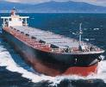
“ “ “ by airplane?
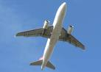

“What do you prefer?”

Step 2
Everybody says what he/she knows of America.
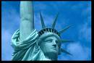

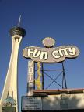

Step 3
Numbers
Activity 1: let’s count from one to thirteen or more.
Activity 2: teacher shows one number to the children and they say the number aloud
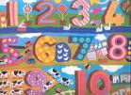

Skills:
Children draw numbers
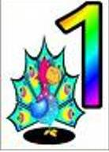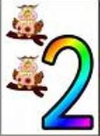

ONE TWO

Step 4
The teacher tells the story to the children:

“Once upon a time there were people, called Pilgrims, in Europe.
Someone lived in England, someone in Germany, someone in Spain, someone in France and in other countries.
The Pilgrims had different religions so their king said: ”You, can’t stay here, go away!!”
The Pilgrims were very poor and sad, but they heard that many years ago Christopher Columbus had gone to America, so they said: “Let’s go to America! When we will be there will produce tobacco, cotton and sugar”.
They made a big ship and called it “Mayflower”.
“Let’s start our voyage!” they said. But it was a hard long voyage. There were storms in the sea and the “Mayflower” was often in danger
Finally the pilgrims arrived in America. The first pilgrim said:
“This land is mine! I’ll stay here!”
The second said:” this land is mine! I’ll stay here!
The same for the third, fourth etc….
The Pilgrims founded 13 colonies and became colonists.
But when they arrived, it was winter and very cold, they didn’t have houses and food.
There were Indians in that place.
Indians helped colonists and so they became friends.
The colonists said thanks to Indians and invited them for a big dinner.
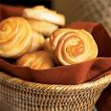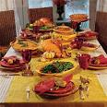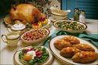
This was the first Thanksgiving day.
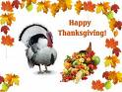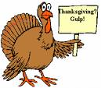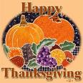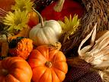

Also now, every year on (the) 27th of November Americans celebrate the Thanksgiving day with a friendly big dinner.

They eat delicious food as turkey, vegetables and pumpkin pie.

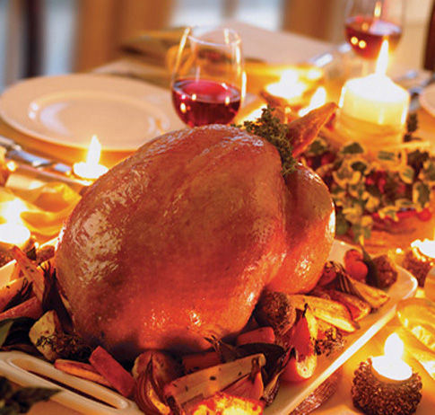

At first teacher tells the story to her children by using
“Total Physical Response”.

After that, she shows them some flash cards with important key words as:
- Map of Europe
- Map of America
- Pilgrims

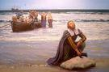
- Ship

- Tobacco

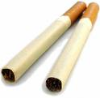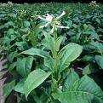
Cotton

Sugar
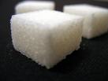

Indians
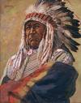v

Food

Turkey

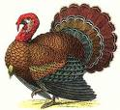

Vegetables

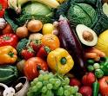

Pumpkin

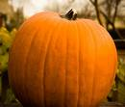

Activity:
Children choose the flash cards while the teachers says those words while telling the story again.

Children look at the map and discover the big sea between Europe and America.

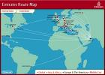

They play a game:
Some children pretend to be Pilgrims from different countries Spanish, Germanic ……
They say “Let’s go to America!” and enter a circle in the shape of a a ship.
They travel along the sea (the floor). The voyage maybe dangerous because sharks could be in the sea and some Pilgrims could die.

When they arrive in America (a big place parted in 13 places) the others say : “I’ll stay here, this is my land”.
The Pilgrims who cannot find a land, are out of the game
The children who are able to catch a piece of land will be the winners.

Listening Activity
The teacher asks children to watch the video.
This Land is Your Land (Bruce Springsteen-Live

This land is your land this land is my land
From California to the New York Island
From the redwood forests to the Gulf Stream waters
This land was made for you and me.
As I was walking that ribbon of highway
I looked above me there in the skyway
I saw below me the golden valley
This land was made for you and me
I roamed and rambled and followed my footsteps
Through the sparkling sands of her diamond deserts
And all around me this voice kept saying
This land was made for you and me
As the sun was shining and I was strolling
Through the wheat fields waving and the dust clouds rolling
I could feel inside me and see all around me
This land was made for you and me

The teacher asks the children to listen to the song
This Land is your land
This Land is your land
this land is my land
from California
to the New York Island
from the redwood forest
to the gulf stream water
this land was made for you and me
As I went walking
that ribbon of highway
I saw above me that endless skyway
I saw below me that golden valley
This land is made for you and me
I roamed and rambled
and followed my footsteps
O'er the sparkling sands of her diamond deserts
While all around me a voice was sounding, saying
This land was made for you and me

Skills:
They draw the globe and the Continents.
They draw a line between Europe and America.

Step 5
The teacher tells about her experience when she went to a Thanksgiving dinner with her friends; the food that she ate.
(she shows children photos about the dinner ⇨ see images above)

Activity:
In small groups, children search pictures of food in magazines and cut them out.
They classify food into two parts, in the first part they put only food for a Thanksgiving dinner, the remaining food will be put in the second part.
Together they will stick the result of their work in a posteasks the children to say the name of he food aloud.
Teacher and children can cook a simple recipe.

Skills:
Children draw an imaginary meeting between the Pilgrims and the Indians.
Children draw the Thanksgiving dinner party of their imagination

