TASK 1

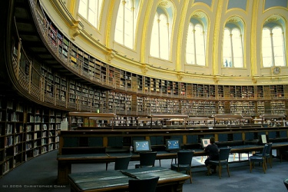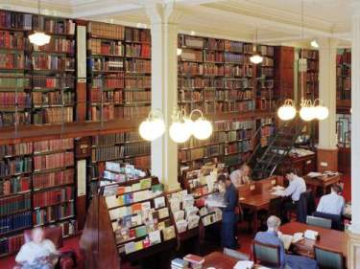

After watching the film you will write a text to explain:

- what English settings the film has shown
- what important institutions the naïve reader comes across
- how the role of academy comes into play
- how documents and letters come to the forefront
- how Victorian and modern London are presented (what does the director focus his camera on)
- how the different ideas of possession are conveyed (physical love, mental love, attempts to put one's hand on precious letters, documents, objects of research, value etc.)
- how literary erudition is shown in the film (dialogue exchanges, pictures, audio, music, other)
- how the characterizations of the four protagonists are created
- how the director shows the bond developing between Maud and Roland
- how unconventional love stories are treated
- how the juxtaposition of present and past is developed
- (montage, close-up, long shot, two shot, point of view shot , medium shot, flashback, flash forward, panoramic effects, other)

