**Gnocchi with Beef Ragù**

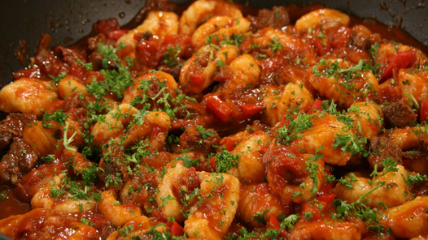

|  |  |
| --- | --- |
| Gnocchi | Beef Ragu |
| 500g potatoes, washed but not peeled  1 egg  125g plain flour  1 pinch of salt | 500 ml tomato passata  1 cup beef or chicken stock  ¼ cup red wine  ½ cup basil  ½ cup coriander  4 cloves garlic  1 onion  2 red peppers  2 red peppers  1 spoon cumin seeds  1 spoon smoked paprika |

Method

Gnocchi

1. Place potatoes in pot of cold water, bring to the boil and simmer until cooked.
2. Strain potatoes and peel while still hot.
3. With a mouli or potato press, mash potatoes on a bench.
4. Add flour, salt and one egg.
5. In a large pot of boiling salted water add the gnocchi and stir gently.
6. The gnocchi will be cooked when it floats to the top.
7. Remove the gnocchi from the pot and mix into a big bowl of your favourite sauce.
8. Add some cheese and serve with a nice glass of red wine.

*Beef Ragu*

1. Place the diced beef in to a large mixing bowl with the spices, salt and pepper
2. Heat the oil in a large casserole.
3. When the oil is hot, brown the beef in batches
4. Add the onion, garlic and chilies and sauté gently for 2-3 min.
5. Add the tomato passata, pureed peppers, stock and wine and bring to the boil.
6. Transfer the casserole to the oven and cook, covered for 2 hours.