WORKSHOP 5

PETERLOO. A FAILED NEGOTIATION

The aim of our One Act Play is the illustration of the contradictions existing during the first phases of the industrialization process in England.
We chose to create and record the One Act Play because the related workshop allowed to reflect on a problem considering it from the different points of view of all the actors involved.
Giving voice to different characters, you gradually become aware of how critical thinking is invited whenever you want to overcome the narrow border of a simpler binary interpretation of reality: one that can only see matters in terms of either true or false.
A binary perspective sends back to a medieval idea when a Manichean vision of the world was generally adopted because it was probably very reassuring.
The Act deals with The Legal reaction to the Peterloo Massacre.

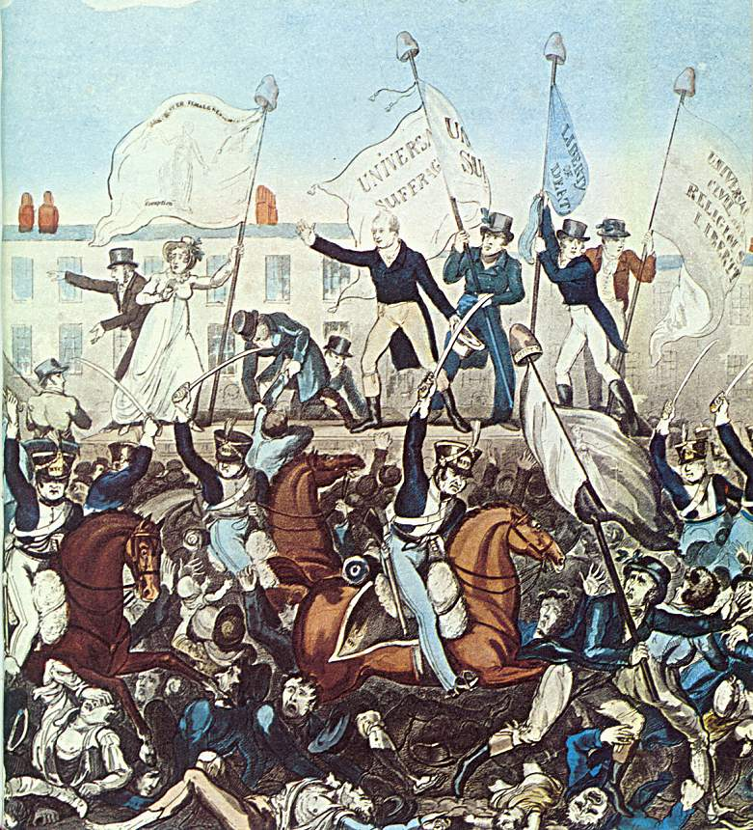

GEORGE CRUIKSHANK'S the Yeomanry attacking the meeting in St Peter's Fields, Manchester

One - Act Play

recording

Dramatis personae:

Judge (a public officer appointed to decide cases in a law court)
Henry Hunt: leader of the riot at St. Peter’s field on 16th August 1819, a workers’ mouth speaker. He plays the defender of workers’ rights
Mr. Jeremy Barker: factory owner
Worker at Jeremy Barker’s factory

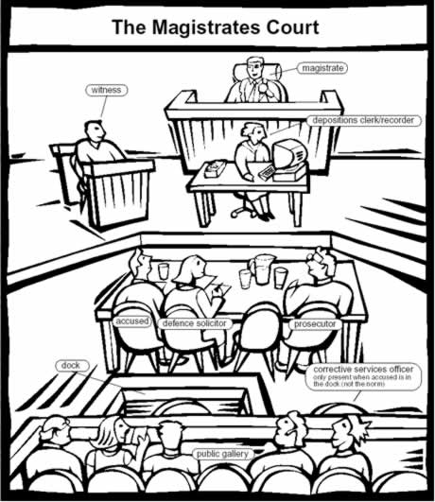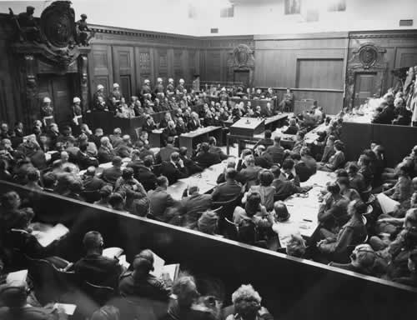
(Talking to the audience)

Judge: Good morning, Sirs. The trial today is in matter of Henry Hunt.
He fed the revolt at St. Peter’s field on 16th August 1819.

(Addressing Mr. Hunt)

You know revolts are illegal, don’t you, sir? And, despite that you were
one of the speakers there. Does that correspond to the truth?

Mr. Hunt: Yes, Sir I was. More than 60 000 people joined the meeting, asking for reform, universal suffrage and fair representation.

Worker: Unfortunately that’s true! Every day we are compelled to work crammed like sardines! Organized in set of twelve-fifteen people in dirty, dark and wet cellars. And what’s more our wages are a shame! Twelve hours never-ending work every day, six days a week.

Judge: Keep calm, sir or you will not be allowed to proceed further!

Worker: Also, we have to bring our children with us in that dusty, noisy
factories!

Mr. Barker: Dusty? Noisy? What do you mean? My factory is brand new full
with cutting edge machines. It is one of the best working textile-
factories in Manchester! And, if you don’t like to work there, you will know there are thousands of people queuing up in line before the gates.

Worker: You ... you … How do you dare? Sir, he speaks here but he is never in the factory. Mr. Barker, you are a master who don’t even know his
workers by name, damned!!

Judge: Please, sir, avoid swearing or I see myself compelled to send you back to your jail cell!

Mr. Barker: I can’t waste my time about you! YOU miserable people working
at looms all day. Always doing the same thing with no mind and business effort! I DO care about my business: I have to face competition, market conditions, and last but not least, production prices! That’s what makes the real difference in business. Selling and purchasing that is the real THING!!

Mr. Hunt: Sir, I would like to make you consider your role AS WELL AS the one of your workers.
Indeed, they are fundamental for YOUR productive system.
They are getting weaker and weaker day AFTER day. They lose hands, arms together with their dignity. Hard work, pollution and starvation! That is their reality. No profit. Unbearble living conditions !!! Shame!!!
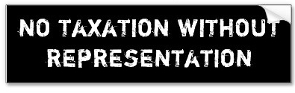

Worker: Look around: What can you see? a river, purple with textile dye, disgusting smell and deafening noise!! That is all you can get around YOUR FIRM an, as for Manchester’s air? You can’t even imagine to breathe here!!

Mr. Hunt: Smoke, ammonia, sulphur and coal clog up our lungs! We lose legs,
arms and hands day after day: and what’s more most workers are
deaf. What about your labour force? How would you cope without
them? Let us know, SIR!!

Mr. Barker: Well, you aren’t compelled to stay here! You perfectly know my
conditions! If they are not your taste, you can leave the factory straightforward. Thousands of people would move heaven and earth to get a job here!!

Worker: No way, sir!! If we leave our job, we won’t be able to provide our families a living. We could eat no longer. Don’t you remember the Corn Laws?

Mr. Hunt: (angrily) The Corn Laws? … Nothing but capitalists’ interests and
what about workers? Don’t they need to see their rights
recognized? Probably you don’t see the point!! That’s the reason they gathered at St. Peter’s field, don’t you think so? Aren’t they worth human treatment?

Judge: Law does not accept demonstrations. The Hussars and Magistrates crushing the riot received the Prince Regent’s congratulations. They were cleared of any wrong-doing by the official inquiry.
I Mr. Davies from Lancashire, judge for the present trial see therefore myself obliged to convict Sir Henry Hunt of "assembling with unlawful banners at an unlawful meeting for the purpose of exciting discontent. As a result you will be imprisoned in Ilchester Gaol. That’s all. The case is dismissed!

FROM NEGOTIATION TO REGULATION

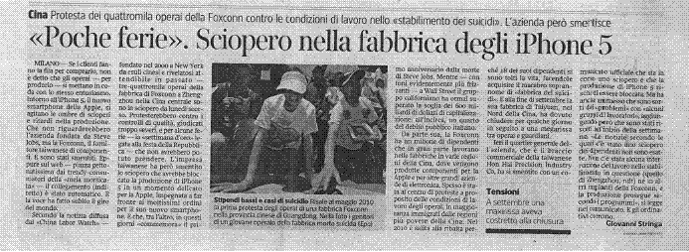

WORKSHOP PROBLEMATIZING:
In our workshop we discussed about the possible reaction of opinion makers and the media to the trial and we tried to imagine the feedback to the Peterloo Massacre in different moments of history.
We therefore supposed two journalists took part in the trial:

- the first one writing for the “Manchester Daily”, a popular newspaper in the early 19th century

and

- the second one working for “The Guardian” a contemporary British daily

Our reflection being:
What would their reports be like? How would they turn out different?

In our opinion reports would surely be quite different:

- the journalist of the nineteenth century would probably insist on the illegal act of the workers’ associations and meetings and he would probably agree with the factory owner and of course with the judge’s verdict;

- vice versa, a contemporary Guardian journalist would probably take Mr. Hunt’s part and draw the readers’ attention on the worker’s situation and demands; he would surely reflect on the urgent need for regulations for workers’ rights.

We could not realize that even today there are very similar situations: globalization has brought them in the fore front as the articles we analyzed have show. As an example we will show just some of them to make our point

LINK 1 – Il Sole 24 Ore, Martedì 25 settembre 2012, p.31

LINK 2 – IL Sole 24 Ore, Martedì 25 settembre 2012, p. 7
LINK 3 – Corriere della Sera, Domenica 7 ottobre 2012, p. 23

LINK 4 - Quotations from J.Winterson, Why Be Hapy When You Could Be Normal? Chapter II

