LETTER CONVENTIONS

Structure

- Right corner: my address
- Left corner, just beneath my address: addressee’s address
- Under our address: the date
- Under addressee’s address: greetings (Dear Mr/Ms/Mrs - formal register; Dear Sarah - informal register)
- Introduction: introduce myself
- Body
- Conclusions
- Sign off: yours faithfully (formal register), your sincerely (informal register)
- Sign up with my name

Advice

The letter’s organisation, if it is regular and orderly (spaces between paragraphs and page’s edge and syntax), is a good introduction of ourselves (“a business card”, if the letter’s addressee is employer).
The register depends on the addressee: formal or informal register make the difference.
The sentences could be short, concise if we are looking for a work with the letter; the contractions are banned! So misunderstandings does not happen.

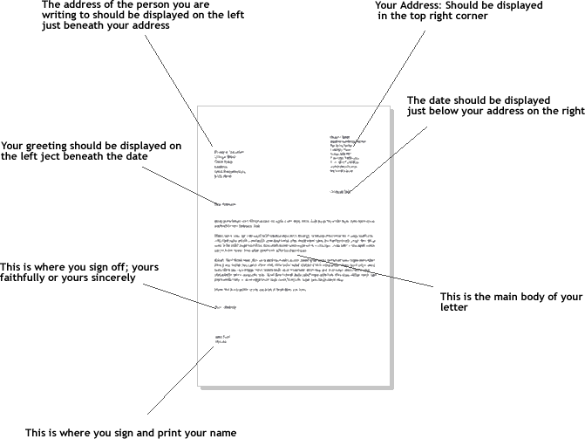
2

4
7 8
8
8
9
6
3
1
5

