From Making Waves, From Modernism to Our Contemporaries
Modernism in Art

When? The first decades of the 20th century
What? A transformation of artistic styles
Realistic descriptions → form, colour and design
Belief in progress

Vorticism | Wyndham Lewis |
VIOLENCE is conveyed through Cubist fragmentation of urban and dynamic environments

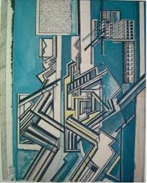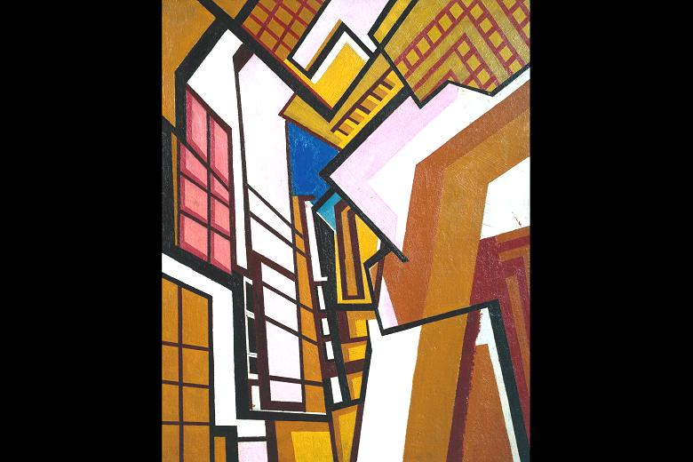
Wyndham Lewis, Design for Red Duet, 1914 Wyndham Lewis, Workshop, 1914-1915

Cubism | Picasso and Braque
There isn’t only one perspective, but the painting shows different views of the object together.
GEOMETRIC FACETS AND PLANES = FLEETING GLANCES

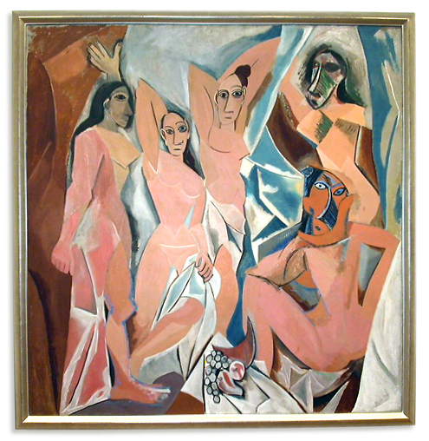
Picasso, Les Demoiselles d'Avignon (1907)

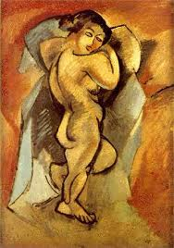
- Reality isn’t arranged in fixed time and space categories
BUT it depends on the observer’s point of view.

Georges Braque, Large Nude

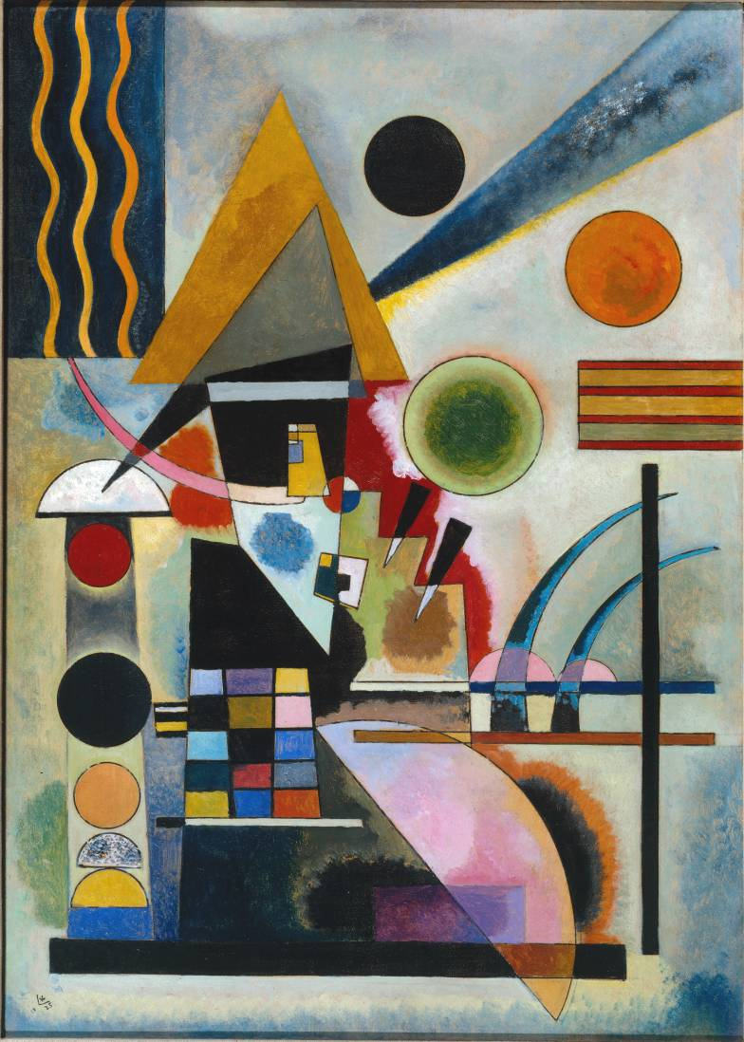
The Russian painter Wassily Kandinsky (←Swinging, 1925) belonged to the German Expressionist group Der Blaue Reiter. He felt uneasy towards the materialism of modern life: in fact his paintings work on geometrical forms and develop an abstract art. It can communicate emotional values such as order, through lines and colors and forms.

Expressionism refers to art which misshapes reality to express the artist’s inner feelings.
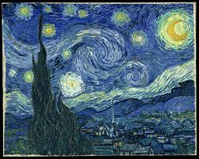
Vincent Van Gogh, The Starry Night, 1889

What happened in the first decades of the 20th century?
FIRST WORLD WAR 1914-1918
Sigmund Freud (Austrian neurologist and psychotherapist), The interpretation of Dreams (1899), The Psychopathology of Everyday Life (1904), Totem and Taboo (1913)
- unconscious + demand of libido : a disturbing irrationality affects human conduct
James Frazer (English anthropologist), The Golden Bough (1890-1915)
- His book deals with primitive rituals and myth
Cubism, Vorticism, Abstract art
- Multiple points of view, dissolution of forms, abstract reality
Albert Einstein (German physicist), General Theory of Relativity (1915)
- Time and Space as subjective dimensions. Science became hypothetical
William James + Henri Bergson

Scientists and artists became aware that the previously accepted structures of reality were simply reflections of men’s frequently own assumptions.
Modernism is characterized by cultural relativism, and by the awareness of the irrational unconscious mind.
Modern novel rejected traditional narratives (Victorianism) and rational descriptions, in favor of a stream-of-consciousness presentation of inner personality.

