**THE CHANGING IN THE CONCEPT OF TIME**

In this path I decide to analize the concept of time, and in particular the changing in this concept. I decided to analize it because time fascinates me: people hinge on time and so they try to control it.

The question that I posed as the basis of my path are: why is time so important? Can people are slaves of something that they have created? What it really is?

Time has ever been important in human beings’ life. Right from the ancient people it was considered precious and people thought they could dominate it. For example in Seneca’s *Epistulae ad Lucilium*, the philopsopher underlines the importance of the present, that is considered the only moment in which men can follow out their self-improvement and encourages his scholar to dominate it.

*Ita fac, mi Lucilii: vindica te tibi, et tempus quod adhuc aut auferebatur, aut subriepiebatur aut excidebat collige et serva. […]*

*Omnia, Lucilii, aliena sunt, tempus tantum nostrum est.*

*[Epistulae ad Lucilium, I]*

But, from the Industrial Revolution the intercourse between men and time changed. Time started to dominate people: workers started to be paid in relation with work hours and the speed of their work was dominated by the speed of the machines; society became clock-governed and so intelligent people reflected about time.

The idea that time flows in a lineat and equally way was replaced by new conceptions: Einstein’s *Theory of relativity* and Bergson’s idea that inner time has a duration that eludes conventioal clock time, caused the beginning. The consequence of these new ideas was the discovery that time isn’t absolute, a new concept that influenced artists (both writers and painters).

**The “end” of the objective time**

Next to the common concept of objective time, during the Modern Age, Bergson, thanks to the new theory of Sigmund Freud’s psychoanalysis, developed the concept of **psychological time**. It is concerned with memory, expectation, duration, … and it moves in flux and is highly subjective.

All writers were influenced by these new theories. For example, let’s consider **James** **Joyce**’s *Ulysses,* a work published in 1922. While the objective time flows very slow and the whole story lasts only one day, the inner time expands from past to future, putting past, present and future on the same layer and making a parallelism between them.

Present: *what an unearthly hour I suppose theyre just getting up in China now combing out their pigtails for the day well soon have the nuns ringing the angelus […]*

Past:  […] *the sun shines for you he said the day we were lying among the rhododendrons on Howth head in the grey tweed suit and his straw hat the day I got him to propose to me yes* […]

Future: *to put about the place in case he brings him home tomorrow today I mean no no Fridays an unlucky day*  *[…]* *whatll I wear shall I wear a white rose or those fairy cakes in Liptons […]*

[Quotation from Molly’s monologue]

Joyce could do it thanks to the technique of the stream of consciousness, in which he focuses on the mental process that developes in humen’s minds. So, according with Sterne’s idea that consciousness flows like a river, the whole monologue, as well as the whole story, proceeds with the association of different images, that are put close without a logic, and so, without a chronological sequence, but in a spontaneous way.

Another important innovation, that underlines the “negation” of the chronological time, is the absence of paragraphs and punctuaction. Memories and ideas flows without a logic, so the human being can’t organize them.

So, Joyce moved in a subjective perspective and deleted the differences between inner world and external world, using the interior monologue.

This technique was also used by **Virginia Woolf** to tell the story through the minds of the principal characters. In her work *Mrs Dalloway,* V. Woolf contrasts psychological time and clock time*.*

Regarding chronological time, as Joyce’s Ulysses, the whole story lasts one single dayand there is not much happens during the day in June that is described in Mrs Dalloway. Woolffocuses on the consciousness of the characters. The narration shifts from one character’s point of view to the other, from present to past, through the extensive use of the stream of consciousness.

An interesting characteristic of the novel is that it isn’t organized in chapters but it is organized into units as Big Ben strikes the hours.Big Ben is as an important character, that has the function of a reminder of social activity, the presence of a material world totally unconnected with human desires.

Also art and music reflects the development of the new concept of time. In art one of the most interesting example of it is Dalì’s *The persistance of memory.*

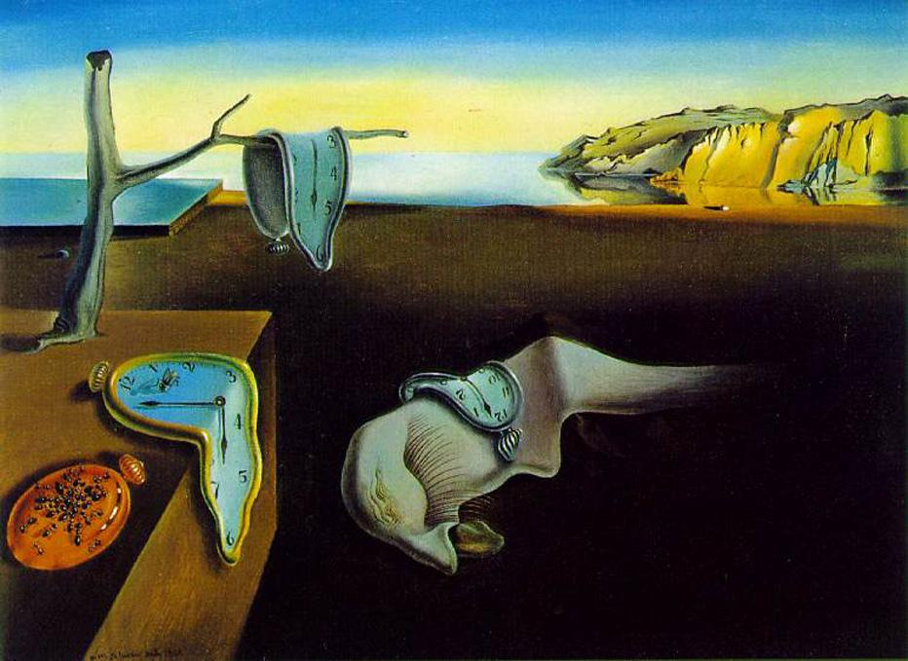

Dalì painted three molten clocks: one is hung by a tree to mean that an event can be delated by the memory, the second one has a fly that reminds to rot, to the idea of the passing of time, and the third one is on an embryonic form, the symbol of life as something that twists the geometrical and mathematical form of the mechanic time. The only one no-molten clock is devoured by ants and represents a sort of revenge, because time devours people’s life.

The chose of molten clocks is a symbolic choice to represent inner time (the time of memory) that differently from objective time (it has always to be respected, followed) is elastic: memory allows the human being to remember something that happened lots of years ago or to imagine the future.

While in music the innovations are shown by Debussy. Indeed he used free and fragmented melodies, that reminds to the free association of images. The rhythm is various and chords aren’t concatenated following traditional rules. These new characteristics reminds to the absence of paragraphs and punctuactions in literature; the way to oppose tradition.

To conclude, from this path I discover there are two different types of time: the time the clock tells and time in the human mind and they are separated one from the other. Clock time governs the progress of life and orders events. The other type of time is the inner one: it is flexible; it is constantly in flux and can be compressed or extended.