Small rolls in pepper sauce
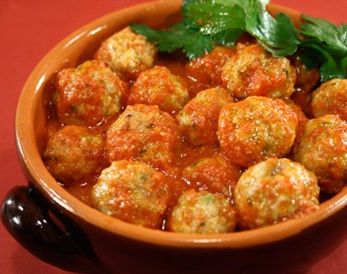
Ingredients for four people

Rolls: | Pepper sauce
400 grams beef mince  30 grams sheep cheese in small cubes  2 full spoons of bread crumbs  1 egg  some parsley  garlic  2 full spoons of flour | 200 grams tomato sauce  3 peppers of different colour (green, red, yellow)  olive oil  salt  pepper
Procedure
- Wash and clean the peppers
- Take off seeds and inner fibres
- Cut the peppers in similar size pieces
- Put some olive oil in a pan with fire on and start cooking the peppers
- Add salt and the tomato sauce and cook for 20 minutes (low heat)
- Take a bowl and add:
- the mince
- the egg
- the cheese cubes
- bread crumbs
- parsley and
- garlic(cut it in very little pieces)

7. Mix the ingredients (you should obtain an homogeneous mixture)
8. Add salt and pepper as needed

9. Wash your hands
10. Give your rolls a shape
11. Put the rolls ion the flour
12. Put the rolls in another pan with some olive oil as long as the rolls get a bit golden.
13. Once cooked, put them into the pan with the tomato and pepper sauce.

