From “The Economist”

New film: “West of Memphis”

Miscarriage of justice
Dec 21st 2012, 10:11 by F.S.

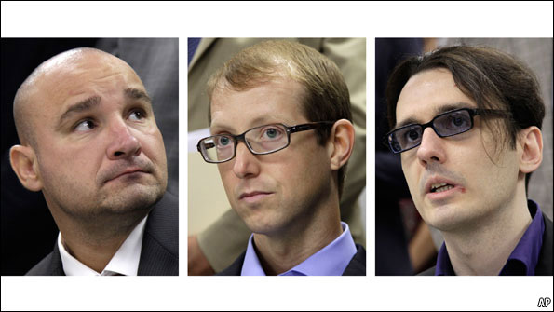
THE plight of the West Memphis Three—three teenagers convicted for murder and released in 2011 after 18 years in prison (albeit with an unusual plea bargain which allowed them to maintain their innocence while pleading guilty)—makes for a fascinating story. It has spawned four documentaries, and a feature film, “The Devil’s Knot”, is in the works. Like the "Paradise Lost" documentaries before it, “West of Memphis”, a new documentary produced by Peter Jackson, director of the Lord of the Rings trilogy and “The Hobbit”, raises serious questions about the American criminal justice system. It shines a light on issues such as police misconduct and an institutional bias in favour of the state prosecution that extends beyond the case itself.
In the summer of 1993, West Memphis in Arkansas was ripped apart by the brutal murder of three eight-year-old boys found naked in a ditch, limbs tied and genitals mutilated. The gruesome nature of the crime prompted observations that it resembled a satanic ritual. Damien Echols, a local outcast known to hold an interest in the occult, and his friends Jason Baldwin and Jessie Misskelley junior, were arrested.
Media frenzy, spurred on by the public furore, accompanied a hurried and flawed investigation. Key suspects were overlooked, DNA was untested, evidence was faked and confessions were extracted under duress. Like many films about the death penalty, “West of Memphis” casts aside impartiality in favour of fervent campaigning. Mr Jackson and Amy Berg, the director, went further and became active investigators in the case. Mr Jackson has spent millions of dollars since 2005 on their legal fees and forensic experts to gather new evidence. It contests, among other things, the satanic ritual theory, concluding that the boys' disfigurement was almost certainly caused post-mortem by giant turtles.
The film combines original footage from police interviews, court trials and news reports with interviews conducted by the film-makers with the accused, their families and original witnesses—one of whom recants her earlier statement. They also interview David Burnett, the trial judge and now a state senator, who repeatedly thwarted campaigners' efforts to secure new hearings ("There is no new evidence," he says.) The narrative is urgent and outraged, examining in depth the role of Terry Hobbes, one of the murdered boys' stepfather, who, until now, was half-heartedly interviewed but not investigated. In scenes added days before the premiere at the Sundance film festival in January, two new witnesses came forward to point the finger at Mr Hobbes. Their affidavits are being considered by police.
There is no doubt that such documentaries have helped to garner public support and funding over the years, and played a part in earning innocent people their freedom. When judges and prosecutors are reluctant to admit procedural failings, this is a huge achievement for any film-maker. But this film also poses questions about the role of the documentary.
One of the film's interviewees calls the case "the first crowd-sourced investigation". But is a celebrity-endorsed public bandwagon headed by Peter Jackson, Johnny Depp and the Dixie Chicks really the best vehicle for judicial change? Perhaps it was felt that including interviews with Mr Jackson himself would bring the film to a wider audience but instead it feels uncomfortably sensationalist. Moreover, Mr Echols, who was on death row, and his wife Lorri are credited as producers.
“West of Memphis” is not the first film to challenge the American justice system. Errol Morris's 1988 film “The Thin Blue Line” won awards for its investigation into the trial of Randall Dale Adams, convicted for the murder of a policeman in 1976. The film was criticised for its dramatic re-enactment sequences and score, with some calling it too obtrusive, but a year after its release Adams's conviction was overturned.
While these stories may seem extraordinary, wrongful convictions are common. 140 people have been released from death row since 1973 after being proven innocent, according to the Death Penalty Information Centre. This figure does not include those released without public support or those encouraged to plead guilty in exchange for their freedom, like the West Memphis Three and Edward Lee Elmore, a mentally disabled inmate who spent 30 years on death row until his release in March. Cameron Todd Willingham, who refused to plead guilty in exchange for a life sentence, was killed by Texas in 2004 even though he strongly appears to have been innocent.
With the plea bargain reached in the case of the West Memphis Three, the state prosecution was able to claim they had punished the murderers and the three men agreed not to sue for wrongful imprisonment. But the campaigning has not ended. As the documentary suggests, the killer may never have been brought to justice and unofficial investigations continue. Campaigners want Mike Beebe, the governor of Arkansas, to pardon the men; a pardon he will not consider until they have served their ten-year suspended sentences.
Perhaps where the system is broken, and in some cases openly skewed in favour of the prosecution, documentaries that bolster the defence are admissible. It may seem partisan or sensationalist, but such films could be an important platform for these campaigns against miscarriages of justice.
"West of Memphis" will be released in Britain on December 21st and America on December 25th

