**EINSTEIN’S PERSONALITY**

* **What about his chilhood?**

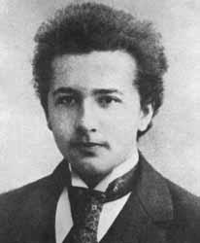Einstein was slow in learning how to speak. His parents even consulted a doctor. He also had a cheeky rebelliousness toward authority, which led one headmaster to expel him and another to amuse history by saying that he would never amount to much, but these traits helped make him a genius. His cocky contempt for authority led him to question conventional wisdom. His slow verbal development made him curious about ordinary things, such as space and time, that most adults take for granted and he tended to think in pictures rather than words.

* **His personal life and his studies**

Albert Einstein was born on March 14, 1879 in Ulm, Germany. He was the first child born to Hermann and Pauline, a bourgeois Jewish couple married three years earlier. Hermann began work as a merchant in the featherbed industry, but when his business collapsed, he moved his family to Munich to start an electrical-engineering business with his brother Jakob. This venture was largely supported by the Kochs, Pauline Einstein's parents. Pauline, a talented musician, introduced her son to the piano when he was a small boy and encouraged his passion for the violin, an instrument he studied from ages six to thirteen. Einstein's childhood takes place in Bismarck's Germany, a country of massive industrialization, but also with rectal forms of despotism that are felt at various levels and in various areas of the social structure. Little Albert was a loner by instinct and as he had learned to speak very late, the meeting with the school was now difficult: Albert, in fact, found consolation in his house, where his mother introduced him to the study of the violin, and uncle Jacob to that of algebra. As a child, he read popular science books with what he called "attention without breath." He hated the strict systems that made the school in those days, like a military barracks. In 1894, the family moved to Italy to look better luck with a factory in Pavia, near Milan. Albert was alone in Monaco to finish the school year at the high school, and then joined the family. The affairs of the factory began to go wrong and Hermann urged his son to join the famous Swiss Federal Institute of Technology, known as ETH Zurich, but he had not a diploma of secondary school. In 1895, he had to face an entrance exam and was rejected for deficiencies in the humanity subjects, but the director of the Polytechnic, impressed by the uncommon ability shown in scientific subjects, urged the boy not to give up and hopes to get a diploma qualifying for enrolment at the Polytechnic school in the Swiss canton of Aargau progressive. Here Einstein found a very different atmosphere from that of the gymnasium of Monaco. In 1896, he was finally able to enrol at the Polytechnic. There he took an early decision: he would not have become an engineer but a teacher.

* **What languages did he know?**
* **Did he like travelling?**

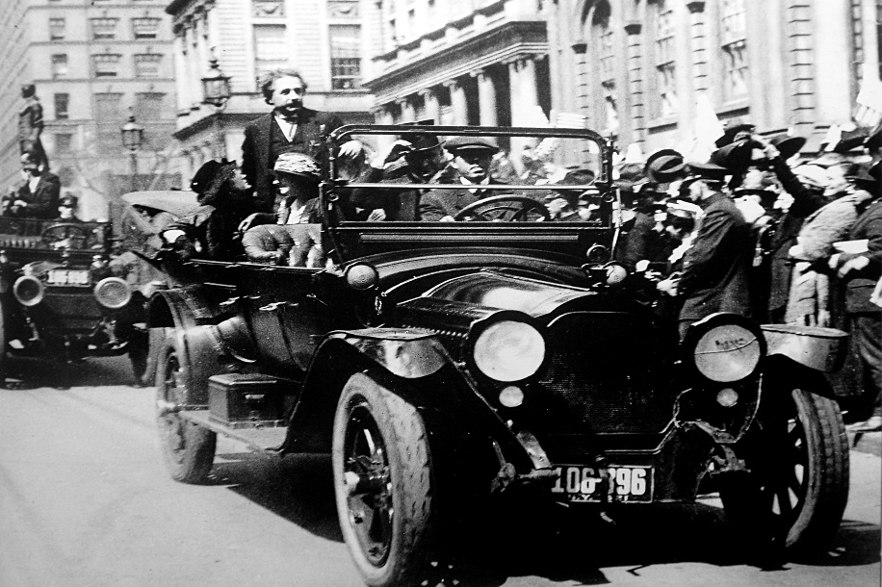Einstein visited New York City for the first time on 2 April 1921. He went on to deliver several lectures at Columbia University and [Princeton University](http://en.wikipedia.org/wiki/Princeton_University), and in Washington, he accompanied representatives of the National Academy of Science on a visit to the [White House](http://en.wikipedia.org/wiki/White_House). On his return to Europe, he was the guest of the British statesman and philosopher Viscount Haldane in London, where he met several renowned scientific, intellectual and political figures, and delivered a lecture at [King's College](http://en.wikipedia.org/wiki/King%27s_College_London). In 1922, he travelled throughout Asia and later to Palestine, as part of a six-month excursion and speaking tour. His travels included [Singapore](http://en.wikipedia.org/wiki/Singapore), [Ceylon](http://en.wikipedia.org/wiki/Ceylon), and Japan, where he gave a series of lectures to thousands of Japanese. Einstein later gave his impressions of the Japanese in a letter to his sons "Of all the people I have met, I like the Japanese most, as they are modest, intelligent, considerate, and have a feel for art." On his return voyage, he also visited Palestine for 12 days in what would become his only visit to that region. “This included a cannon salute upon his arrival at the residence of the British high commissioner, [Sir Herbert Samuel](http://en.wikipedia.org/wiki/Sir_Herbert_Samuel). During one reception given to him, the building was "stormed by throngs who wanted to hear him". In Einstein's talk to the audience, he expressed his happiness over the event: “I consider this the greatest day of my life. Before, I have always found something to regret in the Jewish soul, and that is the forgetfulness of its own people. Today, I have been made happy by the sight of the Jewish people learning to recognize themselves and to make themselves recognized as a force in the world”. In addition to German, he spoke quite well Italian and English because he lived in Italy and United States. When he was in Priceton he was friend of Kurt Gödel, they were very different but Albert liked to speak with him in his native language.

* **Was his a happy life?**

This is Einstein's vision of life:

*"If you want to have a happy life,  
You must devote it to a purpose,  
Not to people or things."*

* **What was his personality like?**
* **Was he a reserved or a sociable child?**

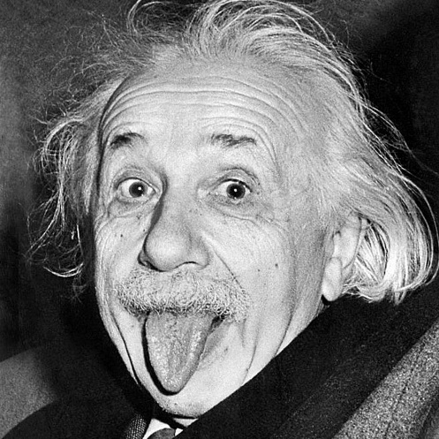Albert Einstein was brilliant and immature, changeable, not sociable, far from the deep and durable love. Arrogance, individualism, cynism and sexism backed up the unlimited gift for study, application and intuition, which gave him fame and eternity. Einstein was a quiet, pondering child, but very hysterical. He was shy and he kept his distance from his peers. He was not a model student: his teachers considered him a bad example for his classmates. He was uncomfortable with the principle of absolute obedience and the military drills that dominated the school's atmosphere. The young Einstein preferred to build houses of cards and play with his sister at home. Einstein had always been afraid of any duty. This is the reason why he used to wear very eccentric clothes for a scientist and a famous professor like him. In old age, in addition to his uncombed hair, he used to wear a sweater, a pair of old threadbare trousers and a pair of sandals. He sometimes went to hold conference, worn with baggy trousers and without socks. He considered trifle these details and he couldn't believe that people thought that they important were referred to build houses of cards and play with his sister at home. Einstein had always been afraid of any duty. Einstein became a suspicious, lonely but fascinating man, always distrustful with women, almost indifferent with the sons. He wasn't interested in his family. From adult he arrived in the old age. He was a cynic old man: when Americans unhooked the nuclear bomb to Hiroshima, Einstein was sleeping. When he woke up, he commented: “Oh, well. Dear me”. With women, he had an adversarial relationship, and he despised the intelligence and the character of the fair sex. Einstein considered women's intellect subordinate. He asserted that he didn't admire fame. The only people who influenced Einstein were his parents. Einstein was never independent and his personal life, not the life of a great scientist, was affected by it. The first person that he confide to before signing the manifesto against the diffusion of the nuclear arm was Johanna Fantova, the last Einstein's lover. A week before the death, he completed a pacifist statement, which symbolizes a kind of spiritual testament of the scientist. It finishes with this sentence: “We address a call like humans to humans: remember your humanity.”

* **His marriage**

Albert Einstein and Mileva Maric met in 1898 while both attended the Swiss Federal Polytechnic (she was the only woman allowed) and on the benches of the study was born their love story. In 1902 they had a daughter, Lieserl, who supposedly died of scarlet fever the following year. The childbirth compromised Mileva’s studies, who decided to sacrifice her scientific ambitions in favour of the family and an academic career of Albert. In 1903, the couple decided to regularize their marriage with a civil marriage. Later they had two sons, Hans Albert and Eduard. It was around 1914 that the couple was in crisis and it is precisely at this point, according to Walter Isaacson, the father of modern physics drew up a set of rules to which the wife had rigidly to stick. The reason that moved the couple to keep up a marriage ended was also adopted by the usual far less famous couples: the good of the children. Einstein dictated his terms to his wife, detailing point by point what she claimed to be. Mileva Maric was to ensure her husband clothes and linens clean and tidy and prepare three meals a day that were to be served in personal study of the spouse. He also had to ensure the cleanliness of the study and bedroom of Albert, but he must not approach the desk of her husband. In addition to practical guidance, there were also orders for the social and private life. Mrs. Einstein had to give up any personal relationship with her husband, unless his presence is not explicitly required for social reasons. He could not sit next to the partner, much less go out or travel with him. Finally, Mileva Maric had strictly to adhere to strict rules, which provided that between the two there was no intimacy and that did not come from his criticism of the spouse. Among other rules imposed there was also a sort of code of obedience, according to which the wife had to be silent or leave immediately the study or the bedroom when she was asked. Finally, the woman must avoid in any way diminishing Albert Einstein in the presence of children. The long list did not help much, in fact, a few months after Mileva Maric left her husband and went to Berlin with her two sons. Five years after their divorce became official. Previously, however, the conduct of matrimonial Albert Einstein was not without its flaws and the scientist was involved in numerous extramarital affairs, going so far as to have an affair with his cousin Elsa, who later became his second wife. To better understand the affective sphere of the German scientist just read a letter that the young Albert wrote to his mother, describing, as told Isaacson, "the joys of science as a refuge from painful personal emotions."

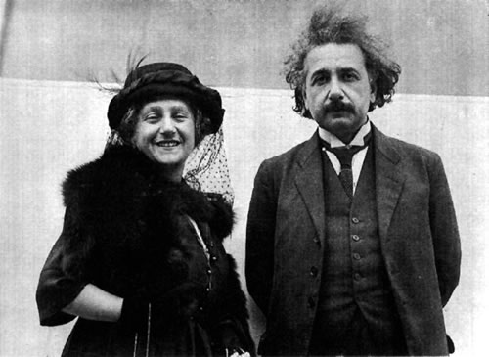

* **How did he relate to his closest friends?**

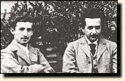Einstein graduated from the Aarau school and entered the Institute of Technology in Zurich. Around this time he recognized that physics was his true subject. Only there could he "seek out the paths that led to the depths." He also realized that he could never be an outstanding student. Fortunately, his friend Marcel Grossmann had the conventional traits Einstein lacked. While Einstein worked in the library or the laboratory, Grossmann took excellent notes at the mathematics lectures, and gladly shared them with his friend before examinations. Einstein later wrote, "I would rather not speculate on what would have become of me without these notes." Einstein grew familiar with the successes of past scientists who had tried to explain the world entirely through atoms or fluids, interacting like parts of a machine, but he learned that Maxwell's theory of electricity and magnetism was defying efforts to reduce it to mechanical processes. Through a new friend, the engineer Michele Besso, Einstein came to the writings of Ernst Mach, a sceptical critic of accepted ideas in physics.

