RETURNING FROM THE PAST

Written by Riccardo Cecchetto

CHAPTER 1

It was raining, and it was a cold day of November. I was returning from work, and that evening I didn’t feel very well.

My name is Richard, and I work in a bank in New York City, the big apple. That evening I decided to walk before going home, and I walked into New York’s streets for about half an hour; after I called a taxi.

Usually the taxi in New York are a lot and you can find someone free, but that evening I waited quarter an hour to take a taxi.

The sky was getting more dark.

When I arrived at home, I felt a different ambient, I opened the door and I heared a freezing silence.

When I went up the stairs, I did a jump backwards….

I was petrified.

CHAPTER 2

Now, I'm a lonely man.

The body that I saw that evening was of my wife. When I went up the stairs she was lying in a blood's bed but she seemed not hurt…...she had warm blue eyes.

In that moment I thought that if I find the guilty that stabbed her, I would do on him all the malice that he did on her, but after I calm down myself and I called the police.

From the angry and from the fear I couldn't do the police number, because my finger was trembleing.

CHAPTER 3

In that moment my only consolation was my best friend Jack. I called him that night some hour after the fact.

I told him the dreadful event and he stayed terrified.

When he ragained himself he told me to spend the night in his house.

I immediately took the coat and I went to him. When he opened the door we embrice ourselves.

All the night we talked about my wife, because for him, she was like a sister.

She was a very beautiful woman, she had blue eyes and brown hairs. She wasn’t borned in New York, but she went here when she married me. In his town she was respected and knowed.

When I met her, she was a very beautiful girl with healthy principle and she didn’t deserve to be killed.

CHAPTER 4

The following morning I got up very early.

It was a sunny day: the sun was shining and there was no clouds in the sky.

I dressed myself and after I did the breakfast for the first time, because usually she did it for me.

I drunka cupo f coffe with a little milk as usual.

When I was drinking my coffe I reflected about the terrible fact that happened.

Something didn’t add up me. This murder got always more strange.

If the police didn’t do forward about this story, I would do it on myself.

I knew that was dangerous, but in that moment I had nothing to lose. The only problem was that I needed help from Jack, but, if he didn’t want to help me, I didn’t know what to do.

CHAPTER 5

That day, I took the coat and I went to my house.

The police weren’t here, but a yellow tape was in front of the door.

I couldn’t enter, so I went to the police station, because I wanted to know if the killer stole something; a police man asked me that I could see my house after three days.

I was very angry and nervous, I wanted to know the truth.

Later I calmed down myself and I set down on a chair: I was thinking who could do a similar gesture so, I noted, Susan (my deceased wife) talked me about a person….her old husband, Mike.

I remember, she told me that he was in the city.

Did he kill her?

But after I thought it back….I thought that in that moment I was stressed, so I returned to Jack’s home.

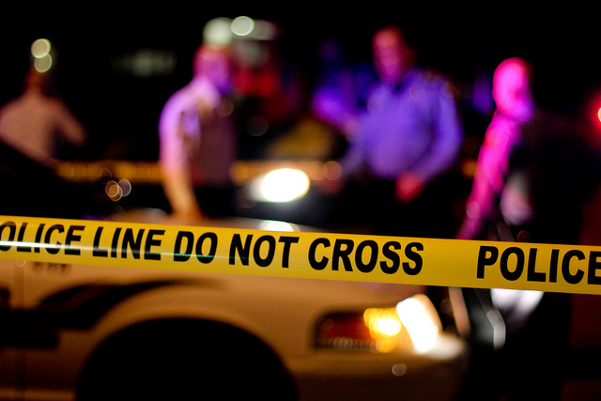

CHAPTER 6

After some days, the bank call me, bacause I didn’t go to work; fortunately it gave me some holidays days when I told the dreadful event.

In this day, the police called me too: they told me that I could return to my house.

After that words, I returned at home and I checked all the jewelery….there were all!

“It’s like I thought!” I told.

I told that words because I knew who was the killer.

Now stayed only one thing to do: call the police and do it fastly…. a free killer was in the city.

CHAPTER 7

When I called the police, they didn’t spent a lot of time to find the killer. They arrested and they took him at the police station.

Obviously the killer was Mike…I had to understand it before, but now I’m quiet and I can walk to New York’s streets safely.

THE END