**GROUP I:Bais, Franco, Waschl**

Politics- Religion and Peace.

(His most important ideas in politics; religion and his relationship with religion his most influential friends for sharing his ideals; his ideas about World War II; his ideas about peace)

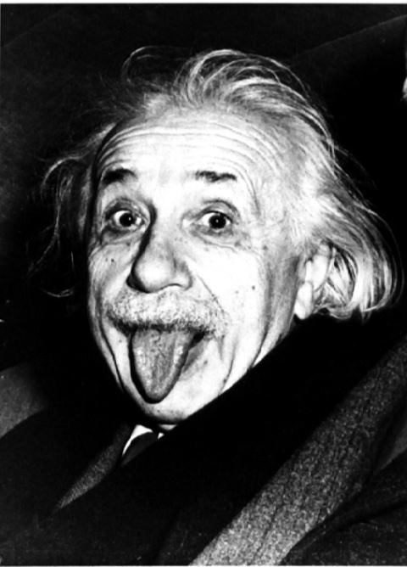

**Einstein’s biographical notes**

Albert Einstein (Ulm; 1879 – Princeton; 1955) was a German-born theoretical physicist. He developed the theory of relativity and he is best known for his mass–energy equivalence formula E = mc2. He was awarded the Nobel Prize in theoretical Physics *"for his services to theoretical physics, and especially for his discovery of the law of the photoelectric effect"* in 1921.

**Religion**

Einstein beliefs about religion have been collected from interviews and writings.

He declared himself an agnostic and dissociated his ideas from atheism, in fact he had an original connection with religion.

He believed in the "pantheistic" God of Baruch Spinoza and not in a personal God: he defined God as an impersonal entity and he deeply believed that he was represented by the harmony of nature's laws and the beauty of all that exists.

As he famously declared: *"A spirit is manifest in the laws of the Universe - a spirit vastly superior to that of man, and one in the face of which we with our modest powers must feel humble. In this way the pursuit of science leads to a religious feeling of a special sort"*.

When someone asked him if he believed in God, he always insisted he did, and explained it in this way: *"We are in the position of a little child entering a huge library filled with books in many languages. The child knows someone must have written those books. It does not know how. It does not understand the languages in which they are written. The child dimly suspects a mysterious order in the arrangement of the books but doesn't know what it is. That, it seems to me, is the attitude of even the most intelligent human being toward God. We see the universe marvellously arranged and obeying certain laws but only dimly understand these laws”*.

Albert Einstein identified very closely with the Dutch Jewish philosopher Baruch Spinoza, who believed that the universe is governed by mechanical and mathematical laws of cause and effect. He also shared Spinoza's love of solitude and intellectual independence.

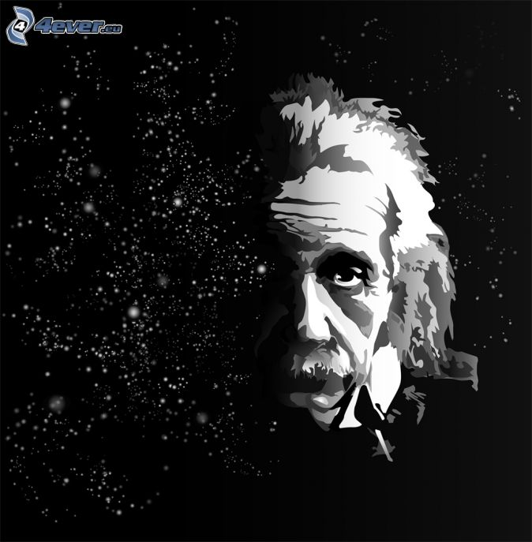Einstein, who studied Spinoza's beliefs in Bern with his friends from the Olympia Academy, was attracted by this theory and he also agreed with Spinoza's denial of the existence of a personal God. Both Spinoza and Einstein rejected their Jewish religious tradition: Spinoza was excommunicated from the Jewish community of Amsterdam in 1656, and Einstein renounced to follow Judaism at the age of twelve.

Einstein was not already an atheist, indeed he understood that science and religion were connected very closely and he added: *"Science without religion is lame, religion without science is blind"*.

Einstein believed that all scientists felt a big amazement in front of the harmony of natural laws, and this cosmic religious feeling was the motivation for scientific work. In his opinion, also Kepler and Newton were inspired by this deep belief in the rationality of the universe.

**Einstein's religion in his childhood**

Einstein's family didn't follow rigorously the Jewish religion and his parents sent him to a Catholic public primary school at age of six, though he received instruction in his own religion from a distant relative.

When Einstein moved on to the Luitpold Gymnasium, he received two hours of religious instruction for Jewish pupils per week. There, he studied the Ten Commandments, biblical history, and the rudiments of Hebrew grammar.

**Einstein's doubts about Jewish religion**

Although he received a strong religious instruction as a child, Max Talmud, the poor Jewish medical student who joined the Einstein family for a weekly meal, soon weakened his regard for traditional religion.

Talmud recommended philosophical and scientific books that led Einstein to doubt the religious precepts he had been taught in school.

Einstein was questioning about the exactitude of the Bible and discontinued the preparation for his bar mitzvah.

He remained indifferent to religious conventions and precepts during his adult life: his first wife, Mileva Maric, was a member of the Greek Orthodox Church, and the marriage took place without the presence of a rabbi or a priest.

He also did not want his children to receive any form of religious instruction and the couple practiced no formal religion in their home.

**Zionism**

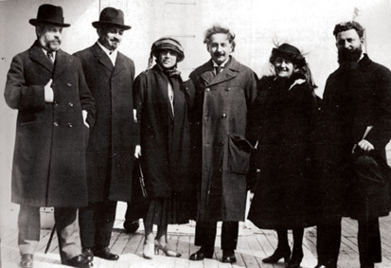We said Einstein was a Zionist, but what was Zionism? Zionism was an international movement of the nineteenth and twentieth century that promoted a Jewish national state in Palestine. Einstein first learned about Zionism when he moved to Berlin in 1911.

Though Einstein did not identify strongly with Judaism, he was passionate about preserving the Jewish values of social justice and intellectual aspiration. Einstein wanted to create a place where Jews could gain an education: in his opinion a Jewish state would serve as a cultural centre and not as a real state. He was also a strong supporter of Hebrew University, and in 1921 went on a worldwide tour to raise money for its establishment.

**April 2, 1921 Zionist Movement fundraising tour**Einstein arrives in America aboard the S. S. Rotterdam

Einstein felt the need to resolve the Arab-Israeli conflict by creating a Council of representatives as a mediating agent: he suggested to create a secret council of four Jews and four Arabs to reconcile their differing views, an idealistic goal that was never achieved.

In 1947, when the United Nations debated the future of Palestine, Einstein argued against the division of the land into an Arab and a Jewish state: he wanted Arabian and Jewish to live together, in the same land.

In 1952, four years after Israel became a Jewish state, David Ben-Gurion, Israel's premier, offered Einstein the position of president of Israel. Although he was deeply interested in the offer, he explained that he did not feel that he had the right skills to do that job.

**Political views**

Einstein was socialist and criticized the American capitalism: he detailed his political views in his compositions such as "Why Socialism?".

Einstein also renounced his German citizenship as a sign of his opposition to National Socialism.

Einstein appreciated female companionship, and he viewed women as objects of sexual desire and domestic satisfaction.

**Peace**

As a young man Einstein did not in principle oppose to the using of arms. In fact he would have served willingly in the Swiss army if he hadn’t had flat feet that invalidated him. The First World War transformed him into a hard-core pacifist. During the 1920s and 1930s he criticized tirelessly the evils of armed struggle, and he urged young men to refuse military service. He lent his name to internationalist commissions, and he hoped that the League of Nations might prevent future wars. The absolutist incarnation of pacifism appealed to Einstein more than Zionism, and spreading the pacifistic doctrine provided an aura of ethical utility. But his pacifism broke on the monstrous evil of fascism. He was a pacifist until Hitler came to power and caused him to revise his geopolitical equations. He urged the building of the atom bomb, but then became a leader in the movement to find ways to control it. Just as he sought a unified theory in science, he sought a world federalism that would impose order on competing nations. His belief in the value of free thought and speech, and his merry willingness to defy authority, caused him to be an adamant opponent of McCarthyism.

**World war II**

During the Nazi rise to power in Germany, Einstein began to rethink his beliefs about pacifism. Although he had always insisted that violence and military action were unforgivable under any circumstances, he realized that the world situation was so grave that war was the only recourse.

In 1930s, Einstein accepted a position with the U.S. Navy during World War II, evaluating and approving plans for new weapons.

In 1939, under the strong influence of the Hungarian nuclear physicist Leo Szilard, Einstein wrote a letter to President Roosevelt encouraging him to accelerate the process of creating and testing nuclear weapons, but he did not want to be involved in the development of the atomic bomb.

Thus he was not closely involved in the Manhattan Project, and was deeply distressed when he knew that atomic bombs had been dropped on Hiroshima and then on Nagasaki.

From the end of the war until his death in 1955, Einstein argued for the abolition of nuclear weapons and readopted a strong pacifist stance: he was especially active in the Emergency Committee of Atomic Scientists, an organization established to educate the general public about atomic weapons.

**Albert Einstein’s friends**

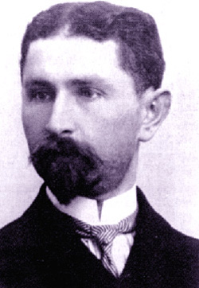**Max Talmud**

Max Talmud was the man who inspired Albert Einstein: he brought to him interesting books like some nice science encyclopaedias, puzzles,... that he read voraciously.

He even introduced the 13 year old Albert with some of the most inspiring scientific and philosophical texts like Euclid's Elements and Emmanuel Kant's Critique of Pure Reason, and thereafter to the works of David Hume and Ernst Mach to let him understand 'reality'. Einstein would later say, "If Euclid failed to kindle your youthful enthusiasm, then you were not born to be a scientific thinker."

**Max Planck**

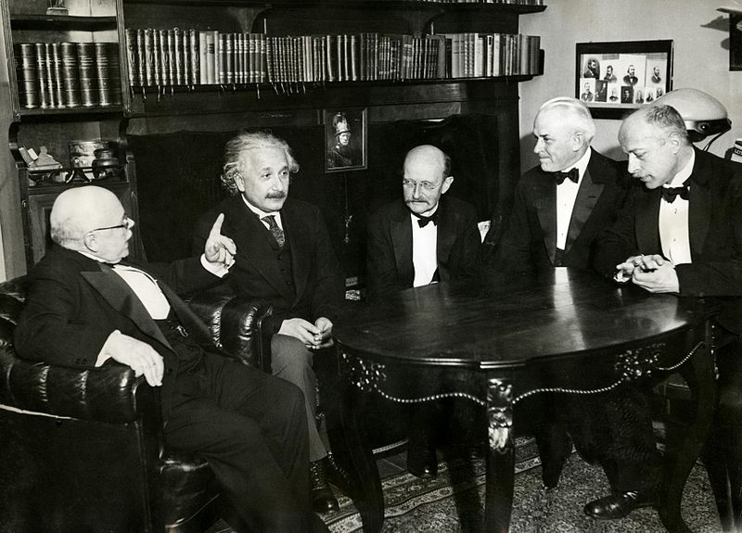In 1905, the three epochal papers of [Albert Einstein](http://en.wikipedia.org/wiki/Albert_Einstein) were published in the journal [*Annalen der Physik*](http://en.wikipedia.org/wiki/Annalen_der_Physik).

Planck was among the few who immediately recognized the significance of the [special theory of relativity](http://en.wikipedia.org/wiki/Special_theory_of_relativity) and, thanks to his influence, this theory was soon widely accepted in Germany.

In 1910, Einstein pointed out the anomalous behaviour of [specific heat](http://en.wikipedia.org/wiki/Specific_heat) at low temperatures as another example of a phenomenon which defies explanation by classical physics.

Planck and [Nernst](http://en.wikipedia.org/wiki/Walther_Nernst), seeking to clarify the increasing number of contradictions, organized the First [Solvay Conference](http://en.wikipedia.org/wiki/Solvay_Conference) (Brussels 1911). At this meeting Einstein was able to convince Planck. In the meanwhile, Planck found a teaching place at Berlin University, so it was possible for him to call Einstein to Berlin.

Soon the two scientists became close friends and met frequently to play music together.

# Saturday,12th April 2014

Today, at 9 o’clock a.m., we met at my home to do a research about the religion and the political ideas of one of the most famous physicists in the world: Albert Einstein.

Riccardo and Valentina entered my house and came into my room, where we compared the information that we collected individually at home before the meeting.

Then we put in a same word document all our researches, divided our work in paragraphs and read for the last time the websites that tell about the aspects of Einstein’s life that we had to analyze.

At half past ten we had a break, then we read and reworked the first paragraphs, changing some words and adding or removing phrases.

Riccardo and Valentina left my home at 12.45 p.m. and went back home for lunch.

(Logbook by Andrea Waschl)

Friday,18th April 2014

Today, at nine o’clock a.m., we returned to Andrea’s house to improve and rework our research.

It was simpler to work on the text this time, because it was already divided in paragraphs and also because everyone had revised an aspect of Albert Einstein’s at home: I had revised the paragraph about Einstein’s religion, Riccardo the paragraphs about Zionism and war and Andrea the paragraph about peace.

We put together our works and revised all the paragraphs, changing some phrases and removing all the repetitions.

After that we had break, than we finished to correct the text and, at 12.30 p.m., we went back home.

(Logbook by Valentina Bais)

Tuesday, 22nd April 2014

Today, at 8 o’clock a.m., we met for the last time at Andrea’s house.

We finished our work, improving the layout and inserting some images for each paragraph.

Then we read the text for the last time and added the paragraphs about Max Talmud and Max Planck, Einstein’s friends.

At 10.00 we had a break, then we revised Saturday’s and Friday’s logbooks and went home at 10.45 a.m.

After the meeting, I wrote the logbook and everyone uploaded the research on the teacher’s website.

(Logbook by Riccardo Franco)