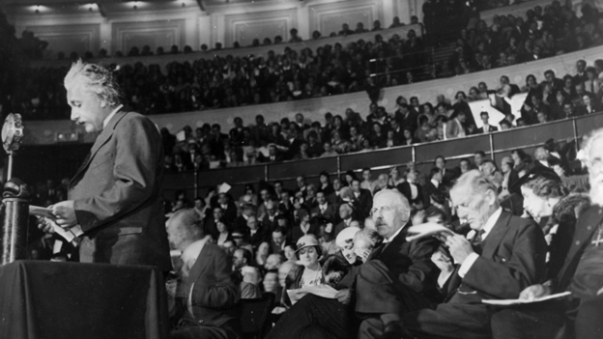***“Try not to become a man of success, but rather try to become a man of value”***

**INTRODUCTION**

Albert Einstein was a German-born scientist who lived from 1879 until 1955. He is famous for his work with theoretical physics, using math to explain what happens in nature or space. In particular, Einstein is well known for his general theory of relativity where he described relationship among space, time, matter and energy; space and time were considered manifestations of the same thing as well as matter and energy. Indeed for these reasons the Nobel Prize in Physics 1921 was awarded to him.

**OUR CURIOSITIES**

1. Why was he awarded the Nobel Prize?
2. Did he receive other prizes and awards?
3. What was Albert Einstein’s reputation among the common people?

**a) WHY WAS HE AWARDED THE NOBEL PRIZE?**

* + *Reasons for Nobel Prize award*

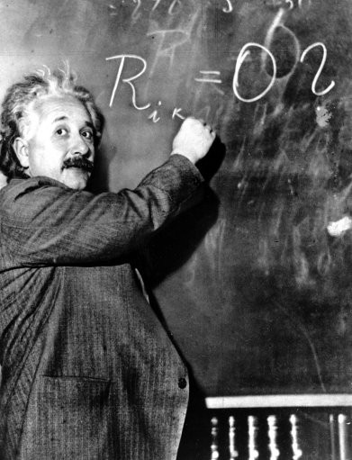Einstein always appeared to have a clear view of the problems of physics and the determination to solve them. He had a strategy of his own and was able to visualize the main stages on the way to his goal. He regarded his major achievements as mere stepping-stones for the next advance. At the start of his scientific work, Einstein realized the inadequacies of Newtonian mechanics and his special theory of relativity stemmed from an attempt to reconcile the laws of mechanics with the laws of the electromagnetic field. He dealt with classical problems of statistical mechanics and problems in which they were merged with quantum theory; but he wouldn't, as it turned out, ever win a Nobel for his work on relativity and gravitation but for the photoelectric effect. Effectively, Einstein became the recipient of the Nobel Prize for his services to theoretical physics, and especially for his discovery of the law of the photoelectric effect which is a very obvious manifestation of the quantum nature of light. In 1905, while working as a patent clerk in Bern, Switzerland, Einstein had what came to be known as his “Annus Mirabilis” — or “miracle year”. It was during this time that the young physicist obtained his Doctorate degree and published four of his most influential research papers, including the Special Theory of Relativity. In that, the now world famous equation "e = mc²" unlocked mysteries of the Universe theretofore unknown. Ten years later, in 1915, Einstein completed his General Theory of Relativity. After several failed observations of total solar eclipses proof came in 1919: On May 29 of that year the English astronomer Arthur Stanley Eddington confirmed Einstein's prediction of light deflection when he observed a total solar eclipse on the volcanic island of Principe in the Gulf of Guinea in western Africa. A second expedition, led by Andrew Crommelin, observed this eclipse in Sobral, Brazil. The Nobel Prize in 1921 was awarded to Albert Einstein but he received the prize really in 1922 because relativity was still considered controversial, so he received the award for his explanation of the photoelectric effect. Physicist of Albert Einstein’s period said he received the [Nobel Prize in Physics](http://en.wikipedia.org/wiki/Nobel_Prize_in_Physics) for his services to theoretical physics, and especially for his discovery of the law of the [photoelectric effect](http://en.wikipedia.org/wiki/Photoelectric_effect). In the 1920s, Einstein also launched the new science of cosmology. His equations predicted that the universe is dynamic, ever expanding or contracting. This contradicted the prevailing view that the universe was static, a view that Einstein held earlier and was a guiding factor in his development of the general theory of relativity.

* + *Award Ceremony speech*

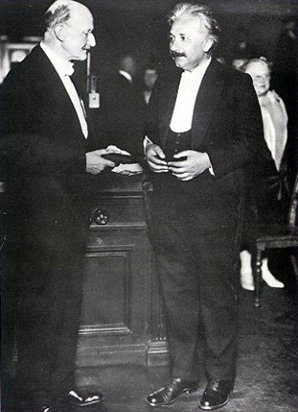Presentation Speech by Professor [S. Arrhenius](http://www.nobelprize.org/nobel_prizes/chemistry/laureates/1903/index.html), Chairman of the Nobel Committee for Physics of [the Royal Swedish Academy of Sciences](http://www.nobelprize.org/redirect/links_out/prizeawarder.php?from=/nobel_prizes/physics/laureates/1921/press.html&object=kva&to=http://www.kva.se), on December 10, 1922.

Your Majesty, Your Royal Highnesses, Ladies and Gentlemen. There is probably no physicist living today whose name has become so widely known as that of Albert Einstein. Most discussion centres on his theory of relativity. This pertains essentially to epistemology and has therefore been the subject of lively debate in philosophical circles.

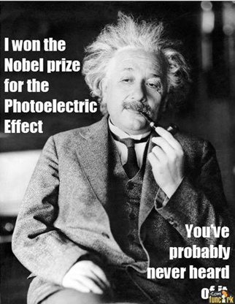 It will be no secret that the famous philosopher Bergson in Paris has challenged this theory, while other philosophers have acclaimed it whole heartedly. The theory in question also has astrophysical implications which are being rigorously examined at the present time. Throughout the first decade of this century the so-called Brownian movement stimulated the keenest interest. In 1905 Einstein founded a kinetic theory to account for this movement by means of which he derived the chief properties of suspensions, i.e. liquids with solid particles suspended in them. This theory, based on classical mechanics, helps to explain the behaviour of what are known as colloidal solutions, a behaviour which has been studied by [Svedberg](http://www.nobelprize.org/nobel_prizes/chemistry/laureates/1926/index.html), [Perrin](http://www.nobelprize.org/nobel_prizes/physics/laureates/1926/index.html), [Zsigmondy](http://www.nobelprize.org/nobel_prizes/chemistry/laureates/1925/index.html) and countless other scientists within the context of what has grown into a large branch of science, colloid chemistry. A third group of studies, for which in particular Einstein has received the Nobel Prize, falls within the domain of the quantum theory founded by Planck in 1900. This theory asserts that radiant energy consists of individual particles, termed "quanta", approximately in the same way as matter is made up

of particles, i.e. atoms. This remarkable theory, for which Planck received the [Nobel Prize for Physics in 1918](http://www.nobelprize.org/nobel_prizes/physics/laureates/1918/index.html), suffered from a variety of drawbacks and about the middle of the first decade of this century it reached a kind of impasse. Then Einstein came forward with his work on specific heat and the photoelectric effect. This latter had been discovered by the famous physicist Hertz in 1887. He found that an electrical spark passing between two spheres does so more readily if its path is illuminated with the light from another electrical discharge. A more exhaustive study of this interesting phenomenon was carried out by Hallwachs who showed that under certain conditions a negatively charged body, e.g. a metal plate, illuminated with light of a particular colour - ultraviolet has the strongest effect - loses its negative charge and ultimately assumes a positive charge. In 1899 Lenard demonstrated the cause to be the emission of electrons at a certain velocity from the negatively charged body. The most extraordinary aspect of this effect was that the electron emission velocity is independent of the intensity of the illuminating light, which is proportional only to the number of electrons, whereas the velocity increases with the frequency of the light. Lenard stressed that this phenomenon was not in good agreement with the then prevailing concepts. An associated phenomenon is photo-luminescence, phosphorescence and fluorescence. When light impinges on a substance the latter will occasionally become luminous as a result of phosphorescence or fluorescence. Since the energy of the light quantum increases with the frequency, it will be obvious that a light quantum with a certain frequency can only give rise to the formation of a light quantum of lower or, at most, equal frequency. Otherwise energy would be created. The phosphorescent or fluorescent light hence has a lower frequency than the light inducing the photo-luminescence. This is Stokes' rule which was explained in this way by Einstein by means of the quantum theory. Similarly, when a quantum of light falls on a metal plate it can at most yield the whole of its energy to an electron there. A part of this energy is consumed in carrying the electron out into the air, the remainder stays with the electron as kinetic energy. This applies to an electron in the surface layer of the metal. From this can be calculated the positive potential to which the metal can be charged by irradiation. Only if the quantum contains sufficient energy for the electron to perform the work of detaching itself from the metal does the electron move out into the air. Consequently, only light having a frequency greater than a certain limit is capable of inducing a photo-electric effect, however high the intensity of the irradiating light. If this limit is exceeded the effect is proportional to the light intensity at constant frequency. Similar behaviour occurs in the ionisation of gas molecules and the so-called ionisation potential may be calculated, provided that the frequency of the light capable of ionising the gas is known. Einstein's law of the photo-electrical effect has been extremely rigorously tested by the American Millikan and his pupils and passed the test brilliantly. Owing to these studies by Einstein the quantum theory has been perfected to a high degree and an extensive literature grew up in this field whereby the extraordinary value of this theory was proved. Einstein's law has become the basis of quantitative photo-chemistry in the same way as Faraday's law is the basis of electro-chemistry.

**b) DID HE RECEIVE OTHER PRIZES AND AWARDS?**

* + *Albert Einstein received lot of other prizes and awards.* The most important of them are:

|  |  |
| --- | --- |
| DATES | EVENTS |
| 1925 | The [Royal Society](http://en.wikipedia.org/wiki/Royal_Society) awarded Einstein the [Copley Medal](http://en.wikipedia.org/wiki/Copley_Medal). |
| 1929 | Max Planck presented Einstein with the [Max Planck medal](http://en.wikipedia.org/wiki/Max_Planck_medal) of the [German Physical Society](http://en.wikipedia.org/wiki/German_Physical_Society) in Berlin, for extraordinary achievements in theoretical physics. |
| 1934 | Einstein gave the [Josiah Willard Gibbs](http://en.wikipedia.org/wiki/Josiah_Willard_Gibbs) lecture. |
| 1936 | Einstein was awarded the [Franklin Institute](http://en.wikipedia.org/wiki/Franklin_Institute)'s [Franklin Medal](http://en.wikipedia.org/wiki/The_Franklin_Institute_Awards) for his extensive work on relativity and the photo-electric effect. |
| 1979 | National Academy of Sciences on Constitution Avenue commissioned the statue in honour of Albert Einstein located in a grove of trees. |
| 1990 | In his name was added to the Walhalla temple for "laudable and distinguished Germans", which is located in Donaustauf in Bavaria. |
| 1999 | Time magazine named him the Person of the Century, ahead of Mahatma Gandhi and Franklin Roosevelt, among others. In the words of a biographer, "to the scientifically literate and the public at large, Einstein is synonymous with genius". Also in 1999, an opinion poll of 100 leading physicists ranked Einstein the "greatest physicist ever”. A Gallup poll recorded him as the fourth most admired person of the 20th century in the U.S. |
| 2008 | Einstein was inducted into the New Jersey Hall of Fame. |

* *After Albert Einstein’s death many physicists instituted many prizes and awards in honour of him.*

The most important of them are:

|  |
| --- |
| The [Albert Einstein Award](http://en.wikipedia.org/wiki/Albert_Einstein_Award) is an award in [theoretical physics](http://en.wikipedia.org/wiki/Theoretical_physics), established to recognize high achievement in the natural sciences. It was endowed by the Lewis and Rosa Strauss Memorial Fund in honor of Albert Einstein's 70th birthday. It was first awarded in 1951 and included a prize money of $15,000, which was later reduced to $5,000. The winner is selected by a committee of the [Institute for Advanced Study](http://en.wikipedia.org/wiki/Institute_for_Advanced_Study), which administers the award. |
| The [Albert Einstein Medal](http://en.wikipedia.org/wiki/Albert_Einstein_Medal) is an award presented by the [Albert Einstein Society](http://en.wikipedia.org/wiki/Albert_Einstein_Society) in Bern, Switzerland. First given in 1979, the award is presented to people who have "rendered outstanding services" in connection with Einstein. |
| The [Albert Einstein Peace Prize](http://en.wikipedia.org/wiki/Albert_Einstein_Peace_Prize) is given yearly by the [Chicago](http://en.wikipedia.org/wiki/Chicago), [Illinois](http://en.wikipedia.org/wiki/Illinois)-based Albert Einstein Peace Prize Foundation. Winners of the prize receive $50,000. |

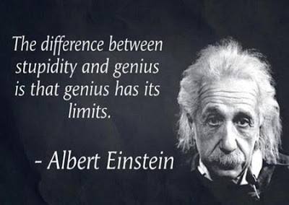**c) WHAT WAS ALBERT EINSTEIN’S REPUTATION AMONG THE COMMON PEOPLE?**

The academic and the scientific community did not consider quickly A. Einstein’s ideas true. Perhaps it was difficult to take seriously a young person who until this time had only earned disdain from his former teachers. In fact his scholastic career wasn't bright because he failed his exams. Perhaps Einstein's thoughts were so unusual and elaborate that no one wasn't able to understand and to consider them like the truth. In addition, during the rise of German nationalism he was the target of campaigns to discredit his theories by reason of his Jewish descent. When Adolf Hitler took power in 1933, the political climate in Germany was changing drastically. Einstein’s theories on relativity became a convenient target for Nazi propaganda. The Nazis promptly declared Einstein an enemy of the state, ransacked his house, and burned his books but luckily, when death threats began; he was visiting the United States. It was after World War I that the scientists approved his ideas and of the same way the common people began to believe in him. Not only his revolutionary theories but also his appearance endeared him to the most part of people. Albert Einstein denoted the typical look belonging to everyone of 20th century. Instantly famous, Einstein was hounded by reporters and photographers wherever he went. Einstein's launch into fame contributed to the birth of a new celebrity age. He became a scientific icon and humanist star, one of the most famous faces on the planet. The public earnestly puzzled over his theories, elevated him into a cult of genius, and canonized him as a secular saint. A century after his great triumphs, we are still living in his universe. Now Einstein is considered a real genius.

Cecchetto Riccardo

Parlati Vittoria

Vianello Luca