CULTURE
WHAT CHRISTMAS SONGS CAN DO
TRADITIONS OF THE CHRISTMAS PERIOD AND HIS SONGS

Christmas is a Christian holiday that celebrates the birth of Jesus. Falls on 25 December for most of the Christian Churches and western Greek-orthodox ones, for the eastern Christianity falls on 6 January and 7 January in what is below the Julian calendar rather than the Gregorian calendar.
Christmas is a feast accompanied by different traditions, social and religious, often varying from country to country.
It is the most important festivity among Christians which are highly linked to the tradition of the crib and, in recent times has also taken a laical meaning. In this context, the Christmas is generally experienced as feast linked to the family, the solidarity, for the decoration of the tree, in the exchange of gifts and the figure of Santa Claus.
The Christmas then is continuing to represent a day of celebration also for non-Christians, assuming different meanings from the religious. Outside of its religious significance, Christmas has also assumed in the last century a significant importance in terms of trade and economic, which is linked to the custom of exchanging gifts. For example, in the United States has been estimated that about a quarter of all the personal expenditure is carried out over the Christmas period.
The Christmas songs are another element common to all over the world. The themes and languages may be different, but they are a source of union, cheerfulness and hope among many people.
One of the Christmas songs more known and sung in the world, is Jingle Bells. It was written by James Pierpont and published in autumn 1857 with the title “One Horse Open Sleigh”. Even if it is associated with Christmas and the Christmas period, originally, the song was written to be sung during the Thanksgiving day.
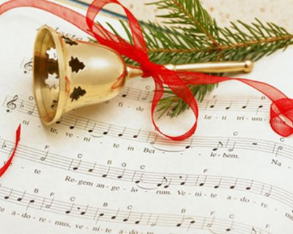
The song is traced back to Christmas by some figures, typically Christmas: the snowy fields, the bells that tinkling, the fun that every person feels, in being carried by a slide in the snow.
Beyond Jingle Bells, there are many other texts which recount in time to the music the rhythms of Christmas.
Part of them is taught in schools of childhood to educate children to a great spirit of brotherhood during the Christmas period. In addition, with the songs, teachers can pass on to their students the values and the popular traditions of the Christmas, that are handed down from generations to generations.

