Cicogna Lisa, Pecorella Francesca, Sgubin Sara

How to analyze

a poem?

Manual of poetry

**Table of contents:**

What is literature?...............................................................3

What is poetry?...................................................................4

How does the poet communicate?................................... .5

Figures of speech………………………………………………..……………6

“A poison Tree”……………………………..…………………………………7

Advices………………………………………………..…………………………..8

What does the title make me think of?...............................9

How to analyze the structure of a poem?.........................10

How does the poet hook the readers and pull them into a text?..................................................................................11

# How does rhythm create a feeling within a poem?...........12

# How to reexamine initial predictions?...............................13

**What is literature?**

Literature (from Latin litterae (plural); letter) is the art of [written](http://en.wikipedia.org/wiki/Written) work. The word literature literally means: "things made from letters".

Literature is a composition that tells a story, dramatizes a situation, expresses emotions, analyzes and advocates ideas.

It is something helps us to grow personally and intellectually, it provides an objective base for knowledge and understanding. It shapes our goals and values by clarifying our own identities, both positively and negatively.

Literature is made up of four genres:

-*Prose fiction* (myths, parables, romances, novels, short stories);

-*Drama* (made up of dialogue and set direction; designed to be performed);

-*Nonfiction prose* (news reports, feature articles, essays, editorials, textbooks, historical and biographical works);

-*Poetry* (relies on imagery figurative language, sound).

In this manual we are going to explain **what is poetry** and **how we can analyze a poem.**

**What is poetry?**

Poetry is an art form in which human language is enjoyed, paying particular attention to the choice of vocabulary, to the way the words have to be ordered, to the images that are evoke from them and to all that concerns semantic contents and evocative figures.

It consists essentially of oral or literary works in which language is used in a manner that it **differs from ordinary prose**. It may use **to convey emotion** or ideas to the reader's or listener's mind or ear; it may also use figures speech, that we are going to explain later.

Poems frequently rely for their effect on *imagery*, *word association*, and the *musical qualities of the language* used. The interactive layering of all these effects to generate meaning is what marks poetry.

Because of its nature of emphasizing linguistic form rather than using language purely for its content, poetry is notoriously difficult to translate from one language into another and, mostly, to understand. So we could consider poetry as the literature container where the connotations and the "baggage" that words carry play a crucial role.

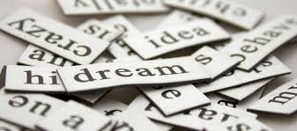

**How does the poet communicate?**

Every act of communication conveys a message that connects those who produce it, namely the issuer, and those who receive it, the recipient, within a context that is a specific communicative situation.  
All the messages relate to an object, something material but also an idea or a situation, which is called referent. The messages are also produced in a code and are conveyed through a medium, the channel.  
When we speak or write the language is the verbal code and the channel can be for example a sheet of paper or the printed page, in the case of written language or air in the case of the spoken one.  
The messages, however, can also be transmitted electronically (sms, e-mail).  
When we send a message, verbal or written, oral, or transmitted, we produce a text.  
Poetry is an act of communication, and therefore also the poetic text can be analyzed through the pattern of communication.  
  
***Who is the sender of the message poetic?***

He is the poet, the one who writes the verses, following his inspiration. However, it differs from '"I" who almost always speaks in the first person in the poem. The author is a distinguished figure, the lyric poet. The "I" acts as a character in the poem, expressing feelings and opinions, or just communicating what he sees or hears. Sometimes the poet speaks in the third person and lets the other characters in his poems. The author instead corresponds to the historical person with his physical characteristics, psychological and biographical.  
  
The lyric is the poetry of subjectivity and the centrality of the ego.

**Figures of speech**

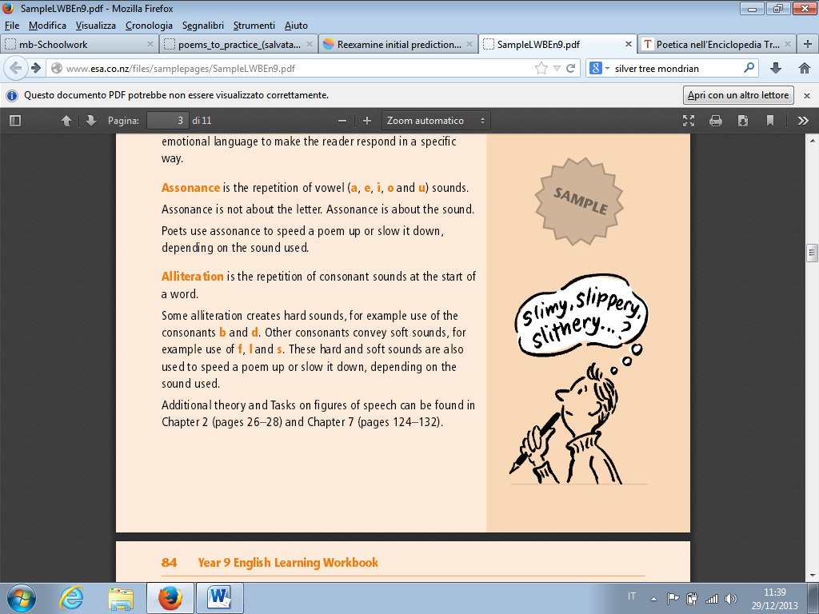Figures of speech are another way to gain vibrancy and interest in the language used in poetic writing. Figures of speech are techniques used by writers to convey ideas, feelings and images. Poets use figures of speech to create, rhythm, rhyme and emotional language to make the reader respond in a specific way.

**Assonance** is the repetition of vowel (a, e , i, o and u) sounds. Assonance is not about the letter. Assonance is about the sound. Poets use assonance to speed a poem up or slow it down, depending on the sound used.

**Alliteration** is the repetition of consonant sounds at the start of a word. Some alliteration creates hard sounds, for convey soft sounds, for example use of f, l and s. These hard and soft sounds are also used to speed a poem up or slow it down, depending on the sound used. **Rhyme** is the repetition of final vowel and consonant sounds in words. Words that sound the same, or almost the same, attract our attention and are easy to remember. You need to take note of where the rhymes are in the poem – at the end of every line or every alternate line? Where the rhyme falls dictates the pattern and speed of the poem.

**Personification** is the technique of giving human qualities to something that is not human, such as objects or things. Personification gives things (like the river in the following example) a personality. A **metaphor** is used to highlight specific qualities of a thing or person. Metaphors are a comparison, where one thing is said to be another. (Metaphors do not use like or as).

A **simile** is also used to highlight qualities of a person or thing. Similes always use like or as. **Symbolism** is the use of a word for something concrete that stands for something abstract. **Irony** is a literary technique that uses a way of speaking or writing in which the ordinary meaning of words is the opposite of the thought in the speaker's mind. **Imagery** is a figurative language that uses words to paint a picture in the reader's mind. It helps the reader imagine how something tastes, smells, feels, looks and sounds. **Onomatopoeia** is a poetic language that is the use of words whose sounds suggest their meanings. **Allusion** is a literary technique that is a reference to a well-known person, place, or thing in literature and history.

**Zeugma** and **syllepsis** are [figures of speech](http://en.wikipedia.org/wiki/Figures_of_speech) in which one single phrase or word joins different parts of a sentence.

O**xymoron** is a [figure of speech](http://en.wikipedia.org/wiki/Figure_of_speech) that juxtaposes apparently contradictory elements (it is not however a contradiction in terms).

**Synecdoche** is a [figure of speech](http://en.wikipedia.org/wiki/Figure_of_speech) in which a term for a part of something refers to the whole of something, or vice-versa.

**Hyperbole** is the use of [exaggeration](http://en.wikipedia.org/wiki/Exaggeration) as a [rhetorical device](http://en.wikipedia.org/wiki/Rhetorical_device) or [figure of speech](http://en.wikipedia.org/wiki/Figure_of_speech). It may be used to evoke strong feelings or to create a strong impression, but is not meant to be taken literally.

**“A Poison Tree”**

by

William Blake

I was angry with my friend:

I told my wrath, my wrath did end.

I was angry with my foe:

I told it not, my wrath did grow.

And I watered it in fears

Night and morning with my tears,

And I sunned it with smiles

And with soft deceitful wiles.

And it grew both day and night,

Till it bore an apple bright,

And my foe beheld it shine,

And he knew that it was mine,

And into my garden stole

When the night had veiled the pole;

In the morning, glad, I see

My foe outstretched beneath the tree.

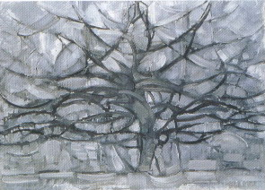

# Piet Mondrian*, Silver Tree,* Painting - oil on canvas, *1912,* Gemeentemuseum Den Hague (Netherlands)

s

**Advices**

1. 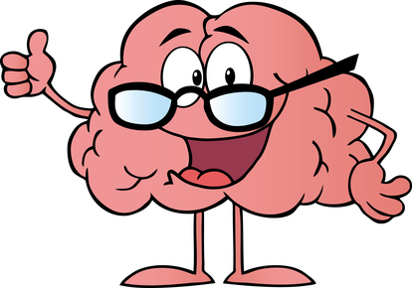Read through at least twice. You will have to read a poem multiple times before even attempting to approach it for deeper meanings. Give yourself a chance to thoroughly and fully experience the poem.
2. Is there a title? Don’t forget to take this into consideration. Readers often skip over a poem’s title, which may contain important clues for understanding the meanings of the poem. Often the title is an introduction that can guide you. For example, Langston Hughes’ “Mother to Son” immediately lets you know who the speaker of the poem is and to whom she is speaking.
3. If there are any unfamiliar words or even a few foreign terms, don’t panic and don’t obsess. On your first read through, just let them go and try instead to focus on the larger meaning of the poem. On the second and subsequent passes, you should then look up those troublesome words or anything else that is problematic for you.
4. You must read the poem aloud. Poems are meant to be heard. Often you will find that places in the poem that gave you trouble on the page suddenly make sense when read out loud. Read in your normal voice.
5. Pay attention to punctuation. Most poems use punctuation to help guide the voice of its reader. You need to pay attention because the end of a line is frequently not the end of a sentence.

When it comes to poetry, punctuation works differently than most other forms of writing. This includes periods, commas, semicolons, question marks, exclamation marks, ellipses, and dashes.

A poet uses punctuation not so much for grammatical correctness but rather for effect. In a poem, the use of a comma or a period or even using neither can change the meaning completely.

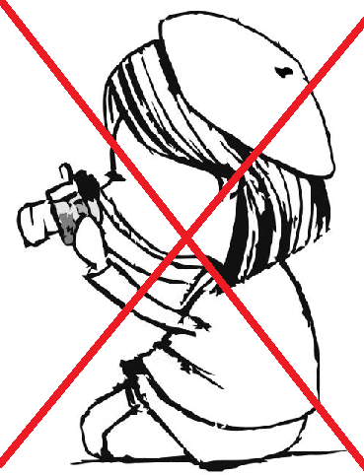

**ALERT!**

Don’t photograph the text: the paraphrase don’t help to understand the poem.

**What does the title make me think of?**

Start by looking at the title of the poem. It was probably carefully chosen. What information does it give you? What expectations does it create? Does the title tell you the subject of the poem? Does the title label the poem as a specific literary type? (ex. “Ode to Melancholy”; “Sonnets at Christmas).

How can you make a **prediction** about a poem based on only a few words? A **prediction** is a statement about what you think it’s going to happen that reader have to make before they begin reading the poem.

Then they look for clues to support their prediction about what they read. If clues exist the intelligent reader can go back to his previous predictions and change them as needed.

**ALERT!**

A common mistake is thinking predictions are facts but they can be considered guesses.

We should think of predictions like initial questions that can later be changed according to the content of the poem.

Let’s start by reading the title of the poem “***A poison Tree***”.

Now I can use my backer knowledge to think about what I early know that is related to this topic. Now I ask myself: What does the title make me think of?

From the title, the intelligent reader can predict that this poem is going to be about focusing on a tree. Now we wonder why the poet. Now we wonder why the poet attributes the adjective “Poison” to tree. Indeed, is this adjective that creates curiosity in the reader to continue reading.

**How to analyze the structure of a poem?**

Why do poet split their poems into multiple stanzas if the whole poem is focused on one overall topic?

A stanza is a small section of a poem, it can consist of one line or many lines.

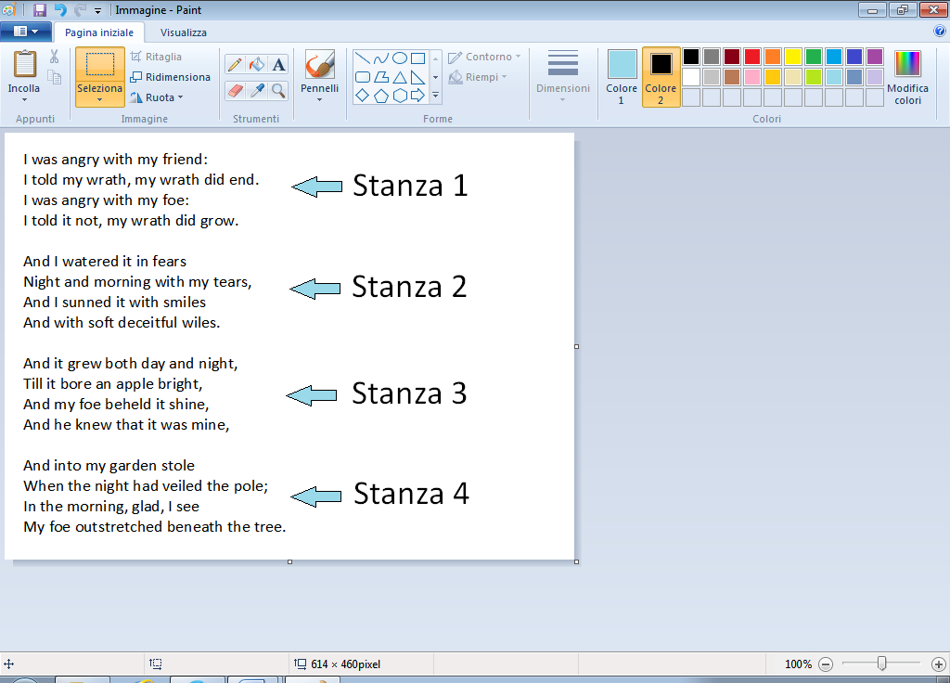You know something is a stanza because it is separated to the other by a stanza break .

**ALERT !**

A common mistake when studying in this topic is thinking that every stanza has the same main idea or the same purpose. It’s true that all the stanzas of the poem fit together like a pieces of a puzzle forming one main idea. However when a new stanza is formed the poem is trying to single to the reader that a new idea is about to began.

The reader’s job is what the stanza says or the main idea and also why the stanza is there.

It’s very important to determine the poem’s structure and organization. Does the poem follow a narrative? Are there ideas grouped together in different sections? Does each stanza cover a separate topic, or is there a continued theme throughout the poem? How is the poem physically organized--it is one long poem, or does it have stanzas or separate lines?

**STEPS:**

1 Re-read and think: “How does each stanza fit in with what I read before?”

2 Jot down the answer next to each stanza.

3 Ask: “Why did the poet choose to structure the poem in this way?”

“A Poison Tree” is organized into four stanzas, made up of 4 lines. Each stanza represents a critical step in the state of inner rage of the poet.

The first stanza explains a conflict between the poet and a friend which were therefore resolved. The second half of the quatrain brings up another conflict, but this anger is with a foe, based on wrath.

The second quatrain is very powerful and tells that fear and anger go together, according to the poet's opinion. This stanza includes a few stylistic devices: rhymes and metaphors, like "And I watered it with fears". Just like a plant is watered to grow, his wrath is watered with tears and fears.

Initially one can assume that the fear of the speaker is unfounded as there has been no mention of threat from the foe, but then “And I sunned it with smiles,” leads ones to think that the speaker may be enjoying watching the wrath grow. The longer the speaker is allowed to contain the anger, the more of an emotion poison it becomes.

The third quatrain tells how the wrath grows into the poison tree. Blake chose this metaphor because wrath is a poison that maybe tans a person’s emotions and powers to reason. The poison tree produces “an apple bright.” Indeed the foe covets the apple, which represents the fruit of speaker’s wrath. The speaker describes how he emotionally nourished his wrath, or tree, until the apple grew from it, which his enemy took although he knew it was his.

The final quatrain so reveals the end result of the foe sneaking into the speaker’s “garden” to take the apple, which finally takes the life of the foe. The speaker has killed his opponent, and he is not only unremorseful, but also happy and proud.

**How does the poet hook the readers and pull them into a text?**

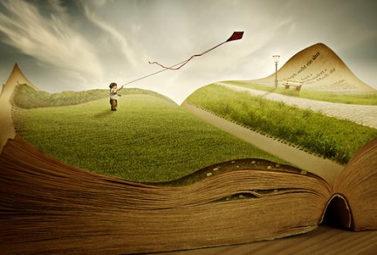What impact can the first few lines have on the reader?

A hook is the beginning of the text.

In a short text maybe is the first sentence or the opening paragraph.

Common hooks include asking question, stating famous quote, using imagery.

**ALERT!**

A common mistake with studying this topic is missing the hook.

To find the hook in the poem you must look for how the poet is introducing a topic, a speaker, or a conflict at the start of the poem.

Let’s start to read the first stanza:

I was angry with my friend:

I told my wrath, my wrath did end.

I was angry with my foe:

I told it not, my wrath did grow.

What strategy is the poet using to draw readers in?

What are readers thinking about at the start of the poem?

How the poet is trying to hook readers in the poem?

To answer the questions you have to analyze the poem in terms of poetic devices. Look for tools of sound (alliteration, assonance, etc.), imagery (sensory detail, word pictures, etc.) and so forth. Think in terms of, "What kind of language tools is this author using? How do those tools help him accomplish his goal?". What imagery does the author use? Does he use metaphor, simile, or personification?

Symbolism is also often used in a poem. A symbol is an event or a physical object (a thing, a person, a place) that represents something non-physical such as an idea, a value, or an emotion. For example, a ring is symbolic of unity and marriage; a budding tree in spring might symbolize life and fertility; a leafless tree in the winter could be a symbol for death.

How would you define the poem’s language (or diction?). Did the author choose to put specific words in the poem for a reason? Is the language flowery? Stark? Sad?

This makes us want to read more to find out, to understand what is the poet trying to say. What is his goal for this poem? What kind of a reaction is he trying to get out of readers?

**How does rhythm create a feeling within a poem?**

The rhythm of a poem is its beat, which is how it sounds when it is read aloud. The rhythm is also about how it flows.

• Is it a fast or a slow poem?

• Do the words encourage you to read it at a certain speed?

• Does the poet use simple words or complicated ones?

• Is the subject of the poem weighty or frivolous?

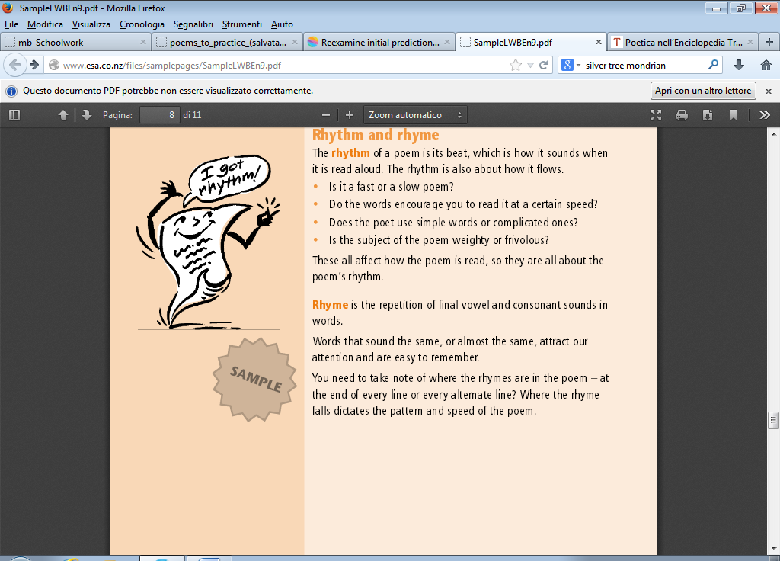It’s necessary to determine the rhyme scheme of the poem. There are many different kinds of rhyme schemes. Rhymes are used to give the poem a musical, pleasing sound. They can also be used to deepen meaning, and strengthen the form of the poem. Is there any meaning behind the placement of the rhymes? Does it put emphasis on a specific idea within the poem?

End rhymes are one of the most common forms of rhymes. When the last word of a line rhymes with another last word of a rhyme, this is considered an end rhyme.

Internal rhymes are when words in the middle of line rhyme with other words in the middle of a different line.

True rhymes are words that rhyme exactly. For example, the words “cat” and “rat” are perfect rhymes.

Off-rhymes are words that almost rhyme, but do not rhyme exactly. These are also called slant rhymes. For example, the words “fate” and “saint” are off rhymes--they sound very similar, but very subtly end in a different way. Off rhymes use assonance and consonance.

These all affect how the poem is read, so they are all about the poem’s rhythm

How do poets use rhythm to impact the feeling of their writing?

Building blocks of words are syllables

For example:

Ice has one syllable

Water has two syllables

Goodbye has two syllables

Worrying has three syllable

Syllables are stressed or unstressed. Every word in English has always a stressed pattern. This is important to review because poet creates rhythm very carefully choosing words. Poet uses stressed or unstressed syllables to make a rhythmic pattern. This freedom helps the reader began a starting feeling from the poem.

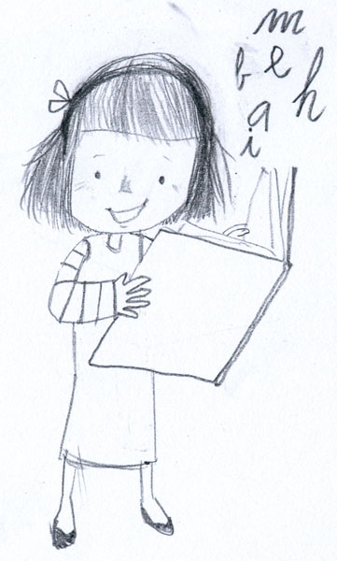

ALERT!

Don’t read the poem aloud means don’t hear the rhythm! Indeed, if you read aloud you have more likelihoods to read the words correctly.

How does the rhythm sound to our ears? It’s fast or slow, smooth or choppy?

How does the rhythm impact the feeling of the poem? Does the rhythm support or contrast with the meaning so far?

Summarizing, the reader has to follow these steps:

1 Read the poem aloud, noticing the rhythmic pattern

2 Determine what the rhythm sound like. Is it fast or slow? Smooth or choppy?

3 Visualize: “Does the rhythm sound like it matches what is happening or it is contrasting

Analyzing “A Poison Tree” we can notice that the rhythm is characterized by the existence of the rhyme. The rhyme scheme is AABB; meaning that the first two lines of each quatrain rhyme as do the second two lines. This rhyme scheme creates a very simple and easy to follow flow for the poem.

**How to reexamine initial predictions?**

What do you do with your predictions once you’ve finished reading a poem?

ALERT!

Don’t forget to go back and review your initial thoughts!

What our prediction accurate?

Were only part of it accurate?

Is there anything else we should include that wasn’t part of our prediction?

Is our prediction supported by evidence from the text?

STEPS:

1 Go back, re-read earlier predictions.

2 Check: “Were my predictions correct?”

3 Highlight evidence from the text to prove/disprove your prediction and re-write as needed.

Initially we wonder why the poet chooses the adjective “Poison” near the name “Tree”. Now we can understand why: the poet warns the reader of the negative effects of malice. The poem focuses on the anger that is hidden within us and the power of communication to resolve conflicts. It can be considered as a warning to the reader about what unchecked anger can do. Communication and releasing such emotions before they fester is the safest path to resolve conflict.