MUSIC AND TRADITIONS
Singing Christmas
Why do people sing Christmas songs?

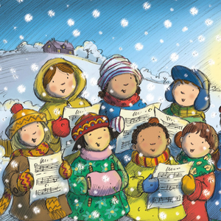
Why do we all sing Christmas songs? Everyone has sung - at least once in life - songs at Christmas. During the school dramas, with our friends, when we watch tv and there is an advertisment... Maybe we don’t even like those songs, sometimes they are idiotic but when we listen to, we can’t do without singing them. They are part of the Christmas tradition, exactly like making the christmas tree, giving and receiving presents and spending time with our family. When we are with the people we love, we are happy and singing is a good way to express our happiness. I think Christmas songs became popular many years ago, when tv, radio, computer and other technological instrument didn’t already exist. People used to sing to spend time and have fun. Nowadays there are many popular Christmas songs. They have different sounds, different lyrics, but they all have a common thing: joy.

I want to study better the difference between English and Italian songs. In Italy, Christmas is a very religious celebration. If I think about Christmas songs, I remember the ones I alway listen to in the Christmas morning when I go to the church. There are only few examples where is named Christmas, but it isn’t a religious song (look at Renato Carosone’s one). In England and America, Christmas is a feast of love and peace. If you watch films, you can see groups of people who go around the town singing Christmas songs and wishing love and happiness to everyone. Christmas is felt like a moment of joy but also of hope and listening to English songs, you can feel it.
To sum up, we listen to and sing Christmas songs because we want to express our hapiness to stay with our family and to forget for a moment all the problems and worries we have.

