**The Christmas songs**

*Why we sing Christmas song during the Christmas period*

The Christmas songs are sang at Christmas because the text of these songs reminds us the Christmas period. Some of these songs speak of the nativity, other of the comet or the christmas tree. In addition for many years it has adopted a similar pace. The jazz was the first musical genre which composed the songs of Christmas.

The Christmas tree has celtic origin in fact served to symbolize the tree of the knowledge of good and evil. The Christmas tree became gradually even a new meaning: it was to symbolize the figure of Jesus, the Savior who has overcome the darkness of sin: for this reason, started to farmhouse of lights.

Even if it is associated with Christmas and the Christmas period, originally, the song was written to be sung during the tank - giving day. Over the years, "Jingle Bells" has been sung and recorded by numerous artists, including Louis Armstrong, the Beatles, Frank Sinatra and Luciano Pavarotti and were created several alternative versions of the song.

However, the text of a plaque affixed to a building in Medford, commemorates the birthplace of Jingle Bells by stating that, in 1850, Pierpont wrote the song in that place. According to the Medford Historical Society (historical society of Medford), the author was inspired by, to the composition of the text as well as the popular races of the slides that were held in the city during the nineteenth century.

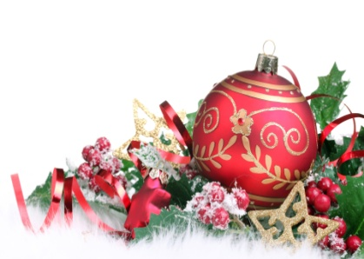The celebratory customs associated in various countries with Christmas have a mix of pagan, [pre-Christian](http://en.wiktionary.org/wiki/pre-Christian), [Christian](http://en.wikipedia.org/wiki/Christian), and [secular](http://en.wikipedia.org/wiki/Secularity) themes and origins. The earliest extant specifically Christmas hymns appear in 4th-century [Rome](http://en.wikipedia.org/wiki/Rome). Latin hymns such as "[Veni redemptor gentium](http://en.wikipedia.org/wiki/Veni_redemptor_gentium)", written by [Ambrose](http://en.wikipedia.org/wiki/Ambrose), Archbishop of Milan, were austere statements of the theological doctrine of the Incarnation in opposition to [Arianism](http://en.wikipedia.org/wiki/Arianism). In the 9th and 10th centuries, the Christmas "Sequence" or "Prose" was introduced in North European monasteries, developing under [Bernard of Clairvaux](http://en.wikipedia.org/wiki/Bernard_of_Clairvaux) into a sequence of rhymed [stanzas](http://en.wikipedia.org/wiki/Stanza). The songs we know specifically as carols were originally communal folk songs sung during celebrations such as "harvest tide" as well as Christmas. It was only later that carols began to be sung in church. Traditionally, carols have often been based on [medieval](http://en.wikipedia.org/wiki/Medieval) chord patterns, and it is this that gives them their uniquely characteristic musical sound.

*Luca Formentin*