C

C

THE

ELti

IDENTItY

AN UNEXPECTED JOURNEY

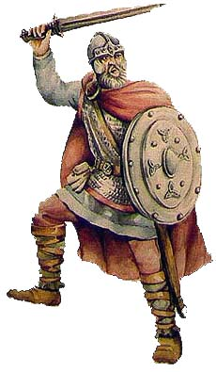

LICEO SCIENTIFICO A. EINSTEIN 3 ALS 2013 – 2014

It was still dark outside when I heard the Druid man’s and my father’s voices. the voices of the Druid man and my father. They woke me up. They were talking about something important and their voices were worried concerned.

My father was the chief of our the village, Eboracum (York’s Latin name). The village was situated in the centre-east eastern part of Britain and it was made up of twenty-six families who lived in wooden huts. They huts were built by the men of the village. First of all, They used to pick up all the necessary to survive: material ( branches, wooden beams and any other useful material from the forest. then They also built the hut’s walls the walls of their huts using twisted branches and wooden beams and finally they covered them hut with painted clay to make it water resistant permeable and stable.

It was still dark outside when I could hear the Druid man’s and my father’s voices. They woke me up. They were talking about something important and their voices sounded worried.

My father was the chief of Eboracum, York’s Latin name of the village. The village was in the eastern part of Britain and was made up of twenty-six families. They all lived in wooden huts, built by the men of the village. They picked up all the necessary to survive: branches, wooden beams and any other useful material from the forest. They also built the walls of their huts with twisted branches and wooden beams and finally covered them with painted clay to make it water resistant and stable.

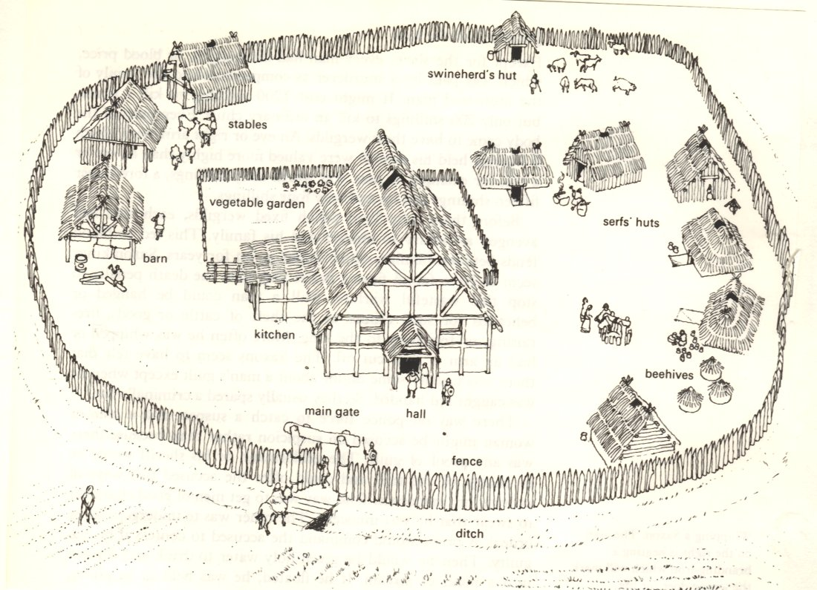

*Eboracum*

On Friday and Saturday nights the Druid man and the people of the village made ceremonies and sacrifices to pray the sun and the moon, their natural immortal gods in Nemeton, the sacred area of the village. The youth could learn a lot about life: respecting nature, the stars, their motion and the power and the majesty of their immortal gods. The most important learning was love for nature and respect for all that it could offer. Their priest, the Druid religious authority was not only a priest but a legislator, too. He was able to understand and explain the ancient laws he had learnt by heart along his life. He taught about the traditions of their people, the stories of their gods and heroes, the ancient wisdom of herbs, special medicaments and spells. He knew how to interpret the future, the destiny of men and Gods’ will.

Their life was hard and difficult. They had to face sudden dangers and therefore surrounded their villages by defensive fences and deep ditches. Their fence protected them for years and years, but lately it was becoming useless!

Hills, forests, meadows, pastures and rivers characterized the Eboracum’s land so people used to cultivating fields, hunting and fishing animals to survive. There were many mines so men used to extract minerals to fashion iron, bronze, silver and gold and realize artefacts.

After this short introduction about the way of living of people I’m going to tell you my unexpected journey.

On Monday morning I was awake and after a good breakfast, I went into the forest over the hill to collect firewood with my older brothers.

I had 12 years and so I had to help my family: bringing to pasture animals, collecting firewood, hunting animals and taking care of my brothers. While we were doing the job, we could hear some voices that we could not understand coming from the forest so we hid a bit scared to the bushes. We could see an incredible scene: a group of Roman soldiers was digging a long ditch wide 7-8 feet and deep one arm. They had been working hard all day and they sometimes stopped to quench their thirst drinking from sheepskin’s bottles.

We were frightened at this scene because we didn’t know what was going on, so we ran away and we went to our village, where our father was training using swords with other warriors. We told him what we had seen. He reassured us telling that it was the construction of one of the Roman roads which now crossed the whole country.

I was still worried so I went to my hut with my father, where he explained me that the men of the village had controlled the Romans for a long time. He told me to not be worried because during this period, the Romans would have built many roads for military, political and commercial purposes. The roads were a good innovation for Britain peoples, the Romans and their army, because they allowed us to move faster.

I was curious and fascinated so I asked to my father if he knew how the Romans built the roads. He told me that initially they dug a ditch, then they filled it with layers of earth, stone and sand until they reached the level of the ground.

At the end the whole was cemented with the mortar. In addition they built channels for drainage of rain water on the sides of the ditch.

Listening to my father, I realized the Romans were more expert than Britain peoples. We had to resign ourselves to the presence of the Roman army.

We spent the rest of the day playing war and imagining the defeat of our invaders.

Days went by, and after spring, my father told me that he had decided to send me to Londinium with my uncle and other men of the village. My uncle knew how to fashion metals and he was highly skilful in working them. He forged gold jewellery and other precious objects of all kinds. He decided to try to sell their goods in Londinium which later the Roman invasion was becoming an important harbour and it was expanding immoderately. I accepted willingly the request imagining the adventurous journey that I could take and the wonders that I could learn.

The preparations for the departure lasted several days. We loaded into the wagon some foods and artefacts that my uncle wanted to sell. In those days I often saw my mother who was bursting into tears for my departure.

The day of the departure arrived soon. It was the dawn of a warm summer day, the caravan, consisted of four wagons pulled by cows and 12 men, left. It was the start of a long yourney. We reached Londinium using Roman roads: they were comfortable, fast and safe.

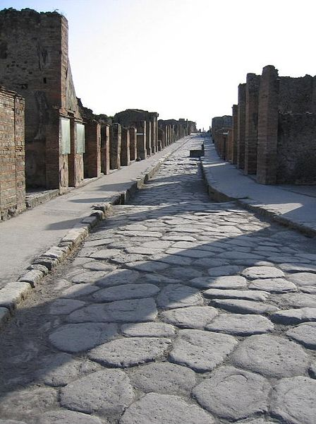 *Roman road*

The journey lasted several weeks. During the day we travelled and during the night we settled on the near woods or we found hospitality in the villages.

During the journey I made interessant discoveries: in clearings, at strategic points, the Romans had set up camps to offer hospitality to their legions. The camp was organized into some tents of different sizes that were made of animals’ skins and there were often wooden constructions.

The camp was preferably constructed near watercourses, woods and meadows so they could get supplies of water, timber and forage.

The Romans were also skilful in building bridges over rivers: I was amazed and admired.

One day we were fording the river with difficulty... when we could heard screams behind us… a group of armed men was attacking toplunder us: they were Celtic warriors.

They looked aggressive and wild. They were robust, their face was painted in blue (the colour blue was obtained by the plant called *Guado*) and they had got long hair. They wore red clothes and they were armed with swords, lances, shields and helmets.  
We defended ourselves with ferocity.

I put into practice all the techniques of fight that my father had taught to me and my brothers during the long winter evenings.

Finally we managed to scare off the warriors and save almost all of our precious cargo. This adventure allowed me to prove that now I was not a child. I was becoming a man!

The journey ended when we arrived in Londinium… what I saw was wonderful! In that moment I remembered when the Druid man told me the stories about Londinium’s growth with the arrival of the Romans. One time a young boy was compelled to leave our village and his family and go to Londinium.

Before the arrival of the Romans, Londinium was a settlement of people composed only by wooden buildings. The Romans turned it into an important commercial centre. They built roads and infrastructures to make it similar of “Rome”, their native land.

The boy had to help the Romans to expand Londinium’ territory building different public buildings that he had never seen before. In particular, he realized the construction of a bridge that allowed people to cross the river without getting wet.

When I could see what the Druid man had told me I felt shocked and amazed!

My uncle found accommodation at an inn: the couches were less comfortable than them we had left in my village, but we ate very well and drank some water.

I ate a good broth and a good wild meat.

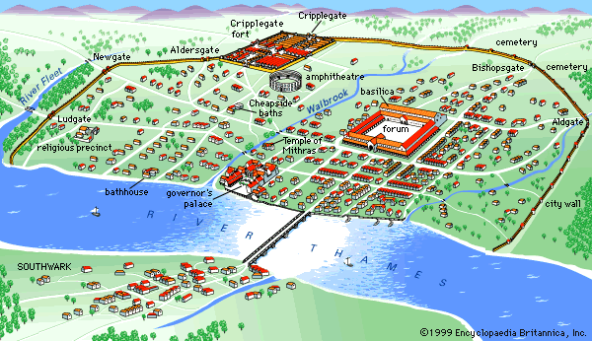

*Londinium*

That evening, when I went to bed, for the first time I felt homesick so I wanted to return to my home and see my mother.

The next morning my uncle left me free to explore the city. Walking through the alleys, I came to the river. It was the largest river I have ever seen, which the Romans called “Tamesis”.  
Its large bed was crossed by boats of various types and some merchant boats were anchored in the harbour.

The merchant boats were large about 10-11 steps and long about 25-26 steps. The dimensions were suitable for the transport of large quantities of goods.

The Romans transported oils, spices, cereals and products coming from their lands in large containers, which they called “amphorae”.

The Romans realized that the transport of goods by sea was more convenient than by land: in this way the voyage was fast and secure enough.

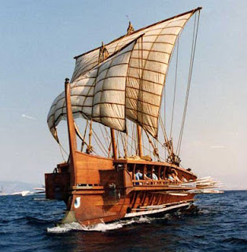 *Roman boat*

As a matter of fact, my uncle decided to barter the artefacts that he had forged in exchange for some Roman products. He hoped to gain something in order to live better.

While my uncle was working I explored the inside of the city; there were different buildings that I had never seen before. An enormous public building collocated in the centre of a square fascinated me. The Romans called it “Forum” or civic centre. It was always crowded with people. The Romans used it to discuss political, administrative and economic affairs.

In addition the “Forum” gave access to the “Basilica”. It was a law court and a town hall.

There was a “Thermae” (Roman bath) which was a centre not only for bathing, but also socializing. I was astonished at looking how the Romans could project complex systems of town planning and architecture. They were supplied with water from the Thames. The water could be heated by a log fire before being channelled into the hot bathing rooms.

There were some buildings where people went to pray their Gods. The major ones were the temples of Jupiter and Isis.

The Roman fort, collocated in the outskirts of the city, had a lot of importance. It was the place where the Roman legions stayed for training.

Londinium had also an “Amphitheatre” ,circular in shape, used by the Romans for public events such as gladiator fights, chariot races, venationes (animal slayings) and executions.

I noticed that the Romans spoke a different and strange language from mine: it was the “Latin”. I didn’t know neither read nor write, but I realized that the Celts, who lived in Londinium just before the arrival of the Romans, had learnt from them how to read and write. So the Romans hadn’t brought only building-innovations in these territories but they had changed the Britain’s culture. My culture was characterized by oral traditions, on the contrary the Romans used to write their traditions and customs. I was interested in learning how to read and write, so during my stay in Londinium, I had learnt it. I realized that one of the major Romans’ skills was that they were able to convert the local people from Celtic warriors and Druid men into Romanised people.

However the Celts kept the use of their language. I noticed that many Latin words were incorporated into Celtic language but the Latin was not spoken by the Celts.

I had been living in Londinium for two years, but one morning I woke up listening a big confusion coming from the forum. I went there to see what was happening and I saw that a mass of people was waiting someone very important, who was appositely coming from Rome.

I saw an imposing man on a horseback arriving to the forum. The crowd was screaming: “Adrian, Adrian is coming!”. He was the Roman Emperor Adrian and beside him Roman legions were following him. He greeted the crowd and gave orders to the legions.

At that moment, I realized that the Roman soldiers wanted to go back to my lands.

I reported what I had seen and I had listened to my uncle and we decided to leave as soon as possible from Londinium in order to return to our village and warn people of the arrival of Roman legions and a possible attack.

We prepared the caravan, and a few days after the departure of the Romans, we left Londinium. Taking advantage of new roads that the Romans had built, we arrived quickly to our village.

The Romans had already taken possession of the land not far from my village and they were building a construction.

The Romans’ intent was not to attack the village but to protect ourselves from the raids of Pitti’s tribes, who came from Caledonia. Hadrian’s wish was to keep intact his empire. As a matter of fact, the Pitti threatened the villages of these territories for a long time.

After three years the Romans completed that immense construction that they called Hadrian's Wall, in honour of the emperor Hadrian who started the construction. The wall was large 3 steps and high 5 steps.

The Romans invaded Britain’s lands and obliged us and other Celtic people to administer territories according to their political and administer organization but they also brought innovations (for example they created a network of communication) and so they improved our conditions of living (people could finally move).

They were able to change the way of living of people and the land where people lived.

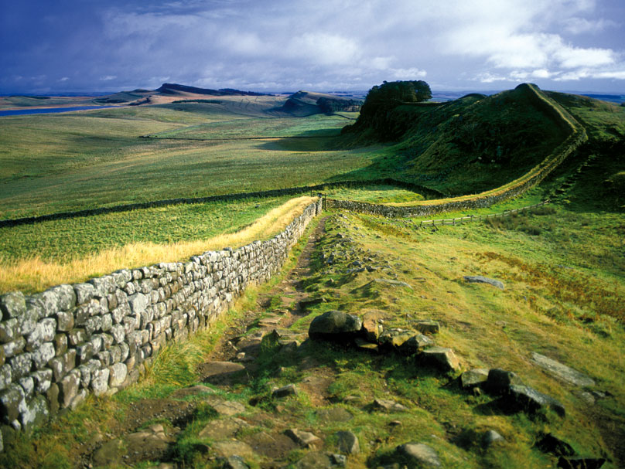

*Hadrian’s Wall*

Lavoro a cura di: Ballarin Kristina, Decorte Aurora e Formentin Luca