**The NUN OF MONZA**

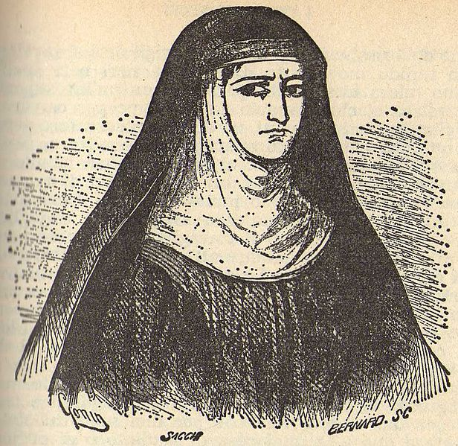The Nun of Monza is a tragic figure, a bitter, frustrated, sexually deprived and ambiguous woman. She befriends Lucia and becomes genuinely fond of her, but her dark past haunts her. This character is based on an actual woman.

Through her back-story we learn that her religious vows didn't stop her physical urges, and she had a relationship with an evil aristocrat, Egidio, who pushed her to become his accomplice in the murder of a nun: this is her tormenting secret. The principal female characters, Agnese and Lucia, meet Gertrude (The Nun of Monza) while escaping from the villain Don Rodrigo. They shelter in her convent, looking for hospitality. Gertrude becomes close to Lucia. Egidio asks her to help him to kidnap Lucia on behalf of the bandit *Innominato*, who is working for Rodrigo. She refuses, and instead helps Lucia. Her decision is difficult for her, emphasizing Manzoni's view of her as a weak tool of evil, unable to resist threats and temptations, but basically not cruel. Later in the novel, at the end of Chapter 37, Lucia learns of Gertrude's repentance, confession of guilt, and consequent sentence.