*Christmas Time*

**A tradition that will never die**

People love Christmas songs

Christmas is one of the most important feast day for the

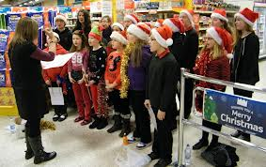majority of the world. It is celebrated on the 25th December.

In this festivity Christian people celebrate the birth of Jesus that is them God.

There are various tradition about Christmas day like Christmas trees and Christmas decorations. People decorate their homes with a lot of lights, mistletoe, holly, little Christmas balls and Christmas trees.

A choir sings Christmas songs in a shopping centre

Children believe that Santa Claus arrives on Christmas night and brings with him a lot of presents for everyone. This is one of the most famous traditions.

Moreover people sing Christmas songs together. The texts of these songs are usually about Santa Claus and love but many deal with the birth of Jesus. Some famous songs related to this period are: Carol of the Bells, Jingle Bells Rock, Happy Xmas (War is over), Last Christmas, Santa Claus is coming to town and Let it snow.

Everyone sing on Christmas. Christmas songs make people stay together and inject enthusiasm into them. People that have a stressful, an hectic, or a difficult life during the year can relax on Christmas period and Christmas songs instil hope about a better life in their selves: this is why people will never stop to sing on Christmas.