**Religion**

**An important mission**

**The arrival of Christianity in Great Britain**

Christianity spread over Great Britain during the 5th and 6th centuries, thanks to the effort of Roman bishops and Celtic and Anglosaxon missionaries.

After the Romans left in 407 AD, the Saxons, the Angles and the Jutes, who were Anglosaxon peoples, invaded Britain. They came from Germany and Denmark and they were farmers, hunters and fishermen. Their culture was not a written one and they practiced polytheistic cults.

In the following two centuries the arrival of Christianity was the most relevant event.

Gradually Roman bishops and missionaries of Celtic (Irish and Scottish) and Anglosaxon origins devout themselves to evangelization of pagan and Aryan populations.

During this period, the so called “Roman Christianity” met the “Celtic-Irish Christianity” that was practiced by Irish abbots in monasteries.

The most influent Irish abbot was San Colombano, because he built hundreds of monasteries or churches and because he diffused Christianity in the whole Europe during his journeys. Anglosaxon monks acquired the desire of “*peregrinatio pro Christo*” from him, that is the passion that leaded the missionaries in their effort.

The first missionary centers were ancient Episcopal Roman towns, while in Ireland, devoid of cities, the monastic institutions became the centre of ecclesiastic organization. Monks­ – priests departed from the Irish monasteries to found churches and chapels in the whole Europe.

**Canterbury Cathedral of today**

In particular, in Britain, the Anglosaxon peoples were evangelized from the VI century thanks to Saint Augustine. He founded the diocese of Canterbury, that became the religion centre of the new cult.

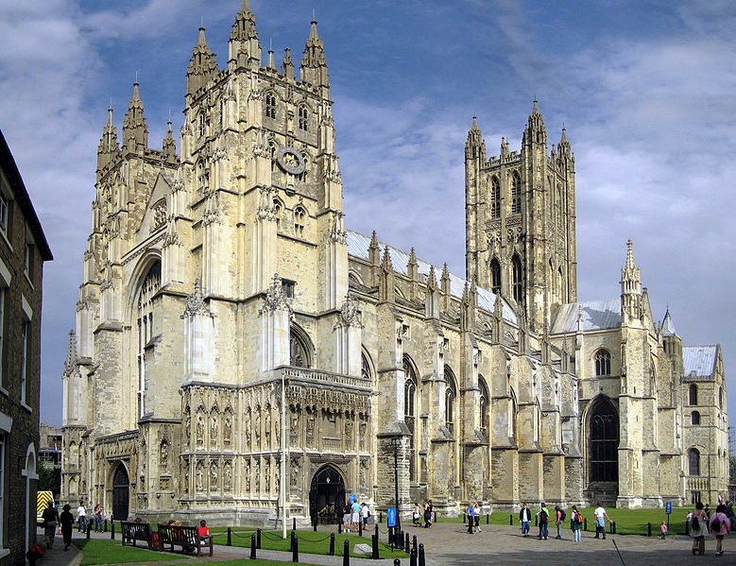In 597 AD Pope Gregory sent a group of about 40 men led by monk Saint Augustine to Kent. King Aethelberht of Kent permitted the monks to preach in his kingdom and in time he was converted. Meanwhile in 627 King Edwin of Northumbria (the North of England) and all his nobles were baptized. The other Anglosaxon kingdoms adopted Christianity following the example of the frist two: in 630 a Christian called Sigeberht became King of East Anglia; Pope Honorious sent a man to convert the West Saxons; missionaries also preached in the kingdom of Mercia (the Midlands) and in 653 King Paeda of Mercia was converted and baptized too and gradually the realm was converted.

The last part of England to be converted to Christianity was Sussex. The conversion of the Saxons turned out to be the most difficult mission, but they finally adopted the new cult after Carlo Magno’s conquest in 804 AD.

In 664, during a council that took place in Whitby, the Celtic and Irish Church adapted to the Roman traditions.

Finally by the end of the 7th century all of England was at least nominally Christian. However some people continued to secretly worship the old pagan gods as late as the 8th century.

The evangelization of northern Germanic tribes followed: it started in the IX century with the conversation of the Danish King Harold I (in the 826) and it finished in the XI century.