# The joy of the music

**Christmas carols**

Carols initially had started as Pagan songs for celebrations such as midsummer, harvest and Winter solstice, during which people used to sing and dance round stone circles.

The Church attempted to curb Pagan practices giving Christian meaning to popular customs. Indeed by the late medieval period the Church took up these Pagan songs and made them a Christian tradition of Christmas.

Soon many people lost interest in singing Christmas carols because they were written and sang in Latin: a language that normal people could not understand.

This was changed by St. Francesco of Assisi, in 1223, when he started his Nativity Plays in Italy. During the performances actors sang carols about the Jesus’ birth in a language that the audience could understand.

These carols immediately spread to France, Great Britain, Spain, Germany and other European countries.

In England, when Oliver Cromwell and the Puritans came to power in England in 1647, the celebration of Christmas and singing carols was stopped. Anyway carols survived since people sang them in secret.

Carols remained mainly unsung until Victorian times, when two men called William Sandys and Davis Gilbert collected lots of old Christmas music from villages in England.

Before carols singing in public became popular, there were sometimes official carols singers called “Waits”, because they only sang on Christmas Eve which

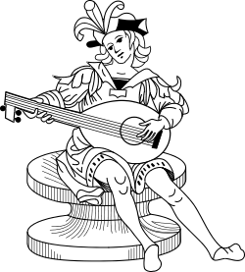

was sometimes called “waitnight”.

Besides, at that time, many orchestras and choirs were being set up to sing carols and this increased even more their popularity.

The most famous Christmas carols, known in all over the world, are: “I saw three ships on Christmas day”, “The twelve day of Christmas”, “Jingle Bell”, “Silent night” and “Adeste fidelis”.