**TIMELINE**

**The most relevant personalities and events from the War of the Roses to Elizabeth I**

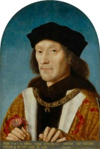

Mistress Anne Boleyn pregnancy

Henry VIII and Catherine had one daughter (Mary) 🡪

No male heir

1485

1509

1501: Marriage between Arthur and Catherine of Aragon

Marriage between Henry VII and Elizabeth of York

**HENRY VII:**

- Power consolidation;

- Treating with France;

-

Henry VII founded the new Tudor dynasty

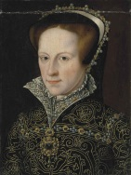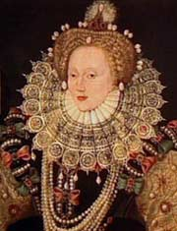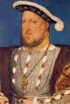

**D. ELIZABETH I:**

- Strong personality and intelligence;

- Excellent education;

- Restoration of Protestantism;

- Unmarried 🡪 Cult of the “Virgin Queen”;

- Unity and defense of England;

Repression of Spanish invasion (1588)

**HENRY VIII:**

- Chivalry and education;

- Female household;

- Sportsman;

- “*Golden Prince*”;

- Rainforcement of England trading position;

- Abilities as a business man

“*Bloody Mary*”; she wanted to restore England to papal obedience; Catholic marriage; deserted.

1603

1558

1521

1522

1547

Act of Supremacy: Foundation of the Anglican Church

1534

Request of divorce

1502: Arthur’s death

Henry VII was granted the title of “Defender of the Faith”

**WAR OF THE ROSES:**

Lancaster VS York

 

1453