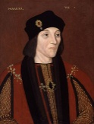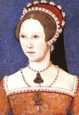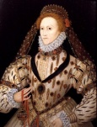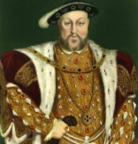

Defeat of the Spanish Armada (1588)

and she defeated England’s enemies at home and abroad

* Excellent education
* Politcal genius
* Church of England restored the country firmly to Protestantism
* Granted Catholics freedom of worship
* Virgin Queen
* belived herself to be the agent of a counter – refermation
* refused to abandon her own faith
* she took the nickname of “Bloody Mary”

Marriage to the Catholic Philip of Spain

Henry VIII and Catherine of Aragon (one daughter and no male heir)

Act of Supremacy and “Supreme head of Earth of the Church”

(1534)

* sportsman
* golden prince
* chivalry and education
* defender of the faith
* female house hold

Marriage between

Arthur and

Catherine of Aragon

(1501)

* turned England into a modern state
* administrate like a business man
* rainforcem of trading postion
* foundation of naval power

**The Wars of**

**the Roses**

[Lancaster

vs York]

Marriage between

Henry VII and

Elizabeth of York

1455

1485

1509

1547

1558

1603

Elizabeth I

Mary I

Henry VIII

Henry VII

***TUDORS DYNASTY***