[**C C**](http://www.tracker-software.com/buy-now)

CHAPTER

1

CHAPTER

2

CHAPTER

3

CHAPTER

4

CHAPTER

9

|  |  |
| --- | --- |
| CHAPTER  8 | |
|  |  |
| Changez faces a man who refers to him with a racist sentence that expresses hate for Muslims. | |

CHAPTER

10

CHAPTER

11

|  |  |
| --- | --- |
| CHAPTER  12 | |
|  |  |
| conclusion is about the return of  Changez in his homeland Laore. | |

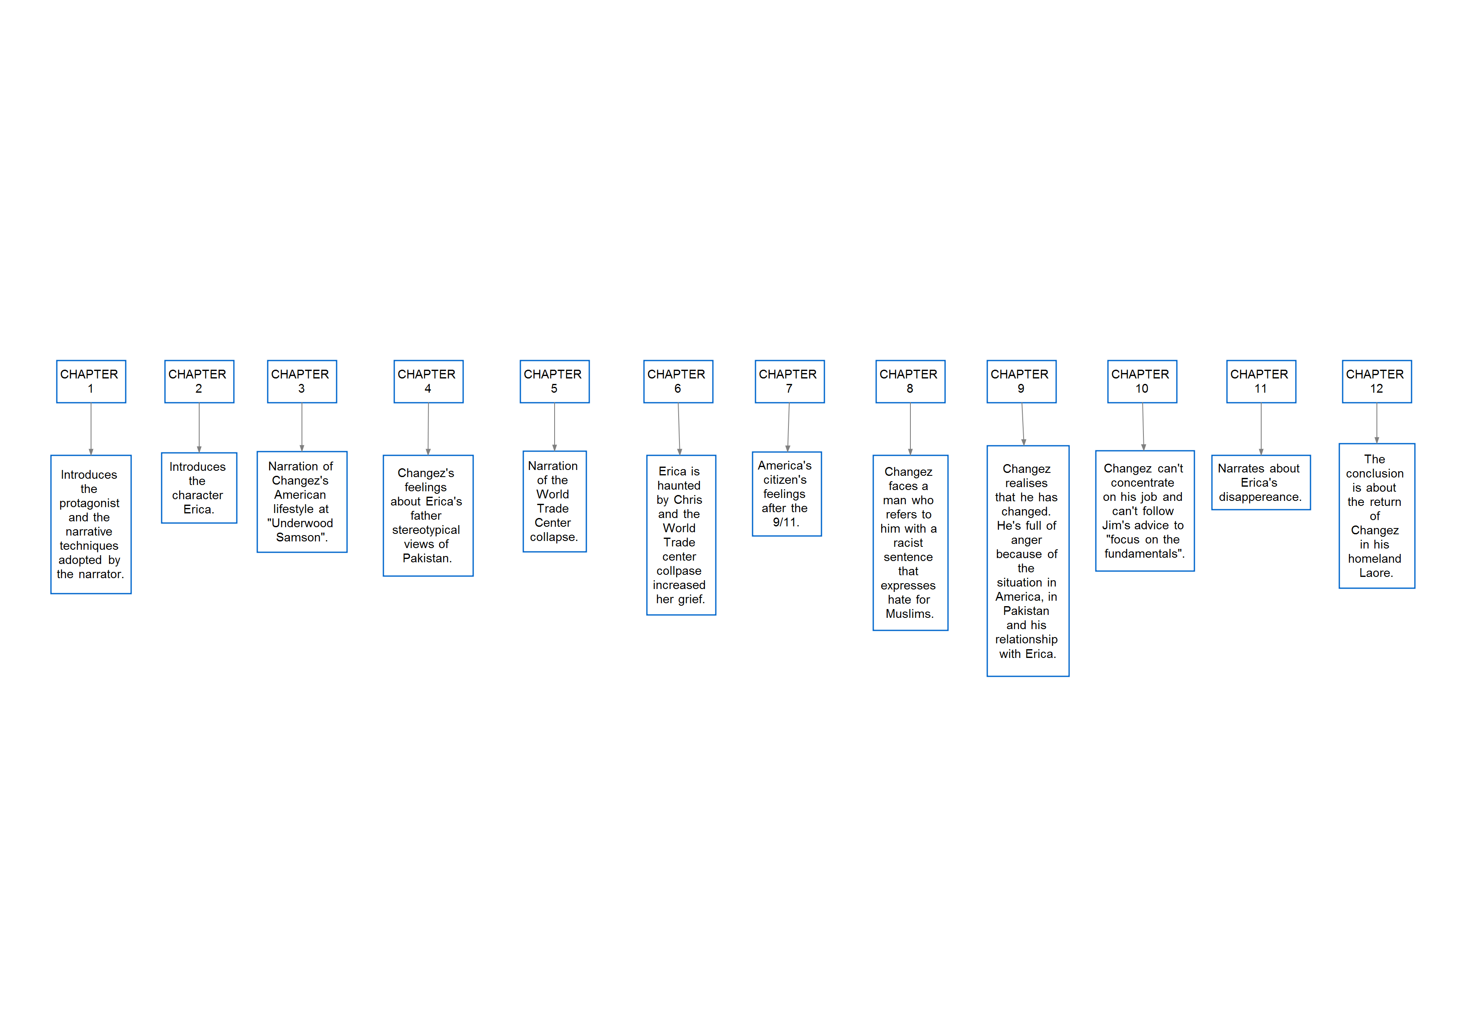

|  |  |
| --- | --- |
| CHAPTER  5 | |
|  |  |
| Narration of the World Trade Center collapse. | |

|  |  |
| --- | --- |
| CHAPTER  6 | |
|  |  |
| Erica is haunted by Chris and the World Trade center collpase increased her grief. | |

|  |  |
| --- | --- |
| CHAPTER  7 | |
|  |  |
| America's citizen's feelings after the  9/11. | |

Introduces the protagonist and the narrative techniques adopted by the narrator.

Introduces the character Erica.

Narration of Changez's American lifestyle at "Underwood Samson".

Changez's feelings

about Erica's father stereotypical views of Pakistan.

Changez realises

that he has changed. He's full of anger because of the

situation in America, in Pakistan and his relationship with Erica.

Changez can't concentrate

on his job and can't follow Jim's advice to "focus on the fundamentals".

Narrates about Erica's disappereance.