Ricordiamoci dell’11 settembre

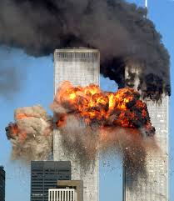The poem is an extract from “*Il* *fuoco che produce luce e fumo*” (2001). It has been written by Giuseppe Conte. It would has to be a response to the facts of 11th September 2001: terrorists attacked the United States. The hijacked four airplanes in mid-flight and flew two of the planes into skyscrapers, the Word Trade Center (also known as Twin Towers), in New York City. Another plane crashed into the western wall of the Pentagon in Arlington, Virginia.   
  
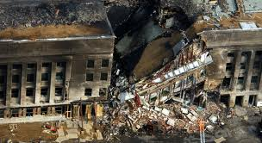

The poem in made up fifteen verses arranged on five “endecasillabi”.

Just looking at the title (that is also the opening verse of the poem) the reader can imagine what the poem is about: indeed 9/11 represent in everyone’s mind a clear cut in world history and attacked the U.S.A. as superpower at her deepest.  
The verb “ricordiamoci” implies a reflection on death and peace. It is interesting to notice the use of the first plural person: the writer is speaking directly to the readers and puts himself at the very same level of them. The writer’s aim is to say that everyone is equal in front of suffering.

With a first reading the reader becomes immediately aware of the strength of the phonological level.   
In the second verse there is assonance of the sound “fu”: “fuoco” and “fulmineo”.   
The third verse presents assonance too: “carburante” and “carne”.  
Words like “fuoco”, “fulmineo ”, carburante”, “carne”, “nebulosa orrenda” “sangue” “materia celebrale” ring out brief and fast. They convey the idea of something unpleasant.

Here the phonological level determinates the semantic field: indeed the feeling is provided also by the meaning of the words. All of them remind to semantic field of pain and suffering.

The words “cerebrale” and “mortale” (in the fourth and fifth verse) present a rhyme.

There is a contraposition between a “nebulosa orrenda di carburante e carne, di sangue e di material celebrale” and “fumo grigio, mortale, […] d’odio e di buio”. Just reading the two sentences the first one seem to materialize in front of the reader’s eyes. On the other hand the second sentence concerns the semantic field of metaphysics because of the use of the adjective “mortale” and the substantives “odio” and “buio”.

The word “apoteosi” reminds to something you cannot control, almost divine. “Polvere” is the only thing remained after the attack. Indeed the expression “apoteosi della polvere” edescribes a situation of human’s impotence, that men could not modify.

The text presents the antithesis between “Inferi” and “Dio” that recalls to an eternal and supernatural fight: it symbolizes the contraposition between evil and good. Once again the human being is powerless, incapable to react.

The first part of the poem (lines 1-10) describes the horror of the attack to the World Trade Center, using a visual vocabulary that present the scene to the reader.

The following part is an appeal to not forget 9/11.  
The assonance “Preghiamo preghiere” recalls religious contest. The writer deals with the theme of different religions: he says that whomever would be one’s God, He has not to be provided as justification for Human’s bad actions.