EDUCATIONAL TRIP ITINERARY

Work group: Beltramino Davide, De Luca Alessandro, Ferro Giada, Franco Riccardo, Vianello Luca

Thursday, 4th February
- 9.00 lessons at ISI school;
- 12.45 lunch;
- 14.00 visit to: Dublin Castle, Chest Beatty Library and St. Patrick Cathedral;
- 17.00 meeting at the Spire;
- 17:30 back home;

On the 4th of February we had to be at school at 9,00 o’clock, so we left approximately at 8:15 because the journey from our houses to ISI school took about 40 minutes (20 minutes by bus and 20 minutes on foot).
From 9:00 to 12:45 we took English lessons with our teachers Michael and Madeleine, then we had our packed lunch in the canteen until 14:00.
After lunch our guide took us to the Dublin Castle. The Castle is made up of two buildings: the oldest one built at the end of 13th century, the most recent built at the end of the 17th century after the burning of the original one.
Near the castle stands Chest Beatty Library with its big circular garden where even helicopters are allowed to land. The library is organized in two sectors, “Sacred Traditions” and "Artistic Traditions", and it is full of illuminated manuscripts, prints, drawings and famous books from different religions and cultures.
After visiting the library we followed the guide to St. Patrick Cathedral, a Protestant church founded in 1191.
At 17.00 the guide led us to the Spire where we took the bus and went back home.
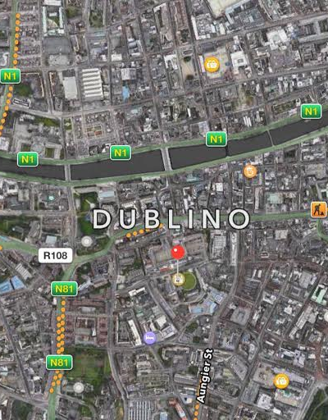
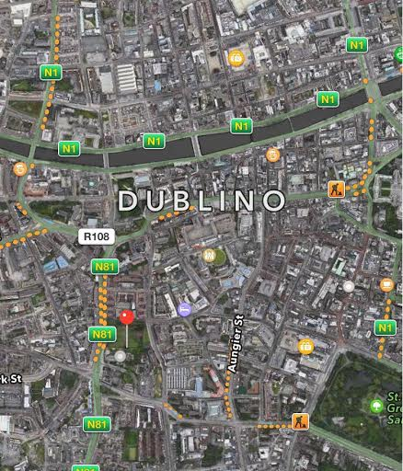
The Chester Beatty Library
St Patrick Cathedral
Dublin Castle

EDUCATIONAL TRIP ITINERARY

Work group: Beltramino Davide, De Luca Alessandro, Ferro Giada, Franco Riccardo, Vianello Luca

Friday, 5th February
- 9.00 lessons at ISI school;
- 12:45 lunch;
- 15:00 James Joyce’s centre;
- 16:15 back home;

On the 5th of February, like the other mornings, we took the bus to school. We started our lessons at 9 o'clock a.m. and we finished at 12:15 p.m.
We had our packed lunch at school. At 2:30 p.m., our guide led us to the James Joyce’s centre. It was booked for 3:00 p.m.
It is a museum dedicated to the life and the works of the Irish poet James Joyce. It exhibits also his furniture from his apartment in Paris. There are also some black and white paintings drawn to represent some of Joyce's quotations. In another room there are paintings of him and his relatives. In the upper floor there is a video about his life. At 4:15 p.m. we left the museum and went to the city centre where you can see James Joyce's statue. It was a rainy and windy day so we decide to go home early.

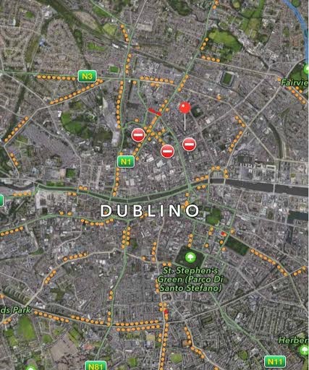

James Joyce Centre

EDUCATIONAL TRIP ITINERARY

Work group: Beltramino Davide, De Luca Alessandro, Ferro Giada, Franco Riccardo, Vianello Luca

Saturday, 6th February
- 9:30 meeting at Clarehall shopping centre;
- 11:30 visit to Monasterboice Monastic Site;
- 12:30 Belfast;
- 13:00 museum of Titanic;
- 14:30 visit to the city centre of Belfast (City Hall and Victoria Street);
- 16:00 meeting to return home;
- 18:30 arrival in Dublin;

On the 6th of February we didn’t go to school because Dubliners use to stay at home on that day. We had a different day, because we went to Belfast. We met ad 9:30 at Clarehall shopping centre. There we took Paddywagon bus. It was not an ordinary journey because while we were going to Belfast our driver explained to us some news about Dublin, Belfast, Monasterboice Monastic Site and the Museum of Titanic.
In the middle of the journey we took a break of about 10 minutes to visit Monasterboice Monastic Site, a small cemetery with Celtic Crosses.
Later we took the bus again and we went to Belfast. We visited the Museum of Titanic: we saw different things about that famous ship. We experienced how people lived in the Titanic with a realistic equipment and we saw where passenger slept. Some videos told about the recovery of the Titanic and about how the world reacted the accident. We had our packed lunch and we left the museum at about 2:00 p.m.
After that we went to the centre of Belfast by bus. We visited the city that is smaller than Dublin. We had a coffe in a bar and we walked along Victoria street and we saw the famous City Hall.
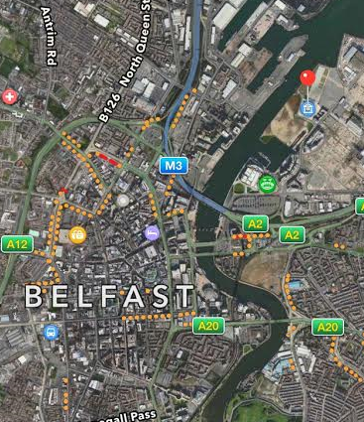
It was a rainy day so we could not see so much. At about 4:15 p.m. we took the bus to go back to our families in Dublin. There was a beautiful setting when we came back. At about 6:30 p.m we arrived in Dublin and then we went to our houses. We had dinner at home and then we went to bed.
Museum of Titanic

