THE WAR AND THE ROLE OF WOMEN TRACED THROUGH D.H. LAWRENCE’S **THE FOX**

The following work is aimed at recognise five common keywords, related to the war and the role of women during the First World War, in the short story “The Fox”.

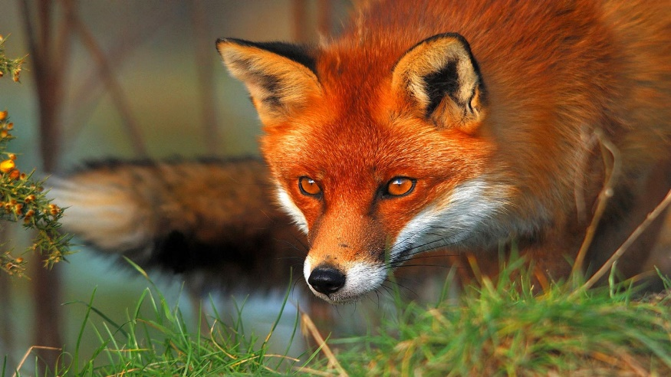

THE FOX

* Introduction to the story- **A brief Summary**

The fox is an engaging short story written by D.H Lawrence in 1922. It provides the reader strong images of two women’s life, Nellie March and Jill Bandford’s, who are near thirty, during the First World War.

Their life is a rural one: they manage a farm in the English district of Berkshire in order to survive, trying to be independent. It is possible thanks to a humble inheritance but it is not a sufficient condition to make them rich or just economically harmless. They constantly do their best although the negative results, trying to maintain a marginal livelihood at the Bailey Farm and leading a monotonous life.

But suddenly, a man, the soldier Henry Grenfel, supplants in their customary and upsets their previous order. He causes them distress dealing with the mutual relationships between them. So, Henry’s sly presence on the farm upsets the affectionate harmony that previously existed between the two women. Therefore, the story treats the psychological relationships of three protagonists in a triangle mating-complex of love and hatred. Another interesting figure of the novel is the fox, by which the story takes its name. The fox is a disturbing element for the two women’s life and work, because he decimates hens and similar animals the women raise and by which they obtain their sustenance. Nevertheless, what is really interesting in such character is his “behaviour” towards March, who is captured by his eyes and his penetrating gaze and stare. The fox is a crucial symbol of the story indeed, he is not just an animal, but he stands for several other meaning, necessary to understand the message and the real links, connections and twists of the whole story.

The reader is so deeply captured by crucial scenes of suspense and expectations. Sure enough, it is a novel of both attraction and repulsion, stability and precariousness, which will end in a dramatic way, completely freaking the reader out.

* The **war** in The Fox

The Fox is set at the end of the First World War, so the reader may expect to discover some relevant elements in order to understand how living in England was during the conflict and which were the main resulting difficulties or possible comforts. In the whole story, even if the word “war” appears only four times, the intelligent reader understands that war is the background of the entire plot.

Now, I will report the whole sentences of the story I consider related to the war and then I will reflect on them, in order to rebuild the message D. H. Lawrence wants to convey regarding such theme.

* War conditions, again, were very unfavourable to poultry-keeping. Food was scarce and bad. (page. 2)
* Since the war, the fox was a demon. (page. 2)
* Banford gave a loud cry(page. 5)
* A young soldier, with his heavy kit on his back. (page. 5)
* The young man--or youth, for he would not be more than twenty--now advanced and stood in the inner doorway (page. 5)
* Having his heavy sack on his shoulders (page. 6)
* seeing something boyish (page. 6)
* 'Well--from Salonika really.' (page. 6)
* 'Ay,' said the youth. 'We've seen enough of rifles.' (page. 7)
* Rapidly and carelessly she prepared the meal, cutting large chunks of bread and margarine--for there was no butter. She racked her brain to think of something else to put on the tray--she had only bread, margarine, and jam, and the larder was bare. (page. 7)
* 'There's nothing but bread and jam,' she said. (page. 8)
* He was such a boy. (page. 8)
* Also he ate largely and quickly and voraciously (page. 8)
* It appeared he was Cornish by birth and upbringing. (page. 8)
* 'Yes, but there won't be any demand for women land-workers now the war's over,' said the youth. (page. 8)
* For the youth, sitting before the fire in his uniform, sent a faint but distinct odour into the room, indefinable, but something like a wild creature. (page. 10)
* Banford flew into the village on her bicycle to try and buy food. She was a hospitable soul. But alas, in the year 1918 there was not much food to buy. (page. 11)
* 'Well'--he hesitated--'at the "Swan" they've got this flu, and at the "Plough and Harrow" they've got the soldiers who are collecting the hay for the army: besides, in the private houses, there's ten men and a corporal altogether billeted in the village, they tell me. I'm not sure where I could get a bed.' (page. 12)
* He was a huntsman in spirit, not a farmer, and not a soldier stuck in a regiment. And it was as a young hunter that he wanted to bring down March as his quarry, to make her his wife. (page. 14)
* And suddenly it seemed to him England was little and tight, he felt the landscape was constricted even in the dark, and that there were too many dogs in the night, making a noise like a fence of sound, like the network of English hedges netting the view. He felt the fox didn't have a chance. For it must be the fox that had started all this hullabaloo. (page. 27)
* So she saw him off in the train that was going West: his camp was on Salisbury Plain. (page. 42)
* With this one fixed idea in his mind, he went to ask for twenty-four hours' leave of absence. (page 44)
* In that great camp of wooden huts and tents he had no idea where his captain was. (page. 44)
* 'May I speak to Captain Berryman?' The captain was Cornish like himself. (page 44)
* He was gone. The captain, upset, took a gin and bitters. Henry managed to hire a bicycle. It was twelve o'clock when he left the camp. He had sixty miles of wet and muddy crossroads to ride. But he was in the saddle and down the road without a thought of food. (page 45)
* There's no food . There's nothing here (page 48)

War is always depicted through indirect textual references, except in the first statements, where its conditions are spelt out. “War conditions, again, were very unfavourable to poultry-keeping. Food was scarce and bad” brings to light the main characters’ negative conditions of living, making the reader conscious of their misery and their lack of food.

The other piece of information the reader has throughout the reading of the story deals with Henry, who stands for a soldier. Some sections of the short story makes the reader conscious about the young man’s itinerary before and during the war and also about his origins indeed “he was Cornish by birth and upbringing”. Another interesting statement is “Also he ate largely and quickly and voraciously”, which reinforces the idea of the lack of food, which is so extended to the soldiers came back from the frontline. What is particularly underlined is his youth, since “he was such a boy”.

However, such pieces of information considered separately are not suitable to understand the writer’s point of view about the war. They seem just to underline some small details of a deeper matter, which are proper to denote the plot of the story, but not to build up an analytical reflection on the war. The elements given by the narrator could represent some [food for](http://context.reverso.net/traduzione/inglese-italiano/food+for) thought, so I will now identify the most relevant ones I discovered in the story.

Keywords about -**The War**-

In my opinion, the most relevant keywords related to the **war** are:

* Misery
* Scarceness of food
* Hardship
* Complexity of survival
* Emancipation attempt
* The **role of women** in The Fox

While tracing the author’s point of view regarding the war is very difficult, discovering the one dealing with women is considerably easier. It is evident since the entire story is focused on two women, their vicissitudes, their relationships and their everyday life. March and Banford are characterized throughout their actions, but also thanks to their thoughts and their feelings. Indeed, the plot is often interspersed with introspective and/or interior sections, looking inward in the women’s minds. It follows that they are not irrelevant or summary characters: they are the object of the whole story, the main focus and the point of convergence of the author’s reflection. Once established their important role, it is relevant to discover what it consists of. To do this, however, I should go back to the story and check over their position in the plot.

“They had taken the farm together, intending to work it all by themselves: that is, they were going to rear chickens, make a living by poultry, and add to this by keeping a cow, and raising one or two young beasts. Unfortunately, things did not turn out well”. This is the beginning and of the novel and I quoted it because it includes the most relevant elements dealing with the characters. They are alone, but they work together, driven by an ambitious goal: managing a farm. However, the implications of such desire and attempt is early moved up. Such choice reveals the writer’s purpose that is talking about two women’s failure.

You may think Lawrence to have negative opinion on women, but it would be a partial judgement, since the story tells also about their bid, their tenaciousness and their striving. Therefore the story could be also interpreted as a praise for the two women’s emancipation attempt. I agree with the latter interpretation, by a certain perspective, but going in depth, it is evident it not the only author’s purpose.

Moving to another sphere, the relational one, another side of March and Banford is developed. Indeed when a man joins their life, they result to be totally incapable. March, in particular, ends up subjugated by the man, by his desires and his power, not able to escape his chains. Banford tries to assert her opinion with all her might, but she succumbs to Henry’s brilliance and cunning, being swamped by a tree, intentionally cut by the man.

At conclusion, it is evident the writer brings to light some women’s qualities, virtues and values, but he does not omit their state of precariousness towards the male gender.

Keywords about -**The role of women**-

In my opinion, the most relevant keywords related to the **role of women** are:

* Emancipation attempt
* Bravery
* Precariousness
* Lack of ability
* Illusory independence

**Credits**

Francesca Pecorella

Class 5ALS