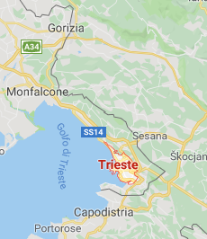
TRIESTE

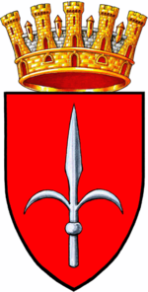
Paolini Carlotta
Piu Giada

Unità d'Italia square is the main square in Trieste, a seaport
city in northeast of Italy. Located at the foot of the hill with the castle of
San Giusto, the square faces the Adriatic Sea. It is often said to be Europe's largest square located next to the sea.
The square was built during the period when Trieste was the most
important seaport of the Austrian-Hungarian Empire and includes
the city's Town Hall.

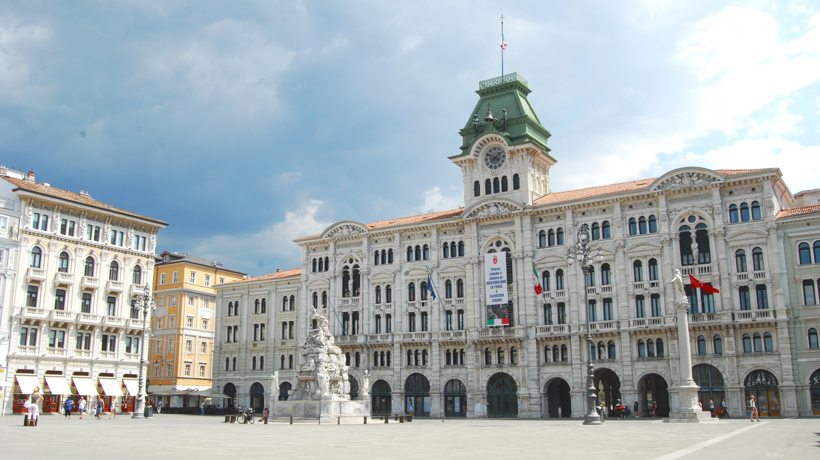

A few steps from the Unità d'Italia square there is the Molo Audace
with a breathtaking view of the Adriatic Sea, the spectacular sunsets
that seems to dive into the water and turn the buildings of the square red
and the city center.
During the Barcolana it is filled with beautiful boats.

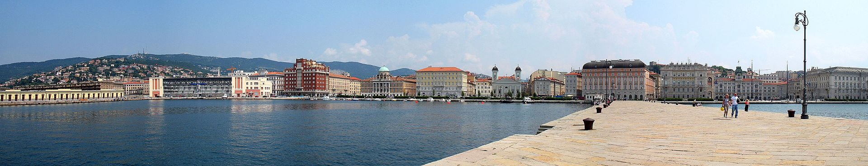

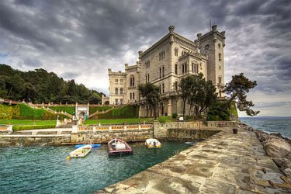
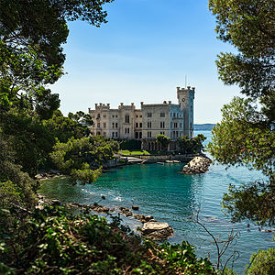

In Trieste you can visit a wonderful castel called
'' Miramare Castel'' located in the north of the city, on the gulf of
the same name.
The Archduke Ferdinand Maximilian of Habsburg and his partner
Carlotta of Belgium lived in the castel.
The castle's grounds include an extensive cliff and seashore park of 22
hectares designed by the Archduke.
You can also visit the inside of the castle where, on the ground
floor you can see the apartments of the royal couple.

Anyone passing by Trieste should visit the Risiera of San Sabba .It's a five-storey brick-built compound, that was used during World War II as a Nazi concentration camp for detention and political prisoners, and a transit camp for Jews.
You can remember what the prisoners had to face, through videos, testimonies and finds if you go there.
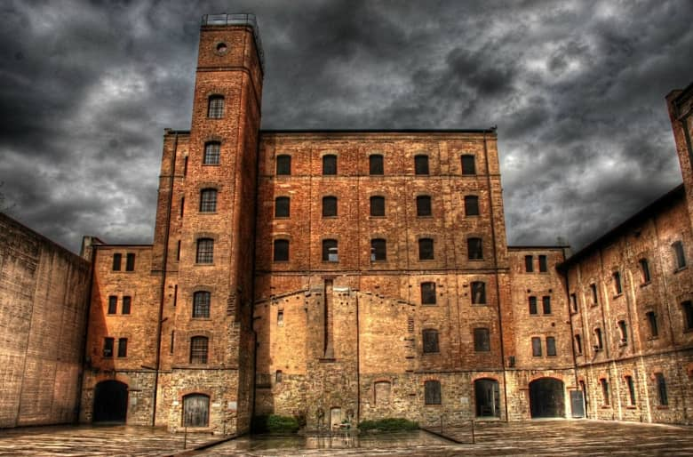

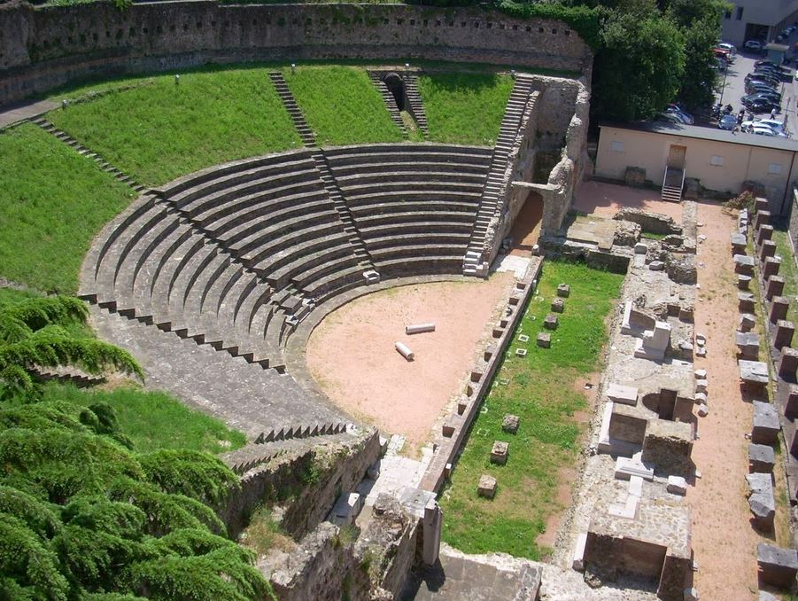

If you love Roman culture you can't miss the Roman theater of
Trieste in the heart of the city, at the foot of the San Giusto
hill. The famous cathedral takes its name from it.
Occasionally it is still used for outdoor summer shows.

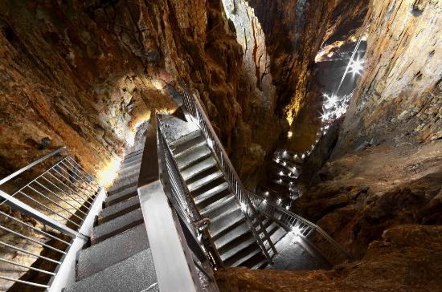
If you want to organize a different trip from the usual view and see a natureal
masterpiece, you must visit the Giant Cave in Trieste.
The cave contains many large stalactites and stalagmites,
many of exceptional beauty.
The most impressive stalagmite is Colonna Ruggero,
12 meters high. Sweatshirts and comfortable
shoes are recommended because you have to pass several steps.

Choose your ideal trip!

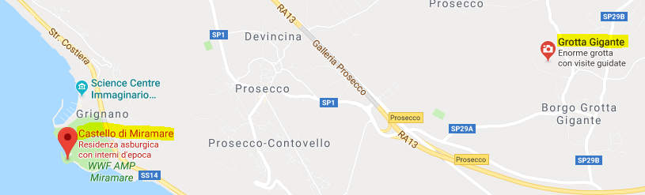



Miramare Castel

Giant Cave



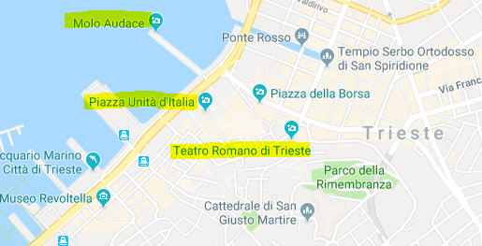

Molo Audace
Unità d'Italia Square
Roman Theater

