**GRAPHOLOGY: ANALYZING HANDWRITING**

The present work aims at sharing the results of the information gathered during the session on forensic graphology by the expert Ms. Sara Cordella, a forensic graphologist herself.

It is part of what goes under the name of “A learning session”, considered compulsory in the curriculum of italian state secondary schools.

The idea is to offer students an occasion to experiment what some job positions may be like so that the experience may work as guidance.

The professional profile of a graphologist is strictly connected with the interpretation of the way people write / the way one writes. It follows that a graphologist should be provided with documents, letters or other texts that represent the object of their interpretative work / should have access to the texts of who is the owner of the text under analysis.

The first section of the work will be devoted to illustrating the instructions and guidelines provided during the sessions. Indeed they are related to the different writing aspects of the texts under discussion.

The second session will offer some illustrating examples from different sources.

The third section will record our efforts: we translated the guidelines into an interpretative practice to show the competences were gained.

The conclusion will discuss the process work and its results commenting on points of strenght and weakness.

**OUR HANDWRITING’S ANALYSIS**

* *COLAUT’S ANALYSIS ON FORMENTIN’S HANDWRITING*

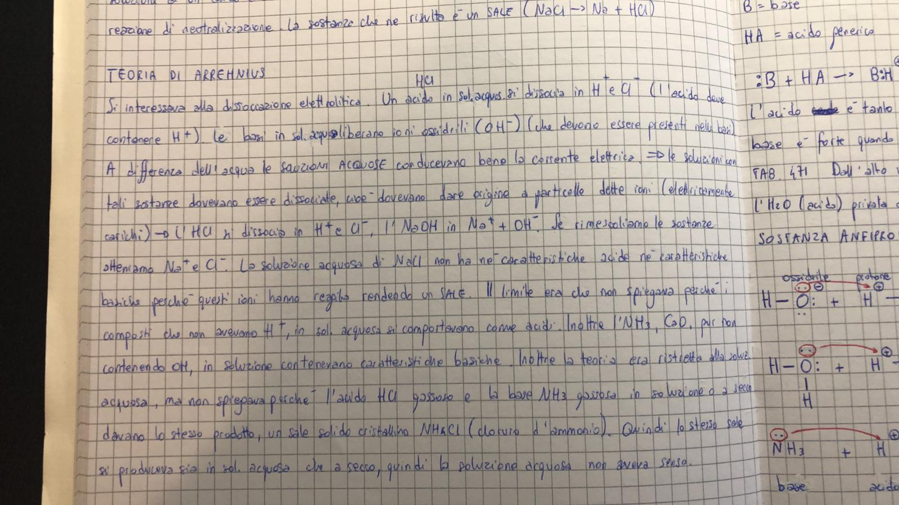

Even Formentin’s writing tends to spread either on the left and on the right side of the sheet, meaning that he is bond to the figure of the mother and the father and remembers the past and embraces the future. Then his letters develop in height and in low, so he is balanced between concrete things and creativity. Moreover the letters are angular, the angle represents the spermatozoon, the ability of survival and tenacity. His font calibre is small, so he hasn’t got an high tone, he has the ability of synthesis and he is aware about everything. The space between the letters is tiny so he is kind but at the same time he is a “closed person”, so he keeps things for himself. His writing is readable, so he doesn’t so round of words, his rods are straight, so he applies more pressure and he is rigid and strong willed. Finally his calligraphy is parallel and this aspect underlines that he doesn’t get tired doing things but he finds himself “stuck” when he is let too much free.

* FORMENTIN’S ANALYSIS ON SASSI’S WRITING

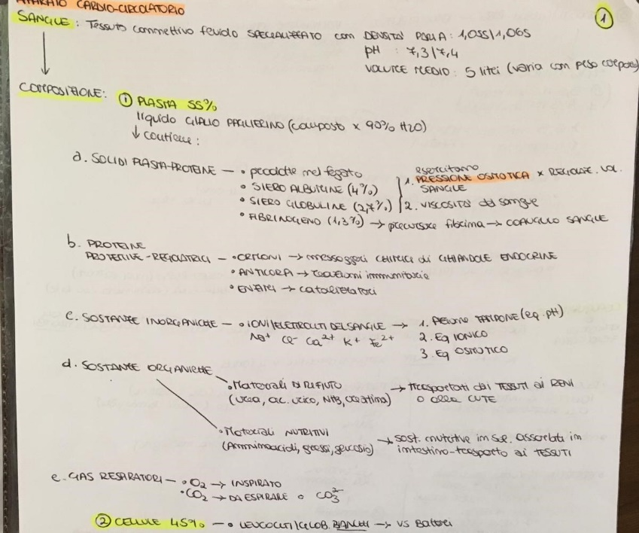

First of all, considering the distance from the borders, Sassi’s handwriting seems neither to tend to the right border, nor to the left one: such feature suggests she’s both attached to her father and to her mother, but she’s also independent. Also, the equal distance could mean she’s neither tied to the past and nor she thinks too much about her future. Then, one can notice there are not taller letters than others, and this could suggest a sort of balance in her mind between concreteness and abstract ideas sometimes. Going on with the analysis, one can say Sassi’s letters are curved and not sharp-cornered and this reveals a kind and creative spirit. Considering the distance between words, there is some space between them, and this could suggest she’s an independent person, but she has to take her time to make decisions. Instead, there’s a very little space between the letters, and this could confirm she’s a kind person, but also that she’s reserved. The font is pretty tiny. The present features confirms her reserved personality: she probably prefers keeping her secrets with her.For what concerns the direction of her handwriting, it seems to get higher sometimes: she has an inclination to be creative and to have ideals and projects for her life. In the end, what comes to the surface by reading Sassi’s handwriting is that she’s a kind and reserverd person; moreover she’s mature and both concrete and creative, then, she’s conscious of the world around but at the same times she loves dreaming about her future.

* SASSI’S ANALYSIS ON COLAUT’S WRITING

In the present text I'm going to analyze Alberto Colaut's handwriting, referring on the eighteen signs of writing that the writer shows.

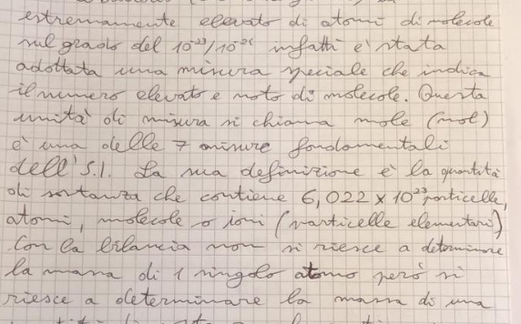

The right border of the writing implies an approach to the future and a willing to plan it;

The bars of letters are not all long or small. It implies that the person is connected to the reality and the concreteness and also to the ideals;

The angle in his handwriting denote his resistance to change and his tenacity, therefore they are not very obvious;

The big gauge denotes an ability to analyze and a willing to control. It also denotes his sociability;

Little space between letters denotes the need of a own dimension;

The space between words is not excessive, so he is able to think for a little time before acting;

The handwriting follows the paper line: it is sign of the ability to realize goals in a coherent way and a connection with the reality;

Letters are lightly overturned to the right, it shows the natural way of writing and his need of other people.

**WHAT DOES HANDWRITING TELL ABOUT A PERSON?**

* *TWISTED WRITING*

Twisted is the calligraphy where the axes of the letters have such a confusion and a difference of angle that these axes even meet. This type of writing doesn’t look neat and it feels really confused, just like the writing subject’s confusion, and it cannot only be physical but even a mental “chaos”. This person probably is unreliable and always unreliable. Moreover this subject will hardly finish an assigned task, he won’t keep for a long time the same ideas and he will be subject to frequent mood swings.

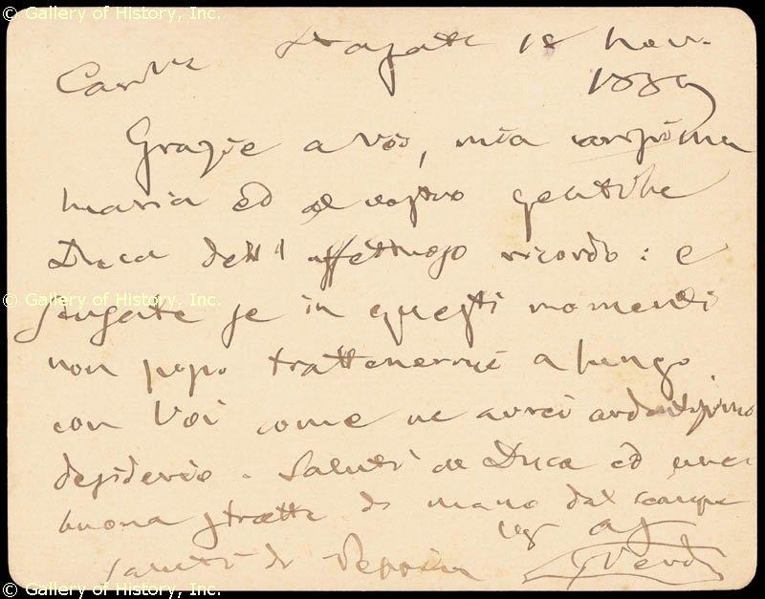

For example this image represents an example of a twisted writing, indeed if we trace an axe for every word you can clearly imagine them meeting in determined points, so probably who wrote these lines has some of the characteristics previously said.

* *LINE: KEEPS THE LINE*

Who keeps constantly the line is a reliable person and follows his tasks, but he suffers of unconscious fear of not being able to face difficulties. He doesn’t excel in work because he avoids competition, follows the directions given by others and has a schematic mentality. This writing aspect also underlines firmness, strength of personality and will to complete tasks. But who keeps too strictly the line has a low self esteem, has a real big fear of not being right for those activities or tasks and he doesn’t want to take decisions because of his fear of the world.

* *RISING OR DESCENDING BASELINE*

In handwriting analysis, baseline helps to determine writer’s way to approach to life and his perception of the reality; it’s like a bridge to our subconscious mind. In brief, it reveals foundation of our personality.

It is one of the most significant elements of handwriting analysis.

But what is the baseline? It is the imaginary line that comes out when we write on a blank sheet of paper.

Moreover, the baseline is a sign of writer’s moods, honesty, principled character, social control, personality, mindset and flexibility.

**The direction of baseline** is what allows the graphologist to determine such features of the writer’s personality. Rising baselines generally suggest optimism, while descending ones describe pessimism and sadness.

1. *RISING BASELINE*

It is index of optimism

Writers with such a handwriting generally are well-balanced, loyal, focused on their job and they constantly tend to get better in what they’re doing: they’re determined people. From the point of view of feelings, they’re emotionally stable, in opposition to the subjects with a descending handwriting. Moreover, these people are peace loving and they have a flexible personality. However, rising baseline hasn’t always a positive meaning. The confidence they have in themselves can sometimes bring them to think there are no rules to be observed so in some cases they tend to believe they’re free to do whatever they want.

1. *DESCENDING BASELINE*

It generally suggests pessimism and a negative approach to life, but it can also be index of lazyness and insecurity. It can result in temporary fatigue, exhaustion, illness or, in extreme cases, in depression, as it has been noticed in some suicidal letters. Hopeless and disappointment are common feelings between people with this kind of handwriting. In particular their moral weakness tends to come to the surface when they have to face troubles, sacrifices and contraddictions: such people do not believe in themselves and they can’t stand the weight of their responsibilities and this is why they often tend to ask the others for help. Descending baseline is typical of elderly people, since it reveals low energy from a physical point of view.

Examples:

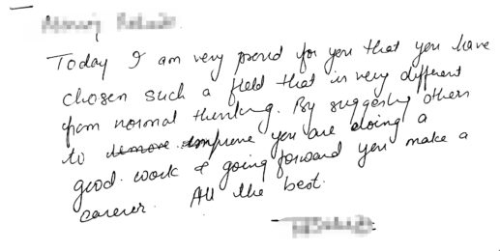

This is an example of ascending writing. It suggests an ambitious and determined person. According to the general traits belonging to the ascending baseline, the writer could be an optimistic and well balanced person who always try to make the best to improve herself, but it could also be the index of a person who has got too much confidence in herself, even if this trait is typical of exaggerated ascending handwritings.

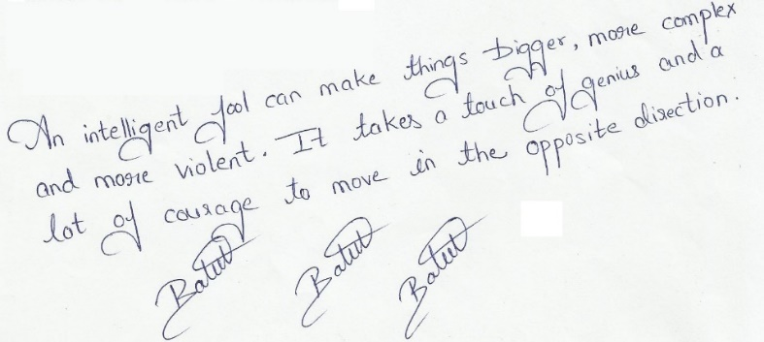

This is an example of an exaggerated ascending baseline. This kind of handwriting is ambiguos. On one hand it reveals and incredibly optimistic person who has no rules and lacks praticality. He/she often is an egoistic and unreliable person. On the other hand, such handrwriting can belong to a person who’s trying to hide sad feelings and depression to pretend to be happy to other people’s eyes.

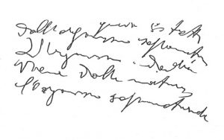

This is an example of descending baseline. Since the descending tendency is immediately visible, one can try to make some conjectures: the handwriting suggests a sad mood and it seems as if the writer has got no energy to keep his handwriting on the line. He/she is probably depressed because sadness seems to be the leading feeling. Morover, what comes to the surface after a careful analysis, is that the writer couldn’t realise his words where going downward because they keep descending even in the last part of the reading: this could mean that the writer probably is of depression since a long time.

* *PRESSURE ON PAPER*

A characteristic of handwriting is the pressure exerted on the sheet. It could be heavy, light, but also average.

Heavy and light pressure on sheet underline writer's typical features.

Heavy line is recognizable by the shape of the sheet which, after writing, becomes corrugated.

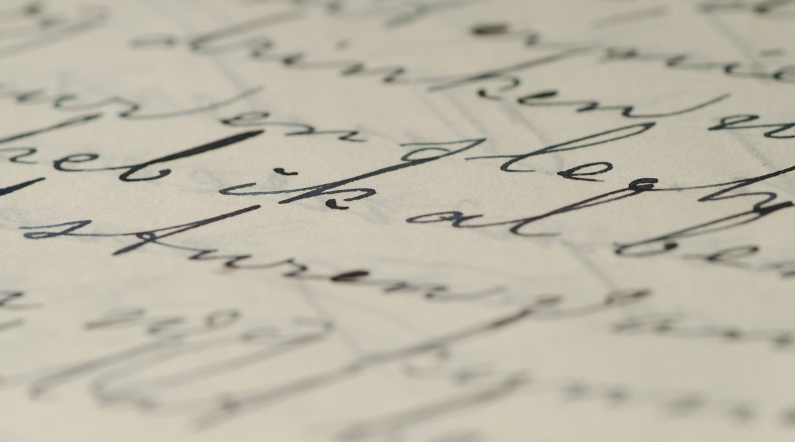The present is an example

As you can see, some words are visible from the back of the sheet.

In graphology heavy pressure indicates that the writer has got a great deal of energy. The energy mentioned here is not only physical energy but it may be mental energy too.

This type of person may keep fighting to the end until he gets what he wants.

A heavy pressure in writing may also show that the writer has a particular personality:

He can be overly concerned with the time;

He can experience a lot of stress;

He can be very ambitious and competitive;

He can be focused on routine;

Summarizing, heavy pressure shows a strong personality and a person full of energy to

spend in work hardly. If the pressure is excessively heavy, the writer may react quickly to criticism.

In graphology light pressure indicates that the writer has got less energy than a writer writing with heavy pressure.

This person may prefer activities that require less physical work.

He may also be sensitive and he may show an empathy to people.

This person may also be more flexible than a person who writes with heavy pressure and this may make him more adaptable to changing situations.

So, the person may have got an high level of perception and physical weakness because he may work hard mentally and he may have a lack of vitality.

Who writes with an average pressure in real life may not find extremes.

An example of heavy, average and light pressure is:

