**ANGELA ARCURI OBSERVATION ON A.FRANTI’S NOTES**

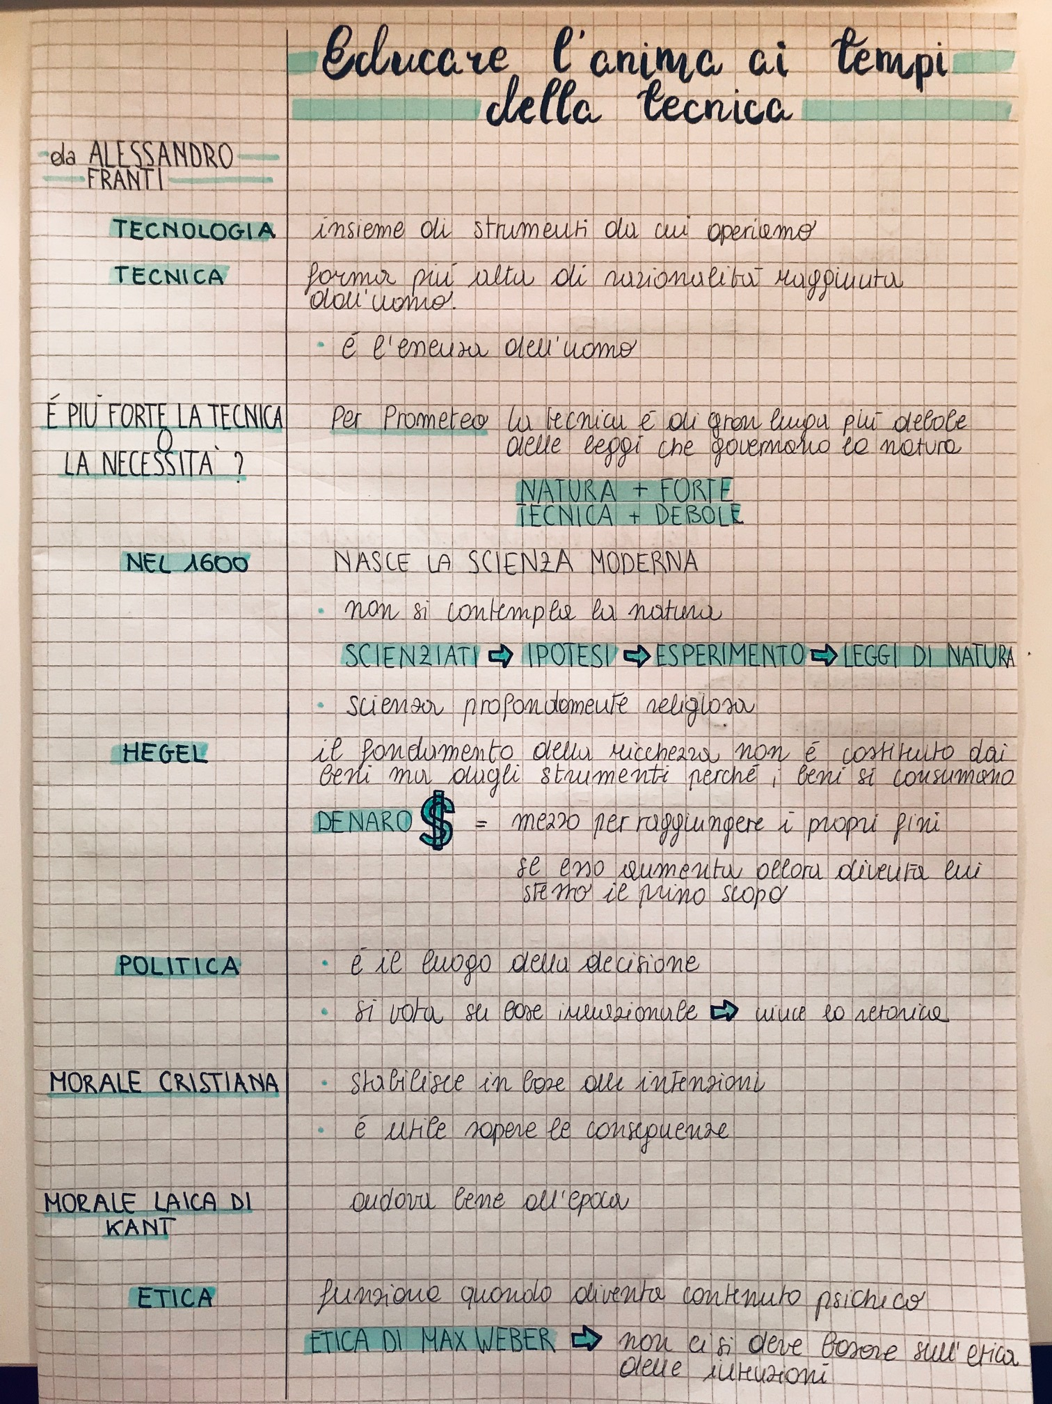

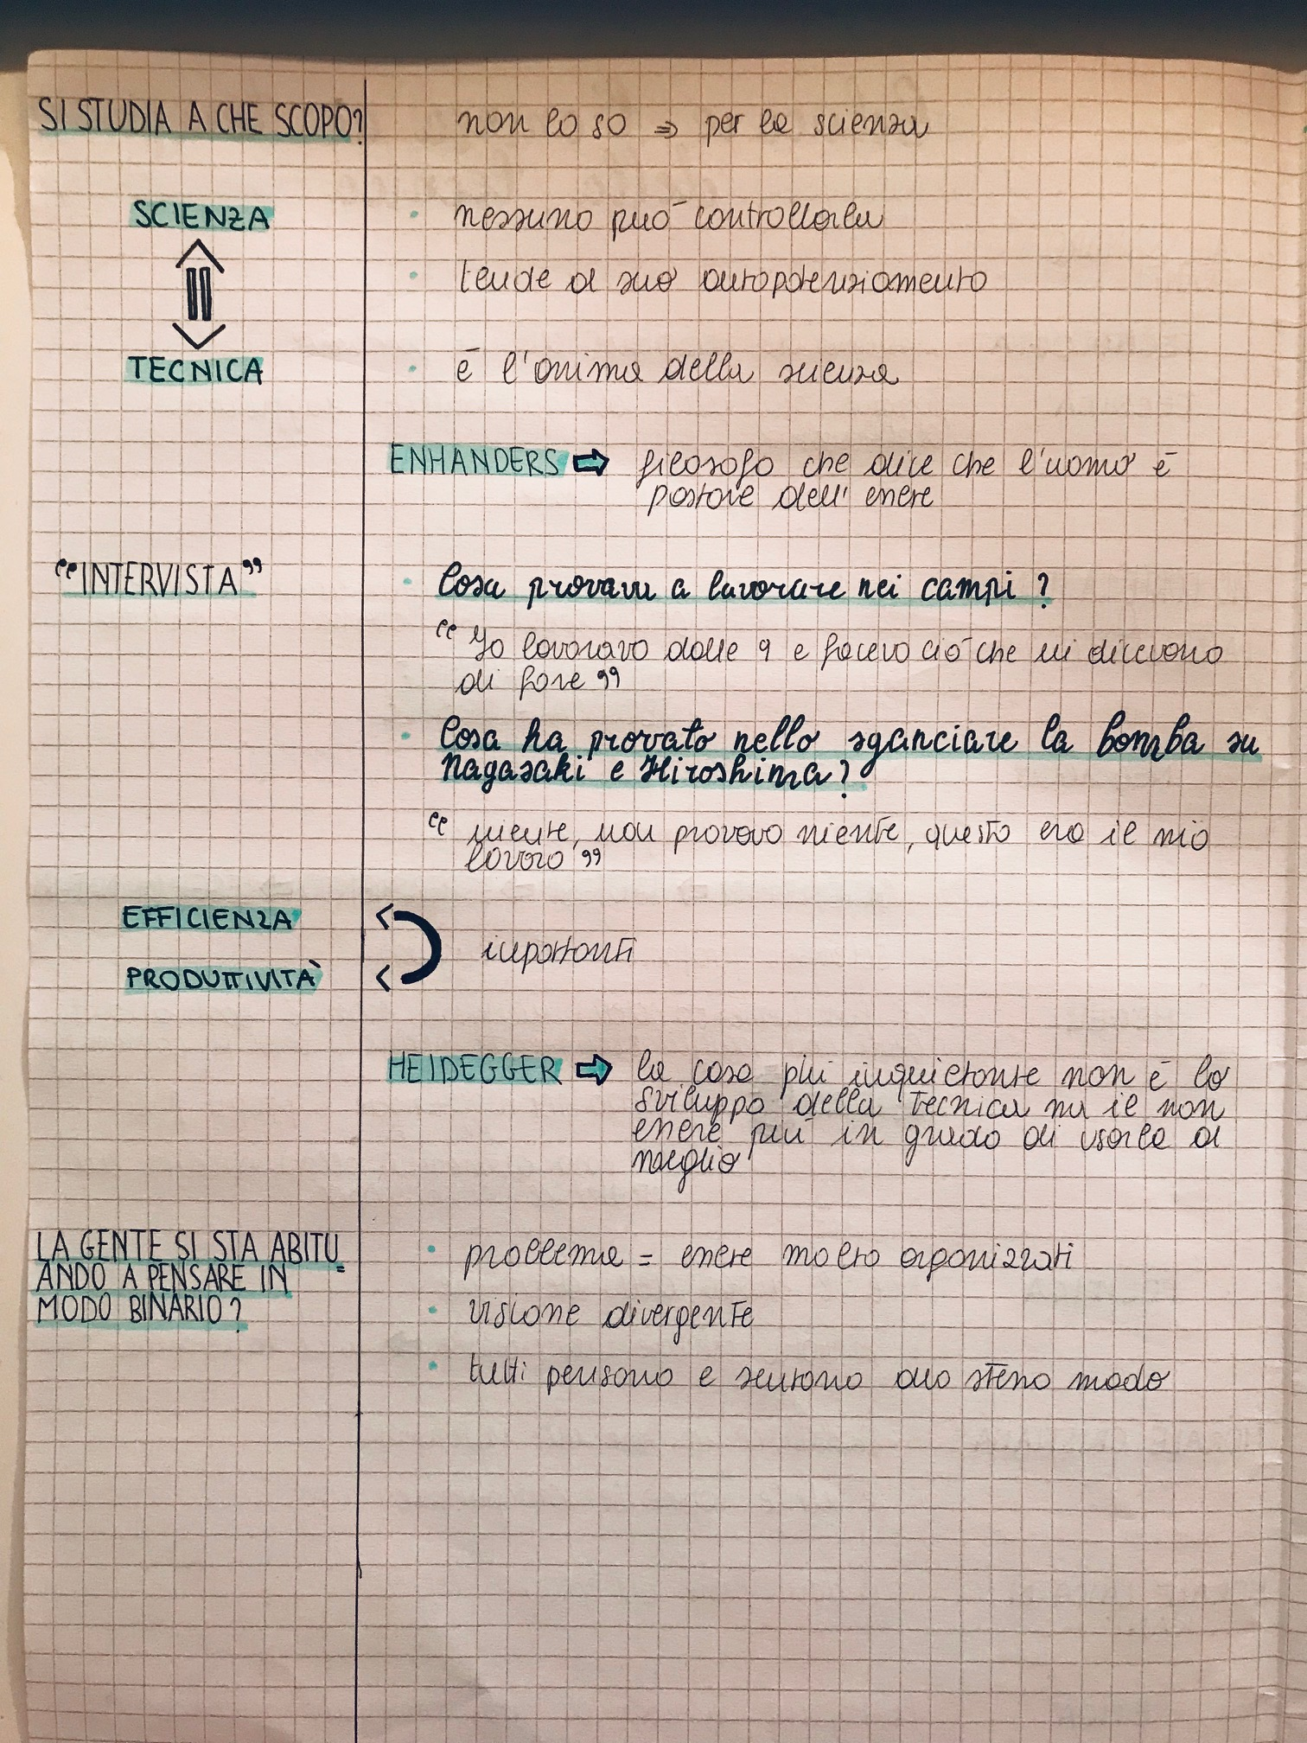

**ANGELA ARCURI OBSERVATION ON A.SINICO’S NOTES**

